HW78V/HW76V电控使用说明书
前言
Prefac
欢迎使用本公司产品，制衣行的正确投资选择！
Welcome to use the our products, it is the right investment choices in garment industry!

本说明书为本公司新研发的“HW78V控制箱”产品参考手册，请认真阅读此手册以更好的运用本公司产品！
This user manual is for our newly developed “HW76S” products reference manual, Please read this manual carefully, hope it can give you useful help!

安全说明：General SafetyInstructions

阅读本说明前以下要求说明请注意：
Before reading the manual, please note the following requirements:
1：用户使用作业前必须可靠接地，保证人身安全.
The user must be grounded before operations to ensure safety.
2：非专业人士请勿拆卸控制箱.
Non-professionals do not disassemble the control box.
3：控制箱与电机远离强磁高辐射环境.
The control box and motor away from the magnetic high radiation environment.
4：不要在过热环境中作业.
Do not work in hot environment .
5：不要在过于潮湿环境中作业.
Do not work in humid environments.
6：220V电控：【220V接入供电时电压稳定在（AC200V~260/单相）之间】
220V electronic control: [220V access to power supply voltage stability between (200V~260V)]
电源供电电压 Voltage | 220V单相1phase
频率Frequency | 50~60HZ
电机转速Speed | 200-5000RPM
电机扭矩Motor torque | ≤4.2N.M
110V电控：【110V接入供电时电压稳定在（AC100V~130/单相）之间】
110V electronic control: [110V access to power supply voltage stability between (100V~130V)]
电源供电电压Voltage | 110V单相1 phase
频率Frequency | 50~60HZ
电机转速Speed | 200-6500RPM
电机扭矩Motor torque | ≤4.2N.M
安全叮嘱：
Safety requirement:
1：电机电控接通电源时（开机状态）请不要把脚放在脚踏板上.
Do not put your feet on the pedals when the control box and motor is switched on (boot status)
2：本产品请专业人士安装调试.
Let professionals to install and debug this product
3：严禁在通电时打开控制箱与电机端盖.
Do not open the control box and the motor cover when energized
4：换针，穿线或更换底线时请关闭电源.
Please turn off the power when changing the needle, threading or replacing the bottom line
5：安装，拆卸维修时请拔掉电源插头.
During installation and removal service, please turn off the power and pull the plug
6：翻抬缝纫机时请关闭电源.
Please turn off the power when turn lift sewing machine
7：使用本产品请远离高频电磁波和电波发射器等，以免所产生的电磁波干扰伺服驱动器而发生错误动作.
When use this product, please stay away from high-frequency electromagnetic waves and radio wave transmitters, etc., in case the electromagnetic waves generated interfere with the servo drive to occur wrong action .

郑重申明：
Solemnly Declare:
1：不遵守安全使用说明操作规章，发生意外后果自负.
Do not comply with the manual book operating regulations and the safety requirements, all accidental occurrence should be taken by yourself.
2：未经本公司授权，请勿擅自改动产品，由此而引起的后果本公司不负任何责任.
Without our authorization, please do not alter our products, our company is not liable for any consequences arising there from.
3.由于产品的改进，本手册内容可能随时变更，恕不另行通知.
It will not noticed that the manual changed with the development of the products.

保修策略：
Warranty policy:
1：本产品自购买起免费保修2年，终身维护。保修期内除人为损坏外出现的任何质量问题可免费修.
Since from the purchase of this product, the free 2-year warranty, lifetime maintenance. During the warranty period, any quality problems the product will be free repaired, except artificial damage.
2：未经本公司同意自行拆卸，改装造成损坏将不给于保修.
Without our consent disassemble or modify, the damaged will not give in warranty
3：但凡出现无法解决的问题可以联系本公司.
Whenever find the problem can not be solved, you can contact with our company

目录

Contents
- 显示屏常用操作介绍
Introduction of display screen common Operation

二、如何进入参数与如何修改参数
How to enter parameters and how to modify the parameters
- 操作参数说明表
Operating Parameter Description Table

四、控制箱端口说明
The control box Port Description

五、错误代码解析
Error code analysis
六、电控相关的要求及操作使用注意事项
Electrical control related requirements and operating precautions

一、显示屏常用操作介绍：
Introduction of display screen common operation：
1.显示屏介绍如下：
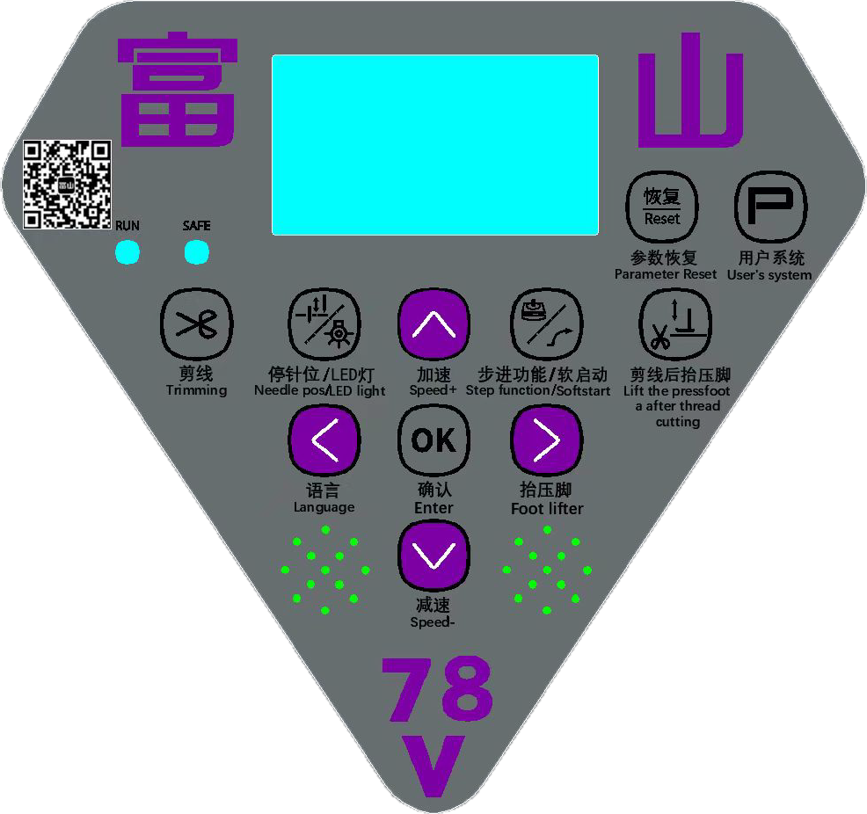

2.功能介绍：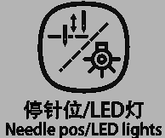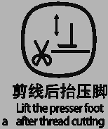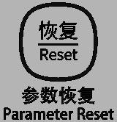
序 号  No.1 | 按 键 图 标  Button Icons | 功 能 说 明  Function Description | 快 捷 说 明  Quick Description
1 | （参数返回键）  Parameter back key | 进入参数修改时按 键可以返回上一级参数  when enter into the parameter modify, press button can back to the previous parameter | 按住两次再按进入用户参数模式（需要输入密码，详表1）;
2 | （锁屏/确定键）  Lock screen/Confirm key | 1.锁屏:开机长按3S进入，待机20S锁屏  2.确定键:参数进入确定和保存参数  1. Lock screen: Lock the screen  2. Confirm key: Parameter determines the Save button
3 | （参数调整加键）  Parameter adjust add key | “”键（修改参数时向上加参数值）  “”button (modify the parameters plus ) | 在主界面时按键实现加速度  On the main interface, pressto achieve speed add
4 | （恢复键）  Reset key |  | 长按3 秒恢复用户参数  Long press it 3 secs to reset to the user parameter
5 | （参数调整减键）  Parameter adjust | “”键（修改参数时向下减参数值）  “”button (modify the parameters minus ) | 在主界面时按键实现减速度  On the main interface, pressto achieve speed reduce
6 | （语言/左移键）  / Left side key | 1.左移键:在参数列表中用来返回上一页面和向左移动光标用  1.. Left side key :in the parameter list to return to the previous page and left side move | 在主界面时按键实现语言选择  Press on the home key implementation screen language selection
7 | （抬压脚/右移键） | 1.右移键:在参数列表中进入参数调整用  1.Right side key :in the parameter list to enter into the parameter adjustment  2.点按键屏幕显示半后踏抬压脚功能和停车自动抬压脚功能：  半后踏抬压脚功能：开启/关闭  停车自动抬压脚功能：开启/关闭  2. Tapthe Foot Lifter key, the screen will display the half-back-treadle presser foot lifting function and auto presser foot lifting on stop.  Presser Foot Lifting Functions:  - Half-back-treadle Presser Foot Lifting Function: Enable / Disable  - Auto Presser Foot Lifting on Stop Function: Enable / Disable | 在主界面时长按键进入快捷参数修改：  046-拨线延时启动时间（默认180）  047-拨线维持时间（默认45）  065-半后踏启动时间（默认150）  - 步进抬压脚总角度（默认700）  - 步进抬压脚速度（默认550）  - 步进放压脚速度（默认550）  - 步进抬压脚力度（默认2）  - 步进放压脚力度（默认2）  On the main interface, pressto achieve speed add  046-Sweep action delay time（default 180）  047-Sweep action holding time（default 45）  065-Half-backward step time（default 150）  - Angle of foot presser（default 700）  - Speed of foot presser lift up(default 550)  - Speed of foot presser lift down(default 550)  - Power of foot presser lift up(default 2)  - Power of foot presser lift down(default 2)
8 | （停针位/LED灯键）  needle position stop key/LED lights key | 1.停针位键:在主界面切换上下停针位  2.LED灯键:LED灯键  1.Right side key :in the parameter list to enter into the parameter adjustment  2.LED lights key:LED lights key | 点按可以进行停针位和LED功能选择  - 停针位功能：上停针/下停针  - LED功能：1档-5档递增  - Stop stitch position function :up stop stitch /down stop stitch  - LED function:1-5 speed in crease
9 | （步进/压脚键)  Stepping/Presser Foot function key | 在主界面切换步进/压脚键  in the main interface to transfer Stepping/Presser Foot function key | 1.长按步进键,进入步进功能参数调整;  2.软启动键: 点按键，功能开启  Click stepping to enter function parameter adjustment ;  1.Slow start function key :Click button, when function open, the upper led light is on, when function close, the upper led light is off  ;
10 | （剪线功能键）  thread cutting function key |  | 长按进入快捷参数修改：  036—剪线延启动时间（默认025）  037—剪线保持时间（默认200）  038—剪线全功率时间（默认065）  040—剪线维持功率（默认050）  041—剪刀释放时间（默认035）  043—剪刀复位开关使能（默认001）  044—剪刀工动作模式（默认001）  045—预留  090—在主界面上显示指定的数据（1）  Long press to enter into the quick parameter modify:  036--thread cutting delay start time (default 025)  037--thread cutting maintain time(default 110)  038--thread cutting full power time(default 065)  040--thread cutting maintain power(default 050)  041--knife release time (default 035)  043--knife reset switch enabled(default 001)  044--knife action mode(default 001)  045--reserve  090--Display the specialed data on the main interface
二、如何进入参数与如何修改参数:
How to enter parameters and how to modify the parameters:
系统参数进入解析（长按锁屏键解锁）：
1.长按（）键将进入“系统参数”列表（需要密码2014进入）。
2.修改完毕参数后需要长按（）键锁存参数并退出系统参数调节。
1.Tapkey twice will enter the “System Parameters (requires Password 2014enter)
2.After modifying the parameters key save parameter and exit system parameter adjustment.

恢复出厂设置：Restore factory settings
长按“”键键约3秒即可。
then press “” key 3 seconds.
注：以上是进入方法，具体参数号代表的参数意思详情如下“操作参数说明表”
System parameters entering analysis:

三、操作参数说明表：

Operating Parameter Description Table:
菜单号  System parameter list | 功能说明  Function Description | 功能参数默认值  Function parameter default values | 功能参数范围  Function parameter ranges | 单位  unit | 参数说明  Parameter Description
P1 | 最大缝纫速度  Max sewing speed | 4500 | 200 ~6000 | 转 / 分钟  Round / Minute | 锁定速度，从外部按加键，速度上不去（这里速度只能锁定到出厂要求的速度）  Locked speed, press add key, the speed can not add(here, the speed only can add to the factory set)
P2 | 起缝速度  Start sewing speed | 250 | 150 ~ 800 | 转 / 分钟  Round / Minute | 调节启动时前面二针速度  Adjust the previous two needles speed when start
P3 | 踏板加速曲线  Pedal acceleration curve | 85 | 10 —100 % | % | 数值越大，加速越快；数值越小，加速越慢  The value is bigger,  the acceleration is more fast;  the value is smaller,  the acceleration is more lower
P4 | 第一针速度  Pedal slope | 2000 | 200-3200 |  | 数值越大，第一针启动越快；  数值越小，第一针启动越慢  The larger the value,the faster the first pin starts:  The smaller the value,the slwer the first stitch will start:
P5 | 第一针模式  Reserved | 1 | 0-3 |  | 0：关闭  1：启动第一针模式，每次剪线复位后开启  2：每次启动都有  0:Off  1:sart the first stitch modo and turn it on after each wire cut reset  2:It is on every start
P11 | 软启动选择  Slow Start Selection | 0 | 0 — 1 |  | 0：禁用 1：启用  0: Disable 1: Enabled
P12 | 软启动针数  Slow start Stitch number | 1 | 1 — 30 | 针数  Stitch number | 数值越大，慢缝针数越多；数值越小，慢缝针数越少（需要P11开启有效）  The value is more bigger,  slow sewing stitches is more ;  the value is more smaller,  slow sewing stitches is little.(need P11 is open)
P13 | 软启动速度  Slow start speed | 400 | 200 — 800 | 转 / 分钟  Round / Minute | 数值越大，前踏踏板速度越快；数值越大，前踏踏板速度越快（需要P11开启有效）  The value is more bigger, front-step pedal, the speed is more faster.(Need P11 is open)
P20 | 加速灵敏度  acceleration sensitivity | 004 | 1-6 |  | 数值越大，低速区域越大，速度变化越大；数值越小，低速区域越小，速度变化越小  The value is more bigger,  low speed area is more bigger, speed change is more bigger;  the value is more smaller,  low speed area is more smaller, speed is more smaller
P21 | 恢复出厂设置  restore factory setting | 0 | 0-3 |  | 0： 1： 2: 3：
P22 | 电机驱动方向  Motor drive orientation | 1 | 0- 1 |  | 0：逆时针0:Counterclockwise  1：顺时针1: Clockwise
P23 | 显示当前速度  Displays the current speed | 0 | 0-1 |  | 0：关闭 1：开启  ※（开启参数后，显示区会显示电机运行速度值）  0: Close 1: Open  ※(After opening parameter, display area will shows motor running speed value )
P24 | 显示调速器电压  Display governor voltage | 202 |  |  | 0：关闭 1：开启参数后， 显示区会显示调速器输出数值  ※（调试器数值：中立位置200±15%、全后踏0-28、半后踏29-124、全前踏315-1023）  0: Close 1: After opening parameter, display area will shows foot controller output value  ※(Foot controller value: middle position 200±15%, full back step0-28, half-back step 29-124, full front step 315-1023)
P25 | 自动跑合运行  Automatic run-run | 0 | 0 -1 |  | 0：关闭 1：开启  0：OFF 1: ON  ※开启后需要前踏调速器才能跑和，后踏停止跑和  0：OFF 1: ON  ※When open , need to front step pedal, it can running, and back step is stop running
P28 | 开机自动找上针位  Find the upper needle position automatically when machine open | 1 | 0-1 |  | 0：关闭1：开启  0：OFF 1: ON
P34 | 上停针角度  The angle of up needle position | 0 | 0-30° | 度degree | 微调上停车位  Slightly adjust upper needle position
P35 | 下停针角度  The angle of down needle position | 150 | 100-300° | 度degree | 微调下停车位  Slightly adjust upper needle position
P36 | 剪刀动作延时启动时间  Delay time for Scissors action | 20 | 0 — 2000 | 毫秒Millisecond | 机器停稳，下剪刀电磁铁出刀时间，数值越大出刀越慢，数值越小出刀越快  When machine is stop steady, trimmer magnet give knife time, the value is more bigger the knife is more slower, the value is more smaller the knife is more faster
P37※ | 剪刀动作时间（全功率+维持功率）  Scissors action time (full power + maintain power) | 10 | 10 — 2000 | 毫秒 Millisecond | 下剪刀电磁铁动作时输出最大功率和维持功率时间  Trimmer magnet action output biggest power and maintain power time
P38 | 剪刀动作全功率时间  Full power scissors action time | 65 | 10 — 990 | 毫秒 Millisecond | 下剪刀电磁铁动作时输出功率时间，数值越大，剪线力度越大；数值越小，剪线力度越小  Trimmer magnet action output power time, the value is more bigger, the thread cutting power is more bigger; the value is more smaller, the thread cutting power is more smaller
P39 | 剪线全功率时功率  Thread cutting full power power | 80 | 20-100 | 毫秒 Millisecond | 下剪刀电磁铁输出的功率（不可调）  Trimmer magnet output power(can not adjust)
P40 | 剪线维持功率  Thread trimming holding power | 50 | 1 — 100 | 百分比 Percentage | 下剪刀电磁铁打出后维持力度，数值越大，剪刀回位越慢；数值越小，剪线力度越快，（数值小了会剪不到线）  The maintain force after the down thread cutting line magnet hitting, the value is more bigger, knife reback is more slower; the value is more smaller, thread line cutting force is more quickly,(if the value is too small, can not cutting the thread line)
P41 | 剪刀动作释放保护时间  The protect time of knife action release | 35 | 20 — 800 | 毫秒Millisecond | 下剪线电磁铁动作完后保护时间，数值越大，保护时间越长，（数值越大会影响抬压脚速度）  The protect time when down thread line cutting magnet action finish, the value is more bigger, the protect time is more longer(the value is more bigger will influence the foot pressure lifting time)
P42 | 剪刀保护时间  Knife protect time | 001 | 0-5 |  | 不能调Can not adjust
P43 | 下剪刀安全开关  Knife safe switch | 1 | 0 — 1 |  | 0：禁用 1：启用  0: Disable 1: Enabled
P44 | 剪刀工作模式  knife work mode | 1 | 0-1 |  | 0:禁用（用手转动机器手轮，全后踏后剪线）  1:启用（用手转动机器手轮，前后踏后不会剪线）  0: Disable(use hand to round the hand wheel, full back step pedal can thread cutting )  1: Enabled(use hand to round the hand wheel, full back step pedal can not thread cutting)
P46 | 拨线延时启动时间  Thread picker delay start time | 80 | 0-2000 | 毫秒 Millisecond | 机器停稳，拨线刀出刀时间，数值越大出刀越慢，数值越小出刀越快  The machine stops steadily, and the drawing knife takes longer time, the larger the value is, the slower the knife takes, and the smaller the value is, the faster the knife takes  2：抬压脚后吹气启动延时时间  数值越小，抬压脚后吹气间隔时间越短  数值越大，抬压脚后吹气间隔时间越长  参数默认为20
P47※ | 拨线时间（全功率+维持功率）  Wiper action time (full power + maintain power) | 100 | 10-2000 | 毫秒 Millisecond | 拨线电磁铁动作输出最大功率和维持功率时间  Dial-in electromagnet action output maximum power and power maintenance time
P48 | 拨线全功率时间  Thread picker full power time | 80 | 10-990 | 毫秒 Millisecond | 拨线电磁铁输最大功率时间，数值越大，拨线力度越大；数值越小，剪拨力度越小  The time of the maximum power of the dial-in electromagnet, the greater the value, the greater the dial-in strength; The smaller the value, the smaller the shear strength
P49 | 拔线全功率时功率  Full power power of cable unplugging | 80 |  |  | 拨线电磁铁输出的功率  Power output of dial-in electromagnet
P50 | 拨线维持功率  Thread picker full power time | 50 | 1-100 | 百分比 Percentage | 拨线电磁铁打出后维持力度，数值越大，剪刀回位越慢；数值越小，剪线力度越快，（数值小了会拨不到线）  Dial electromagnet after the maintenance strength, the larger the value, the slower the scissors return; The smaller the value, the faster the cutting force, (the smaller the value will not be able to dial the line)
P51 | 拨线释放保护  Thread picker release protection | 25 | 20-800 | 毫秒 Millisecond | 拨线电磁铁动作完后保护时间，数值越大，保护时间越长，（数值越大会影响抬压脚速度）  The higher the value is, the longer the protection time will be. (The greater the value will affect the speed of presser foot)
P52 | 拔线保护时间  Unplug protection time | 5 | 1-5 |  | 不可调  Can not adjust
P53 | 拨线保护开关  Thread Wiper Protection Switch | 0 | 0
P54 | 拨线动作模式  Thread Wiper Action Mode | 1 | 1-2 |  | 左切机型时：抬压脚后吹气，参数调整为2
P55 | 吹气时间  Air Blow Time |  | 20 |  | 左切机型时：抬压脚后吹气时间，参数调整为20
P56 | 压脚延时启动时间  Presser foot delay start time | 110 | 0-2000 | 毫秒Millisecond | 剪完线电机停转后，多长时间开始抬压脚  After thread line cutting and motor stop running , how long time to start foot pressure lift
P57※ | 压脚动作时间（全功率+维持功率）  Foot pressure action time (full power + maintain power) | 260 | 100 — 2000 | 毫秒 Millisecond | 抬压脚电磁铁的初始力度和维持的时间  Foot pressure magnet’s start force and maintain time
P58 | 压脚动作全功率时间  Foot pressure action time at full power time | 160 | 10 — 990 | 毫秒 Millisecond | 抬压脚电磁铁的打出力度保持时间  The maintain time of the foot pressure magnet hit force
P59 | 压脚全功率时功率  Foot pressure full power power | 100 | 60 — 150 | 毫秒Millisecond | 抬压脚电磁铁的初始力功率  The start power of foot pressure magnet
P60 | 压脚动作维持功率调整  Foot presser action maintain power adjustment | 20 | 1 — 90 | 百分比 Percentage | 抬压脚电磁铁的力度保持时的时间  The time when the foot pressure magnet power maintain
P61 | 压脚动作释放保护时间  Foot presser lifter action releasing protect time | 65 | 20 — 800 | 毫秒Millisecond | 抬压脚电磁铁抬起放下后机器启动保护时间，数值越大时间越长  After the foot pressure lifter magnet lift and down, the machine head start protect time, the value is more bigger, the time is more longer
P62 | 压脚抬起后自动放下时间  Automatic presser foot lift down time | 10 | 1 — 120 | 秒 Second | 抬压脚多长时间后自动放下的时间  How long after the pressure foot automatically down time

P63 | 压脚保护开关  Presser Foot Safety Switch | 0 | 0-1
P64 | 压脚动作模式  Presser Foot Action Mode | 0 | 0-1
P65 | 半后踏启动时间  Half back pedal start time | 45 | 0 — 2000 | 毫秒Millisecond | 脚踏调速器半后踏后，多长时间开始抬压脚  Half-back step pedal, how long time to start foot presser lift
P70 | 电机最大电流限制  Motor max electric current limit | 350 | 50 — 600 |  | 限制电机功率（影响穿透力和温升）  Limit motor power(Affects Penetration and temperature rise)
P71 | 最高速度锁定  Maximum speed lock | 4500 | 200—6000 | 转 / 分钟  Round / Minute | 锁定速度  Lock speed
P72 | 系统密码  System Password | 2014 |  |  | 进入调整系统参数密码  The code to enter into adjust system parameter
P73 | 语音音量  Volume of voice  prompts | 30 | 0-30 |  | 数值越大，音量越大  The higher the value,the higher the volu
P74 | 语言选择  Language | 0 |  |  | 0:中文  1:英文  2:  0:Chinese  1:English  2:
P75 | 开机语音  Starting voice | 1
P76 | 吹气延时启动时间  Air Blow Delay Time | 14 | 0-2000 | 毫秒Millisecond | 吹气完成电机停转后，多长时间开始抬压脚  Howlong after the blower finishes and the motor stops rotating should the presser foot start to lift
P77 | 吹气维持时间  Blow Maintain Time | 20 | 1-600 | 毫秒Millisecond | 吹气保持时间 ：  数值越小，保持时间越短  数值越大，保持时间越长  Blow Holding Time  Thesmaller the value, the shorter the holding time.  The larger the value, the longer the holding time.
P78 | 吹气全功率时间  Blow Full Power Time | 160 | 160 | 毫秒Millisecond
P79 | 吹气全功率时功率  Air Blow Full Power | 80 | 20-100 | 毫秒Millisecond | 电磁阀控制吹气的初始力功率
P80 | 吹气维持功率  Air Blow Hold Power | 80 | 1-100 | 毫秒Millisecond
P81 | 吹气释放时间  Air Blow Release Time | 45 | 1-800 | 毫秒Millisecond
P82 | 吹气保持时间  Air Blow Hold Time | 0 | 0-120 | 毫秒Millisecond
P83 | 吹气保护开关 | 0 | 0-1 | 毫秒Millisecond
P84 | 吹气动作模式  Air Blow Safety Switch | 1 | 0-4 | 毫秒Millisecond | 0: 关闭1:长吹  2:先间隔吹后间隔吹  3:先吹后，  4:抬压脚吹
P85 | 吹气  Air Blow | 0 | 0-2
P86 | 断吹开启针数  Blow Cut Enable Stitches | 10 | 1-250
P87 | 断吹关闭针数  Blow Cut Disable Stitches | 10 | 0-250
P90 | 在主界面上显示指定的数据  Displays the specified data on the main screen | 0 | 0-4 |  | 0:关闭  1:计数  2:速度  3:脚控电压  4:电压  0:Close  1:Counting  2:Speed  3:Foot controller voltage  4:Voltage
P91 | 老化跑和时间  Aging running time | 5 |  | S/秒 | 数值越大跑合时间越长，数值越小跑合时间越小  The value is more bigger, running time is more longer, the value is more smaller, the running time is more shorter
P92 | 老化跑合停止时间  Aging running stop time | 2 |  | S/秒 | 数值越大跑合停止时间越长，数值越小跑合停止时间越小  The value is more bigger, the running stop time is more longer, the value is more smaller, the running stop time is more shorter
P93 | 老化跑合速度  Aging running speed | 4500 | 200-5000 | 转 / 分钟  Round / Minute | 老化跑合速度调整和锁定  Aging running speed adjust and lock
P94 | 用户速度调整限制 | 5000 | 200-6000
P95 | 虚拟速度开关  Virtual Speed Switch | 0-1 | 0 |  | 开启后，设置速度超过4500转的部分，只会跑原来的一半（设置5500，实际5000）  Whenenabled, any set speed exceeding 4500 RPM will run at half the excess value.  (Example: set to 5500 RPM, actual speed is 5000 RPM)
P99 | 显示屏版本号  Panel version No. | 226
P100 | 电控版本号  Control box version No. | 5102
P101 | 步进电机方向  Step motor direction | 0 | 0-1 |  | 0：逆时针0:Counterclockwise  1：顺时针1: Clockwise
P102 | 步进电机原点偏移量  Origin offset of stepper motor | 32 | 0-400 | 度degree
P103 | 步进电机原点偏功率  Step motor origin bias power | 10 | 0-50 | 毫秒 Millisecond | 开机时步进电机寻找原点位置的运行功率  When starting up, the stepper motor looks for the running power of the origin position
P104 | 步进电机剪线功率  Step motor wire cutting power | 85 | 0-95 | 毫秒 Millisecond | 步进电机剪线时电机输出的功率  The output power of the stepper motor when cutting the line
P105 | 步进电机剪线角度  Cutting angle of stepper motor | 800 | 0-2800 | 度degree | 步进电机剪线方向电机运动的角度，数值越大，出刀量越大。数值越小，出刀量越小  Step motor shearing direction The motor movement Angle, the greater the value, the greater the knife output. The smaller the value, the smaller the knife output
P106 | 步进电机进刀速度  Step motor feed speed | 80 | 0-950 | 毫秒 Millisecond | 步进电机剪线方向电机运动的速度数值越大，出刀速度越快，：数值越小，出刀速度越慢。  The larger the value of the motor speed in the direction of the stepping motor's cutting line, the faster the cutter speed. The smaller the value, the slower the cutter speed
P107 | 步进电机退刀速度  Step motor retracting speed | 100 | 0-950 | 毫秒 Millisecond | 步进电机剪线结束时电机运动的速度，数值越大，退刀速度越快：数值越小，退刀速度越慢。  At the end of the line cutting of the stepping motor, the higher the motor speed is, the faster the cutting speed will be: the smaller the value is, the slower the cutting speed will be
P108 | 步进进刀力度  Stepping feed force | 2 | 0-5 | 度degree | 步进电机剪线时电机运动的力度，数值越大，进刀力度越大：数值越小，进刀力度越小。  When the stepping motor cuts the line, the greater the value, the greater the feeding force: the smaller the value, the smaller the feeding force
P109 | 步进电机退刀力度  Retracting force of stepping motor | 2 | 0-5 |  | 步进电机剪线方向电机运动的角度，数值越大，退刀力度越大。数值越小，退刀力度越小。  Step motor shearing direction The motor movement Angle, the greater the value, the greater the knife back. The smaller the value is, the smaller the retracting force is
P110 | 步进电机抬压脚角度  Step motor lift foot pressure angle | 500 | 0-2800 | 度degree | 步进电机抬压脚时电机运动的角度，数值越大，压脚抬起的越高。数值越小，压脚抬起的越低。  When the stepping motor lifts the press foot, the greater the motor movement Angle, the higher the press foot will be lifted. The smaller the value, the lower the foot lift
P111 | 步进电机抬压脚速度  Step motor lift foot pressure speed | 550 | 0-950 | 毫秒 Millisecond | 步进电机抬压脚时电机运动的速度，数值越大，压脚抬起的越快。数值越小，压脚抬起的越慢。  When the stepping motor lifts the press foot, the higher the motor movement speed, the faster the press foot will lift. The smaller the value, the slower the foot lift
P112 | 步进电机放压脚速度  Step motor pressure foot speed | 550 | 0-950 | 毫秒 Millisecond | 步进电机抬压脚时电机运动的速度，数值越大，压脚放下的越快。数值越小，压脚放下的越慢。  When the stepping motor lifts the press foot, the motor movement speed, the greater the value, the faster the press foot down. The lower the value, the slower the foot drops
P113 | 步进抬压脚力度  Step motor lift foot pressure strength | 2 | 0-5 |  | 步进电机抬压脚时电机运动的力度，数值越大，抬压脚力度越大。数值越小，抬压脚力度越小。  When stepping motor lift press foot, motor movement strength, the greater the value, the greater the lift press foot strength. The smaller the value, the smaller the strength of the lifting foot
P114 | 步进电机放压脚力度  Step motor pressure foot strength | 2 | 0-5 |  | 步进电机放压脚时电机运动的力度数值越大，抬压脚力度越大：数值越小，抬压脚力度越小。  The greater the motor movement strength value, the greater the lifting foot strength: the smaller the value, the smaller the lifting foot strength
P121 | 锁缝角度设定  The setting of reverse tacking angle | 50 | 0-6000 | 度degree | 锁缝功能结束机针运行的角度：  数值越大，锁缝动作结束后机针运行角度越大。  数值越小，锁缝动作结束后机针运行角度越小。  The angle which the the needle operated after the function of reverse tacking : the greater the value, the greater the needle operation angle after the sewing action is finished.  The smaller the value, the smaller the running angle of the needle after the sewing action is finished.
P122 | 锁缝延时启动  The delaying operation time of reverse tacking | 20 | 0-2000 | 毫秒 Millisecond | 锁缝功能动作延时的时间：  数值越大，动作延时时间越长。  数值越小，动作延时时间越短  The delaying time of sewing function: the greater the value, the longer the time delays; The smaller the value, the shorter the action-time delays .
P123 | 锁缝开关  The switch of reverse tacking | 1 | 0-1 |  | 0：禁用 1：启用  0: Disable 1: Enabled
P124 | 锁缝运行速度  Lockstitch machine speed | 2000 | 0-5000 | 转 / 分钟  Round / Minute | 锁缝功能运行的速度：  数值越大，速度越快。  数值越小，速度越慢。  The greater the speed as the function is turned on, the faster it will be. The smaller the value, the slower the speed.
P125 | 前密缝开关  Front seam switch | 1 | 0-1 |  | 0：禁用 1：启用  0: Disable 1: Enabled
P126 | 前密缝针数  Number of front close stitches | 5 | 0-10 | 转 / 分钟  Round / Minute | 前密缝功能运行针数：  数值越大，针数越多。  数值越小，针数越少。  Number of stitches running in front seam function  The larger the value,the more stitches  The smaller the number,the fer stitches
P127 | 后密缝停止针数  Number of stop stitches at back seam | 1 |  |  | 后密缝停止针数：  数值越大，后密缝针数越少。  数值越小，后密缝针数越多。  Number of stop stitches  The larger the value,the fewer the number of back close stitches.  The smaller the number,the more back tight stitches.
P128 | 后密缝开关  Rear seam switch | 1 |  |  | 0：禁用 1：启用  0: Disable 1: Enabled
P129 | 后密缝针数  Number of back close stitches | 5 | 0-10 |  | 后密缝功能运行针数：  数值越大，针数越多。  数值越小，针数越少。  Number of stitches running in the back seam function:  The larger the value,the more stitches  The smaller the number,the fewer stitches
P130 | 后密缝速度  Back seam speed | 3000 |  | 转 / 分钟  Round / Minute | 后密缝功能运行的速度：  数值越大，速度越快。  数值越小，速度越慢。  The speed at which the rear seam function operates:  The higher the value,the faster the speed.  The smaller the number ,the slower the speed.
P131 | 抬压脚减速行程  Presser Foot Lift Deceleration Stroke | 100 | 5-1000 | 毫秒Millisecond
P132 | 抬压脚减速速度  Presser Foot Lift Deceleration Speed | 200 | 100-1200 | 毫秒Millisecond
P133 | 放压脚减速行程  Presser Foot Lower Deceleration Stroke | 300 | 5-1000 | 毫秒Millisecond
P134 | 放压脚减速速度  Presser Foot Lower Deceleration Speed | 100 | 100-1200 | 毫秒Millisecond
P135 | 步进压脚两段开关  Presser Foot Lower Deceleration Speed | 1 | 0-1 | 毫秒Millisecond
P136 | 步进剪线两段开关  Presser Foot Lower Deceleration Speed | 0 | 0-1 | 毫秒Millisecond
P137 | 抬压脚两段开关  Presser Foot Lift Two-Stage Switch | 0 | 0-1 | 毫秒Millisecond
P138 | 前密缝开始针数  Front Bartack Start Stitch Count | 1 | 0-15 | 毫秒Millisecond | 前密缝功能开启前运行针数
P143 | 锁屏开关  Screen Lock Switch | 0 | 0-1
P144 | 锁屏密码  Lock Screen Password | 2025

四：控制箱端口说明：

The control box Port Description：
端口序号  The port number | 端口连接的器件名称  Port device name for the connection | 端口说明  Port instruction
1 | 上剪刀端口  Blow air port | 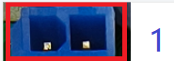 | 2:1 | 2:霍尔输入信号  hall input Signal  1:5V
2 | 拨线端口  Upper and lower scissors | 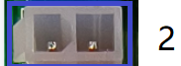 | 2:1 | 2:吹气输出  blow output（800-2）  1:34V
3 | 锁缝端口 | 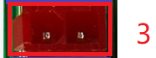 | 2:1 | 2:霍尔输入信号  hall input Signal  1:5V
4 | 吹气端口 | 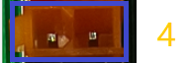 | 2:1 | 2:霍尔输入信号  hall input Signal  1:5V
5 | 密缝端口 | 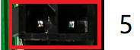 | 2:1 | 2:霍尔输入信号  hall input Signal  1:5V
6 | 预留 | 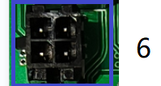
7 | 安全开关  Presser foot output port | 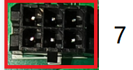 | 3:2:1 | 3:GND  2:霍尔输入信号  hall input Signal  1:5V
8 | 步进电机端口  Safety switch | 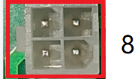 | 2:1 | 2:霍尔输入信号  hall input Signal  1:5V
8 | 步进电机端口  Safety switch | 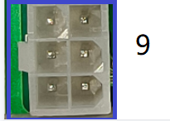 | 3:2:1 | 3:GND  2:霍尔输入信号  hall input Signal  1:5V
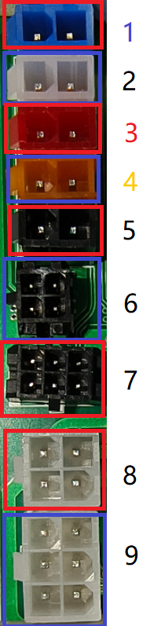

五、错误代码解析：

Error code analysis：
显示的错误码  Display error code | 错误码意思  Error code meaning | 错误的原因  Various possible for the error | 解决错误  Solution
ER-01 | 找不到停针位  No find needle position | 1:手轮和电机靠的不够近  2:手轮上磁钢脱落  3:手轮磁铁极性装反  4:九针端子头接触不良  5:电机霍尔损坏，更换电机  1：Hand wheel and motor  2：Hand wheel magnet off  3：Hand wheel magnet polarity reversal  4：Nine-pin terminal head Poor contact  5：Motor hall damaged, with the change motor | 1:检查电机信号线有无松动  2:更换手轮  3:更换电机  1:check whether the motor signal line is loose  2:replace the wheel  3:replace the motor
ER-02 | 脚踏板信号错误  Pedals velometer signal wrong | 1:开机时没插调速器  2:调速器插反  3:调速器线断开  4:调速器损坏  1：Not plugged velometer into box  2: velometerInserted upside  3: velometer line broken  4: velometer damage | 1:检查调速器信号线  2:更换调速器  3:更换控制器  1:check the foot controller signal line  2:change the foot controller  3: replace the foot controller
ER-03 | 电机相位信号错误  Motor phase error signal | 1:九针插头接触不良  2:电机安装时霍尔和转子存在大偏差  3:电机霍尔损坏  1:Nine-pin terminal head Poor contact  2:Hall and rotor has large deviations when the motor is mounted  3:Motor hall damage | 1：打开电机上的橡皮盖通过孔看电机转子与定子是否在同一平面保障误差不超过1mm  2:更换电机  3:更换控制器  1:open the rubber cover on the motor through the hole to see whether the motor rotor and stator in the same surface to ensure the error is not more than 1mm  2:replace the motor  3:replace the controll box
ER-04 | 电机堵转保护  Motor stall protection | 1:缝纫机过重或堵死  2:电机过载  3:电机4线驱动线没连接好或插反  1:Sewing overweight or blocked  2:Motor overload  3:4-wire motor drive cable is not connected or inserted upside | 1:检查电机4P线  2:检查缝纫机是否过重  3:更换控制器  1:check motor 4P line  2:check whether the sewing machine is too heavy  3:replace the controller
ER-05 | 硬件过流保护  Hardware over current | 1:缝纫机过重或堵死  2:电机过载  3:电机相位信号线没连接好  4:功率管损坏  1:Sewing overweight or blocked  2:Motor overload  3:Motor phase signal line is not connected  4:Power tube damage
ER-06 | 串口通讯超时  Serial communication timeout | 1:显示屏连接主板线连接不良  2:主板芯片损坏  1:Display bad cable connection Motherboard  2:Motherboard chip damage | 1:检查显示屏与控制器连接线  2:检查控制器是否还可运行，如不能运行就是控制器损坏  3:检查机器旁是否有高频机器干扰  4:更换显示屏  1:Check the connection line between the display screen and the control box.  2:check whether the controller run well, if not, controller damage  3:check whether there is a high frequency machine near the machine interference  4:change the display panel
ER-07 | 存储器不良  Poor memory | 1:主板存储器损坏或不良  1: Motherboard memory corruption or bad | 1:控制器损坏  1:control box damage
ER-9 | 过压  Over load | 电机驱动电源电压过高，220V电源电压超过限定值（AC310V），或负载惯性过大导至再生电压超过限定值(DC440V),或电压检测回路故障。  注：（110V 控制系统电源电压超过限定值（AC155V），或负载惯性过大导至再生电压超过限定值(DC220V)。  1. The motor drive power supply voltage is too high, the 220V power supply voltage exceeds the limit value(AC310V), or the load inertia is too large to the regenerative voltage exceeds the limit value(DC440V), or the voltage detection circuit fails.  Note:(110V control system power supply voltage exceeds limit value(AC155V), or load inertia is too large to regeneration voltage exceeds limit value(DC220V).
ER-10 | 欠压故障  Less volt error | 1.电机驱动电源电压过低，220V电源电压低于限定值（AC91V），或电机驱动电源电压低于限定值（DC130V）,或电压检测回路故障。  注：（110V电源电压低于限定值（AC45.5V），  或电机驱动电源电压低于限定值（DC65V））  1.The motor drive power supply voltage is too low, the 220V power supply voltage is lower than the limit value(AC91V), or the motor drive power supply voltage is lower than the limit value(DC130V), or the voltage detection circuit fails.  Note:(110 V power supply voltage is below the limit(AC45.5 V), or motor drive power supply voltage is below the limit(DC 65V))
ER-12 | 剪刀没有复位报警  Scissors not reset the alarm | 1:复位检测器坏了  2:剪刀卡住没复位  1: Reset the detector is broken  2: Scissors stuck not reset | 1:检查霍尔是否损坏  2：检查感应磁铁是否没有感应到  3:检查感应磁铁磁极是否装反  4:改换电控  1:check whether the hall is damage or not;  2：check the induction magnet to see if there is no induction  3：check if the magnetic pole of the induction magnet is installed in reverse or not  4.change control box
Er17 | A相电流检测故障  A current checking error |  | 请联系售后服务人员  Please contact the service person
Er18 | B相电流检测故障  B current checking error |  | 请联系售后服务人员  Please contact the service person
Er19 | AB相电流检测故障  AB current checking error |  | 请联系售后服务人员  Please contact the service person
Er20 | 欠压故障  Less volt error | 电压低于限制范围  The voltage is below the limit | 请检查输入电源电压是否在额定范围内（AC 180V），若上述无法解决，请联系请联系技术人员  Please check whether the input power voltage is within the rated range (AC 180V), if the above cannot be solved, please contact the service person
Er22 | 控速器故障  Pedal control error | 1.前踩控速器开机  2.控速器数值不对  1.Forward step the pedal to start  2. Controller value incorrect | 1.重新前踏控速器解除  2.按P键＋剪刀剪进入维护参数，再按OK键查看（200±15%），数值大于则更换控速器  1. Re-step the speed controller to release  2. Press the. P. key+ trimmer to enter maintainence mode, and press the OK key to review(200+_ 15%). If the value is higher, pls change the controller
ER-35 | 步进电机硬件过流保护  Stepper motor hardware overcurrent protection | 1：检查步进电机信号线是否松动；  2：检查步进电机电源线是否松动  1：Check if the signal wire of the stepper motor is loose.  2：Check if the power wire of the stepper motor is loose. | 若不能解决，请联系售后服务人员  If the above cannot be solved, please contact the service person
ER-37 | 步进电机相A电流检测故障  Stepping motor phase A current detection failure | 主板芯片损坏  The motherboard chip is damaged | 请联系售后服务人员  Please contact the service person
ER-38 | 步进电机相B电流检测故障  Stepper motor phase B current detection failure | 主板芯片损坏  The motherboard chip is damaged | 请联系售后服务人员  Please contact the service person
ER-39 | 步进电机相AB电流检测故障Stepping motor phase AB current detection failure | 主板芯片损坏  Check if the signal wire of the stepper motor is loose. | 请联系售后服务人员  Please contact the service person
ER-45 | 步进电机编码器故障  Stepper motor encoder failure | 检查步进电机信号线是否松动  Check if the signal wire of the stepper motor is loose. | 若不能解决，请联系售后服务人员  If the above cannot be solved, please contact the service person
ER-46 | 步进电机故障 | 检查步进电机信号线是否松动  Check if the signal wire of the stepper motor is loose. | 若不能解决，请联系售后服务人员  If the above cannot be solved, please contact the service person

电控相关的要求及操作使用注意事项
Electrical control related requirements and operating precautions

主要技术数据

Main technical data

供电电压范围：AC220V±15%

Range of voltage：AC220V±15%
供电电源频率：50Hz/60Hz
Power frequency：50Hz/60Hz

1、 安全注意事项Safety notice

1.1 使用范围 Range of use
本伺服控制器是为工业缝纫机开发设计的，如果在其它方面使用，请注意使用者的安全。
The server-motor is designed for industry sewing machine, when using for other applications, please make sure that the users are safe.

1.2 工作环境 Working conditions
1.2.1 电源电压请遵照电控电压±15%范围内。
1.2.1 Any fluctuations in the power voltage should be within the range of ±15% according to the control box marked.
1.2.2 请远离高频电磁波发射器等，以免所产生的电磁波干扰本控制器而发生错误动作。
1.2.2 In order to avoid error caused by disturbing control box, please keep away from high frequency electromagnetic emitter.
1.2.3 温湿度 : Humidity：
a.请在室温 5°C 以上、 45°C 以下的场所操作。
a. The ambient temperature should be within the range of 5℃ to 45℃ during using.
b.禁止在日光直接照射的场所或室外运作。
b. Avoid exposure to direct sun or outdoors during using.
c.请不要过于接近暖气 (电热器) 旁运作。
c. Keep away from the heating (heater) during using.
d.请保持 30 % ~ 95 % 相对湿度（无凝露）。
d. The relative humidity should be within the range of 30% to 95%.
1.2.4 请不要在可燃气体或爆炸物附近操作。
1.2.4 Keep away from flammable gases or explosive during using.

1.3 安装 Installation
1.3.1 控制器请遵照说明书进行正确安装。
1.3.1 Please install the controller correctly according to the introduction.
1.3.2 安装前请先关闭电源并拔掉电源线插头，然后进行安装。
1.3.2 Please turn off and disconnect the power cord before installation.
1.3.3 装钉电源线时请避免靠近会转动部件，最少要离开3公分以上。

1.3.3 Please keep away from rotating parts when installing the power cord, the distance should be at least 3cm.
1.3.4 为防止噪声干扰或触电事故，请将缝纫机、控制箱接地。

1.3.4 In order to prevent noise interference or electric accident, make sure that the sewing machine and the control box are connected to ground.
1.3.5 打开电源之前，确定此供应电压必须符合电控指定电压±15%范围内。
1.3.5 Make sure that the fluctuation in the power voltage should be within the range of ±15% according to the control box marked before turning on.

1.4 保养维修的规定 Maintenance and inspection
1.4.1 在操作保养或维修动作前，请先关闭电源。
1.4.1 Please turn off before maintenance or inspection.
1.4.2 当翻抬机头，更换机针或穿线时，请确认电源已关闭。
1.4.2 Make sure that the power switch is turned off when turning the machine head, replacing needle or rotary hook.
1.4.3 控制箱里面有危险高压电，所以关闭电源后要等 5 分钟以上方可打开控制箱。
1.4.3 It is very dangerous because of high voltage inside the control box, if you want to uncover the control box, more than 5 minutes is needed to wait after power off.
1.4.4 修理及保养的作业，要请经过训练的技术人员执行。
1.4.4 Maintenance and inspection of the sewing machine should only be carried out by a qualified technician.
1.4.5 不能在电机及控制箱运转的狀态下进行保养或维修。
1.4.5 Forbidden to do maintenance and inspection when the motor is running.
1.4.6 所有维修用的零件，须由本公司提供或认可，方可使用。
1.4.6 All components for repair should be provided or approved before using.

1.5 危险提示Dangerous tips

这个标示符号表示机器在安装时，安全上需要特别加以注意的事项，忽视此标记而进行错误操作可能会导致人员或是机器损伤。This symbol indicates something you should be careful of when installing, failing to follow the instruction could cause injury when using the machine physical damage to equipment and surroundings.

1.6 其它安全规定 Other safety requirements
1.6.1、在第一次接通电源后，请先以低速操作缝纫机并检查转动方向是否正确。
1.6.1 Please operate the sewing machine at low-speed and check whether the direction of rotation is correct for the first time to power on.
1.6.2、缝纫机运转时，请不要去触摸手轮、机针等会动作的部位。
1.6.2 Please don’t touch the up wheel ,needle and other action parts when the sewing machine is running .
1.6.3、所有可动作的部份，必须以所提供的防护装置加以隔离，防止身体接触，请勿在装置内塞入其它物品。

1.6.3 To prevent physical contact, all action parts must be isolated by protective devices, and please don’t put anything into the devices.
1.6.4、请不要在拆下电机护罩及其它安全装置的情形下操作。

1.6.4 Forbidden to operate at the circumstance of motor hood and other safety devices removed.
1.6.5、不要使电机或控制箱掉在地上。
1.6.5 Don’t let motor or control box fall to ground.
1.6.6、不要让茶水等液态物体流入控制箱或电机内部。
1.6.6 Don’t let liquid ,such as tea, flow into the control box or motor.

2. 安装与调整 Installation and adjustment

2.1 控速器的安装Installation of the control box
1).将脚踏控速器安装于台板下方 2). 将踏板与控速器安装连结 3).安装后示意图
1） Install the control box and the foot-controllor beneath the table.
2） Please connect the pedal with the control device
3 ）.Installation diagram
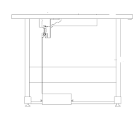
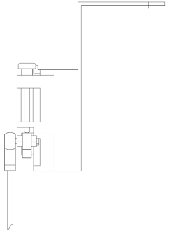

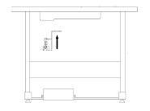

2.3 脚踏板后踏力量的调整 Adjustment of the reverse pressure for foot presser

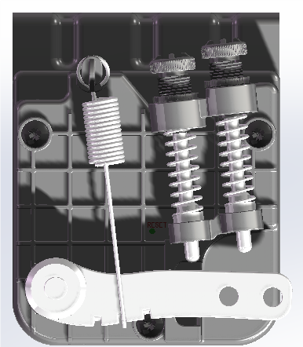

调整需求  Adjustment requirements | 调 整 结 果  Adjustment result
踏板后踏力量的调整  Adjustment of the reverse  pressure for foot presser | 当螺栓愈向下时，则后踏力量愈重。当螺栓愈向上时，则后踏力量愈轻。  Rotate the bolt at down, the reverse pressure will be heavy.  Rotate the bolt at up, the reverse pressure will be light.

3. 接线与接地Connection and grounding

3.1 电源线的接法

3.1 Connection of power supply

本控制器适用于AC220V单相电源，电压输入范围为电控电压±15%。
The controller is suitable for power supply of AC220V (one phase), the fluctuation of input voltage is within ±15% as the plate marked.

注意：

黄/绿色电源线为接地线，为了人员安全及设备可靠工作，一定要做好系统的接地工程。
Notice:
The yellow /green power line are connected to ground, the connection to ground must be well done for insurance of safety and devices
reliable to work.

