目录
- 机壳部分 ………………………………………………………………………P3-P4
- 密封部分(1) ………………………………………………………………… P5-P7
- 密封部分(2) ………………………………………………………………… P8-P9
- 主轴传动部分 ………………………………………………………………P10-P11
- 针杆传动部分 ………………………………………………………………P12-P14
- 针板部分 ……………………………………………………………………P15-P16
- 上弯针传动部分 ……………………………………………………………P17-P19
- 下弯针传动部分 ……………………………………………………………P20-P21
- 针距调节部分 ………………………………………………………………P22-P23
- 送布传动部分 ……………………………………………………………P24-P27
- 切布部分……………………………………………………………………P28-P29
- 前弯针传动部分……………………………………………………………P30-P31
- 压布传动部分………………………………………………………………P32-P34
- 润滑部分……………………………………………………………………P35-P36
- 油盘部分……………………………………………………………………P37-P38
- 夹线器部分…………………………………………………………………P37-P38
- 过线件部分（1） …………………………………………………………P39-P40
- 过线件部分（2） …………………………………………………………P41-P42
- 过线件部分（3） …………………………………………………………P45-P46
- 硅油装置部分 ……………………………………………………………P47-P48
- 压脚部分……………………………………………………………………P49-P51
- 附件部分(1) ………………………………………………………………P52-P53
- 附件部分（2） ……………………………………………………………P54-P55
24.自动感应器部分(1) ………………………………………………………P56-P58
25.漏斗部分……………………………………………………………………P62-P63

26.HX8V-14-00KSC系列专用件（松线装置） ……………………….……P64-P65
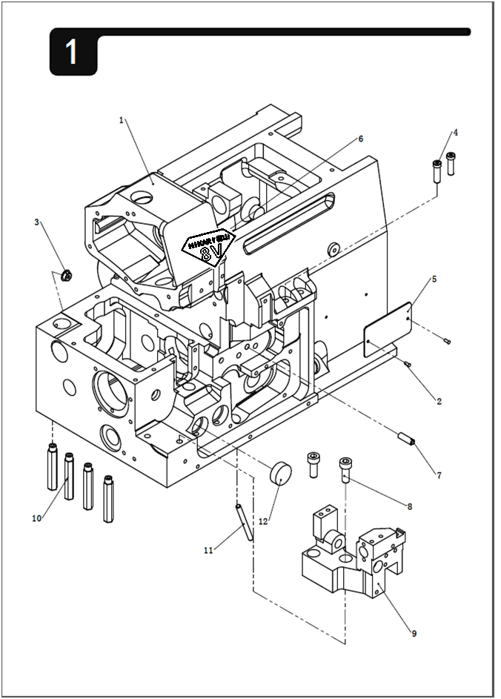

1.机壳部分
序号 | 图号 | 名称 |  | 3 线 | 4 线 | 4  宽 | 5 线 | 5 宽 | 5 厚 | 6  线 | 备注
 |  | 中文 | 英文
1 | 296.01-01A | 机壳 | Machine Head | 1 | 1 | 1 | 1 | 1 | 1 | 1
2 | 17-3200500-5 | 机身编码固定铆钉 | Setscrew | 2 | 2 | 2 | 2 | 2 | 2 | 2
3 | 22-15504017 | 橡胶塞 | Rubber Cushion | 1 | 1 | 1 | 1 | 1 | 1 | 1
4 | 201.01-06G | 过线管 | Thread Guide Pipe | 2 | 2 | 2 | 2 | 2 | 2 | 2
5 | H0-006 | 综合型号牌 | Comprehensive Model Plate | 1 | 1 | 1 | 1 | 1 | 1 | 1
6 | 296.34-43 | 钻石形面板贴 | Smiling face paste | 1 | 1 | 1 | 1 | 1 | 1 | 1
7 | 15-1501005-1 | 限位销 | Limited Pin | 1 | 1 | 1 | 1 | 1 | 1 | 1
8 | 01-506002524-1 | 针板固定螺钉 | Needle Board Setscrew | 2 | 2 | 2 | 2 | 2 | 2 | 2
9 | 246.01-10 | 针板支座 | Needle Board Supporting | 1 | 1 | 1 | 1 | 1 | 1 | 1
10 | 201.01-12 | 支柱 | Support Pillar | 4 | 4 | 4 | 4 | 4 | 4 | 4
11 | 15-2404503-1 | 油管（弹性圆柱销) | Oil Pipe (elastic cylinder pin) | 1 | 1 | 1 | 1 | 1 | 1 | 1
12 | 22-19005500 | 橡胶帽 | Rubber Cushion | 1 | 1 | 1

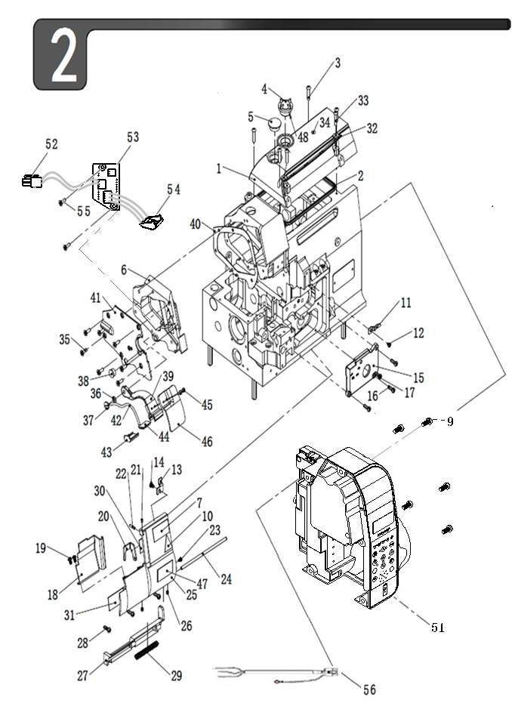
2.密封部分(1)
序号 | 图号 | 名称 |  | 3 线 | 4 线 | 4  宽 | 5 线 | 5 宽 | 5 厚 | 6  线 | 备注
 |  | 中文 | 英文
1 | 296.34-02 | 上盖 | Upper Cover | 1 | 1 | 1 | 1 | 1 | 1 | 1
2 | 296.34-03 | 密封条 | Oil Reservior Gasket | 1 | 1 | 1 | 1 | 1 | 1 | 1
3 | 01-404001623-1 | 上盖螺钉 | Screw | 6 | 6 | 6 | 6 | 6 | 6 | 6
4 | 101.09-01 | 油窗 | Oil Sight Window | 1 | 1 | 1 | 1 | 1 | 1 | 1
5 | 22-19807024 | 橡胶塞 | Oil Plug | 1 | 1 | 1 | 1 | 1 | 1 | 1
6 | 296.02-06 | 机头左盖 | Left Cover | 1 | 1 | 1 | 1 | 1 | 1 | 1
7 | 296.01-05 | 安全标识 | Safety-indicating Plate | 1 | 1 | 1 | 1 | 1 | 1 | 1
9 | 01-505001224-1 | 电机罩螺钉 | Screw | 5 | 5 | 5 | 5 | 5 | 5 | 5
10 | 201.02-10 | 安全标识 | Safety-indicating Plate | 2 | 2 | 2 | 2 | 2 | 2 | 2
11 | 201.02-13 | 前板锁紧舌 | Cloth Waste Cover Stopper | 1 | 1 | 1 | 1 | 1 | 1 | 1
12 | 01-404000523-1 | 前盖板锁紧舌螺钉 | Screw | 1 | 1 | 1 | 1 | 1 | 1 | 1
13 | 201.02-15 | 前盖板锁紧板 | Cloth Waste Locket | 1 | 1 | 1 | 1 | 1 | 1 | 1
14 | 01-404000523-1 | 前盖板锁紧板螺钉 | Screw | 1 | 1 | 1 | 1 | 1 | 1 | 1
15 | 201.02-17 | 前盖板 | Cloth Waste Cover | 1 | 1 | 1 | 1 | 1 | 1 | 1
16 | 01-404001223-1 | 前盖板螺钉A | Screw | 3 | 3 | 3 | 3 | 3 | 3 | 3
17 | 01-604001421-1 | 前盖板螺钉B | Screw | 1 | 1 | 1 | 1 | 1 | 1 | 1
18 | 201.02-20 | 前盖板罩板 | Cover | 1 | 1
 | 293.02-20 | 前盖板罩板 | Cover |  |  | 1
 | 203.02-20 | 前盖板罩板 | Cover |  |  |  | 1 | 1 | 1 | 1
19 | 01-404000623-1 | 前盖板罩板螺钉 | Screw | 2 | 2 | 2 | 2 | 2 | 2 | 2
20 | 201.02-22 | 前盖板防转压板 | Anti-rotating Clamp | 1 | 1 | 1 | 1 | 1 | 1 | 1
21 | 01-803000414-1 | 螺钉 | Screw | 1 | 1 | 1 | 1 | 1 | 1 | 1
22 | 01-803001214-1 | 螺钉 | Screw | 1 | 1 | 1 | 1 | 1 | 1 | 1
23 | 01-503000521-1A | 前盖板防转压板螺钉 | Screw | 1 | 1 | 1 | 1 | 1 | 1 | 1
24 | 201.02-27 | 铰链销 | Looper Cover Hinge Shaft | 1 | 1 | 1 | 1 | 1 | 1 | 1
25 | 201.02-28G1 | 前罩壳 | Cover | 1 | 1 | 1 | 1 | 1 | 1 | 1
26 | 01-804000414-1 | 铰链销紧定螺钉 | Screw | 2 | 2 | 2 | 2 | 2 | 2 | 2
27 | 201.02-30A | 前罩壳下铰链 | Hinge | 1 | 1 | 1 | 1 | 1 | 1 | 1
28 | 01-404001223-1 | 下铰链螺钉 | Screw | 3 | 3 | 3 | 3 | 3 | 3 | 3
29 | 201.02-32 | 铰链销弹簧 | Hinge Shaft Spring | 1 | 1 | 1 | 1 | 1 | 1 | 1
30 | 201.02-33C | 穿线标识A | Threading Sign | 1
 | 202.02-33D | 穿线标识A | Threading Sign |  | 1 | 1
 | 203.02-33C | 穿线标识A | Threading Sign |  |  |  | 1 | 1
 | 204.02-33C | 穿线标识A | Threading Sign |  |  |  |  |  | 1
 | 206.02-33C | 穿线标识A | Threading Sign |  |  |  |  |  |  | 1
31 | 203.02-34 | 穿线标识B | Threading Sign |  |  |  | 1 | 1 | 1 | 1
32 | 201.02-35G | 过线板A | Thread Guide Plate | 1 | 1 | 1 | 1 | 1 | 1 | 1

2.密封部分(1)
序号 | 图号 | 名称 |  | 3 线 | 4 线 | 4  宽 | 5 线 | 5 宽 | 5 厚 | 6  线 | 备注
 |  | 中文 | 英文
33 | 01-404000623-1 | 过线板螺钉 | Screw | 2 | 2 | 2 | 2 | 2 | 2 | 2
34 | 201.02-37 | 油量标识 | Oil Sign | 1 | 1 | 1 | 1 | 1 | 1 | 1
35 | 296.29-46 | 左盖螺钉 | Screw | 7 | 7 | 7 | 7 | 7 | 7 | 7
36 | 08-0900313-1 | 波形垫圈 | Elastic Cushion | 1 | 1 | 1 | 1 | 1 | 1 | 1
37 | 210.27-18A | 切刀连杆销螺钉 | Screw | 1 | 1 | 1 | 1 | 1 | 1 | 1
38 | 22-10705012 | 橡胶塞 | RUbber Stopper | 1 | 1 | 1 | 1 | 1 | 1 | 1
39 | 296.26-01 | 照明灯外罩上 | Led-light base | 1 | 1 | 1 | 1 | 1 | 1 | 1
40 | 296.02-40 | 机头左盖垫 | Sealing gasket | 1 | 1 | 1 | 1 | 1 | 1 | 1
41 | 296.02-41A | 机头左外盖 | left outside cover | 1 | 1 | 1 | 1 | 1 | 1 | 1
42 | X-05-32/01 | 照明灯电源线 | Light Connecting line | 1 | 1 | 1 | 1 | 1 | 1 | 1
43 | 260.26-01-01 | 照明灯外罩盖下 | Lamp Housing Cover | 1 | 1 | 1 | 1 | 1 | 1 | 1
44 | 30050575 | LED照明灯 | LED Lighting | 1 | 1 | 1 | 1 | 1 | 1 | 1
45 | 01-50300821-1 | 圆柱头一字螺钉 | Screw | 2 | 2 | 2 | 2 | 2 | 2 | 2
46 | 260.26-03A | 护目镜 | Light Goggles | 1 | 1 | 1 | 1 | 1 | 1 | 1
47 | 210.27-70 | 防伪专利标贴 | Anti-counterfeiting | 1 | 1 | 1 | 1 | 1 | 1 | 1
48 | 12-190265 | 0型圈 | O-ring | 1 | 1 | 1 | 1 | 1 | 1 | 1
51 | CB-40N-A00A | 一体机AT-3电控 | Electronic Control Panel | 1 | 1 | 1 | 1 | 1 | 1 | 1
52 | X-05-41D | 机头转接线 | Nose Connection | 1 | 1 | 1 | 1 | 1 | 1 | 1
 | X-05-41E | 机头转接线 | Nose Connection | 1 | 1 | 1 | 1 | 1 | 1 | 1
53 | P-056-h16V06 | 发射感应器PCB板 | Sensor PCB Panel | 1 | 1 | 1 | 1 | 1 | 1 | 1
54 | 30050581 | 三光眼发射组件 | Launch tube | 1 | 1 | 1 | 1 | 1 | 1 | 1
55 | 18-403000823-3 | 三件套组合螺钉 | Screw | 2 | 2 | 2 | 2 | 2 | 2 | 2
56 | 30050266 | 电控电源输入线 | Electrical Power Supply Input Line | 1 | 1 | 1 | 1 | 1 | 1 | 1
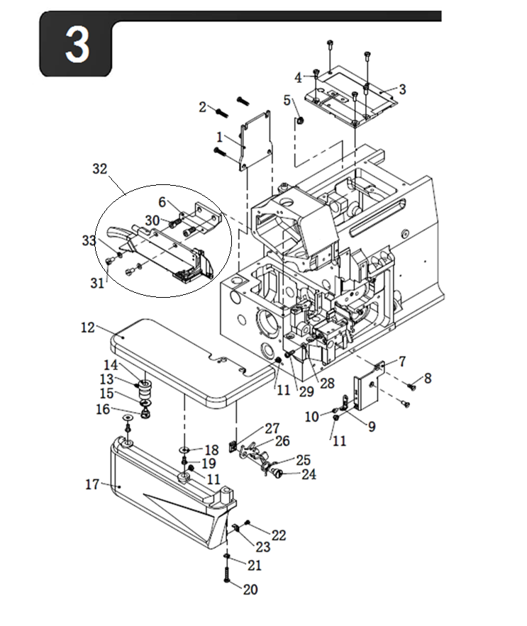
3.密封部分(2)
序号 | 图号 | 名称 |  | 3 线 | 4 线 | 4宽 | 5 线 | 5 宽 | 5 厚 | 6  线 | 备注
 |  | 中文 | 英文
1 | 201.03-01 | 后盖板组件 | Rear Cover ASM | 1 | 1 | 1 | 1 | 1 | 1 | 1
2 | 01-404001623-1 | 后盖板螺钉 | Screw | 4 | 4 | 4 | 4 | 4 | 4 | 4
3 | 260.03-03 | 左上盖 | Cover | 1 | 1 | 1 | 1 | 1 | 1 | 1
4 | 01-704000821-1 | 左上盖固定螺钉 | Screw | 5 | 5 | 5 | 5 | 5 | 5 | 5
5 | 22-08003010 | 橡胶塞 | RUbber Stopper | 1 | 1 | 1 | 1 | 1 | 1 | 1
6 | 296.33-12-04 | 刀组连接块 | Knife set connecting block | 1 | 1 | 1 | 1 | 1 | 1 | 1
7 | 201.03-12 | 防护板 | protective board | 1 | 1 | 1 | 1 | 1 | 1 | 1
8 | 01-104000721-1 | 防护板固定螺钉 | Setscrew | 2 | 2 | 2 | 2 | 2 | 2 | 2
9 | 201.03-14 | 压板 | Pressure Board | 1 | 1 | 1 | 1 | 1 | 1 | 1
10 | 01-535000421-1 | 防护板压板固定螺钉 | Screw | 1 | 1 | 1 | 1 | 1 | 1 | 1
11 | 201.03-16 | 防震塞 | Rubber Cushion | 3 | 3 | 3 | 3 | 3 | 3 | 3
12 | 295.03-22A | 缝台组件 | Cloth Base ASM | 1 | 1 | 1 | 1 | 1 | 1 | 1
13 | 01-804000414-1 | 缝台转动轴固定螺钉 | Screw | 1 | 1 | 1 | 1 | 1 | 1 | 1
14 | 201.03-24 | 缝台转动轴套 | Eccentric Bushing | 1 | 1 | 1 | 1 | 1 | 1 | 1
15 | 08-0700311-1 | 波形弹性垫圈 | Cushion | 1 | 1 | 1 | 1 | 1 | 1 | 1
16 | 201.03-29 | 台螺钉 | Screw | 1 | 1 | 1 | 1 | 1 | 1 | 1
17 | 201.03-30G1 | 缝台下罩壳组件 | Cloth Base Lower Cover ASM | 1 | 1 | 1 | 1 | 1 | 1 | 1
18 | 05-043201350-1 | 下罩壳垫圈 | Lower Cover Gasket | 2 | 2 | 2 | 2 | 2 | 2 | 2
19 | 01-404000823-1 | 下罩壳固定螺钉A | Lower Cover Setscrew | 2 | 2 | 2 | 2 | 2 | 2 | 2
20 | 01-404002023-1 | 下罩壳固定螺钉B | Setscrew | 1 | 1 | 1 | 1 | 1 | 1 | 1
21 | 07-0421111-1 | 弹簧垫圈 | Cushion | 1 | 1 | 1 | 1 | 1 | 1 | 1
22 | 01-503000421-1 | 下罩壳压板螺钉 | Pressure Board Screw | 1 | 1 | 1 | 1 | 1 | 1 | 1
23 | 201.03-34 | 下罩壳压板 | Lower Sover Pressure Board | 1 | 1 | 1 | 1 | 1 | 1 | 1
24 | 201.03-29 | 缝台闸固定螺钉 | Screw | 1 | 1 | 1 | 1 | 1 | 1 | 1
25 | 201.03-28 | 缝台闸弹簧 | Cloth Base Switch-type Spring | 1 | 1 | 1 | 1 | 1 | 1 | 1
26 | 201.03-27 | 缝台闸 | Cloth Base Switch-type Stopper | 1 | 1 | 1 | 1 | 1 | 1 | 1
27 | 201.03-26 | 缝台闸固定板 | Fix Board | 1 | 1 | 1 | 1 | 1 | 1 | 1
28 | 03-604000320-1 | 调节螺母 | Adjusting Nut | 1 | 1 | 1 | 1 | 1 | 1 | 1
29 | 01-404001223-1 | 调节螺钉 | Adjusting Screw | 1 | 1 | 1 | 1 | 1 | 1 | 1
30 | 01-506001224-1 | 螺钉 | Screw | 2 | 2 | 2 | 2 | 2 | 2 | 2
31 | 01-645000821-1 | 导布板紧固螺钉 | Setscrew | 2 | 2 | 2 | 2 | 2 | 2 | 2
32 | 296.33-12 | 直刀组件 | Cloth Guide Board ASM | 1 | 1 | 1 | 1 | 1 | 1 | 1
33 | 05-053101000-1 | 垫片 | Cushion | 2 | 2 | 2 | 2 | 2 | 2 | 2

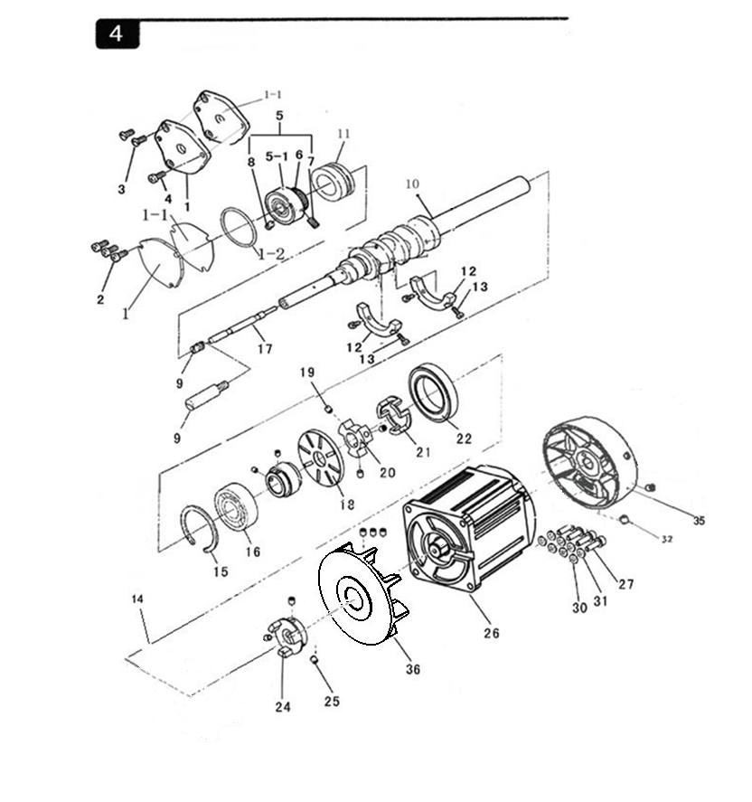

4.主轴传动部分
序  号 | 图号 | 名称 |  | 3  线 | 4  线 | 4  宽 | 5  线 | 5  宽 | 5  厚 | 6  线 | 备  注
 |  | 中文 | 英文
1 | 201.04-01G | 主轴前轴承盖 | Bearing Base ASM | 1 | 1 | 1
 | 203.04-01G | 轴承座组件 | Bearing Base ASM |  |  |  | 1 | 1 | 1 | 1
1-1 | 201.04-01G-01 | 轴承盖密封垫 | Bearing oil seal gasket | 1 | 1 | 1
 | 203.04-01G-01 | 轴承盖密封垫 | Bearing oil seal gasket |  |  |  | 1 | 1 | 1 | 1
1-2 | 12-387265 | O型圈 | O-ring | 1 | 1 | 1 | 1 | 1 | 1 | 1
2 | 01-404000823-1 | 轴承座固定螺钉A | Setscrew A | 3 | 3 | 3
3 | 01-104001021-1 | 轴承座固定螺钉B | Setscrew B |  |  |  | 2 | 2 | 2 | 2
4 | 01-404000623-1 | 轴承座固定螺钉A | Setscrew A |  |  |  | 1 | 1 | 1 | 1
5 | 260.04-05 | 轴承组件 | Crankshaft Ball Bearing ASM | 1 | 1 | 1 | 1 | 1 | 1 | 1
5-1 | 14-6203 | 轴承 | Crankshaft Ball Bearing | 1 | 1 | 1 | 1 | 1 | 1 | 1
6 | 201.04-05-2 | 轴承套（外齿） | Shaft Bushing | 1 | 1 | 1 | 1 | 1 | 1 | 1
7 | 01-805001014-1 | 轴承紧套紧定螺钉A | Setscrew A | 1 | 1 | 1 | 1 | 1 | 1 | 1
8 | 01-805000514-1 | 轴承紧套紧定螺钉B | Setscrew B | 1 | 1 | 1 | 1 | 1 | 1 | 1
9 | 201.04-09 | 主轴端螺钉 | Screw | 1 | 1 | 1
 | 203.04-09 | 凸轮轴 | Cam Shaft |  |  |  | 1 | 1 | 1 | 1
10 | 209.04-00 | 主轴组件 | Mainshaft Components | 1
 | 210.04-00 | 主轴组件 | Mainshaft Components |  | 1
 | 243.04-00 | 主轴组件 | Mainshaft Components |  |  | 1
 | 211. 04-00 | 主轴组件 | Mainshaft Components |  |  |  | 1 | 1 |  | 1
 | 212.04-00 | 主轴组件 | Mainshaft Components |  |  |  |  |  | 1
11 | 201.04-14 | 主轴中轴套 | Mainshaft Bushing | 1 | 1 | 1 | 1 | 1 | 1 | 1
12 | 201.04-12 | 主轴平衡块 | Mainshaft Balance Block | 2 | 2 | 2 | 2 | 2 | 2 | 2
13 | 01-503000821-1 | 主轴平衡块固定螺钉 | Setscrew | 4 | 4 | 4 | 4 | 4 | 4 | 4
15 | 210.04-30 | 轴承挡圈 | braking Ring | 1 | 1 | 1 | 1 | 1 | 1 | 1
16 | 201.04-16 | 单列向心球滚珠轴承 | Crankshaft Ball Bearing | 1 | 1 | 1 | 1 | 1 | 1 | 1
17 | 201.04-18 | 油量销 | Oil Adjusting Bar | 1 | 1 | 1 | 1 | 1 | 1 | 1
18 | 13-14150550 | 油封 | Oil Seal | 1 | 1 | 1 | 1 | 1 | 1 | 1
19 | 01-806000814-1 | 连轴器（1)螺钉 | Screw | 3 | 3 | 3 | 3 | 3 | 3 | 3
20 | 102.02-44A | 连轴器⑴ | Linker(1) | 1 | 1 | 1 | 1 | 1 | 1 | 1
21 | 102.02-45A | 连轴器缓冲垫 | Rubber Ring | 1 | 1 | 1 | 1 | 1 | 1 | 1
22 | 14-61907-2Z | 轴承 | Bearing | 1 | 1 | 1 | 1 | 1 | 1 | 1
24 | 102.02-48A | 连轴器(2) | Linker(2) | 1 | 1 | 1 | 1 | 1 | 1 | 1
25 | 01-806000614-1 | 连轴器(2)螺钉 | Screw | 6 | 6 | 6 | 6 | 6 | 6 | 6
26 | M0-40N | 直驱电机 | Motor Asm | 1 | 1 | 1 | 1 | 1 | 1 | 1
27 | 01-505001824-1 | 直驱电机螺钉 | Screw | 4 | 4 | 4 | 4 | 4 | 4 | 4
28 | HXT11-1A | 手轮 | Hand Wheel | 2 | 2 | 2 | 2 | 2 | 2 | 2
29 | 01-806000614-4 | 手轮螺钉 | Screw | 4 | 4 | 4 | 4 | 4 | 4 | 4
30 | 05-053101000-1 | 平垫片 | Washer | 4 | 4 | 4 | 4 | 4 | 4 | 4
31 | 07-0521313-1 | 弹簧垫片 | Spring Washer | 4 | 4 | 4 | 4 | 4 | 4 | 4
32 | 02-815281014-1 | 手轮螺钉 | Screw | 2 | 2 | 2 | 2 | 2 | 2 | 2
33 | 103.13-107 | 磁钢座组件 | Magnet Block | 1 | 1 | 1 | 1 | 1 | 1 | 1
35 | 296.04-27 | 手轮组件3# | Hand Wheel ASM 3# | 1 | 1 | 1 | 1 | 1 | 1 | 1
36 | 296.34-08 | 风扇 | fan | 1 | 1 | 1 | 1 | 1 | 1 | 1
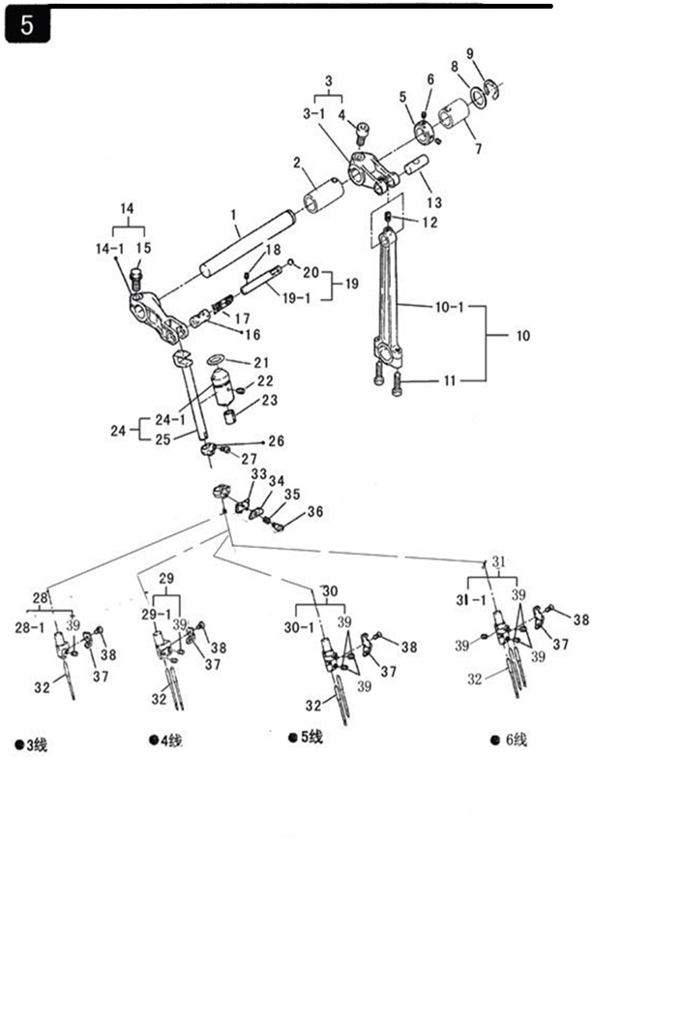
5.针杆传动部分
序  号 | 图号 | 名称 |  | 3 线 | 4 线 | 4  宽 | 5 线 | 5 宽 | 5 厚 | 6  线 | 备注
 |  | 中文 | 英文
1 | 201.05-01 | 针杆传动轴 | Needle Rod Transmit Shaft | 1 | 1 | 1 | 1 | 1 | 1 | 1
2 | 201.05-02 | 机针传动轴前套筒 | Front Bushing | 1 | 1 | 1 | 1 | 1 | 1 | 1
3 | 201.05-03 | 机针传动轴曲柄组件 | Needle Rod Transmit Shaft Crank ASM | 1 | 1 | 1 | 1 | 1 | 1 | 1
3-1 | 201.05-03-01 | 机针传动轴曲柄 | Needle Rod Transmit Shaft Crank | 1 | 1 | 1 | 1 | 1 | 1 | 1
4 | 01-506751224-1 | 机针传动轴曲柄螺钉 | Screw | 1 | 1 | 1 | 1 | 1 | 1 | 1
5 | 201.05-05 | 挡圈 | Thrust Collar | 1 | 1 | 1 | 1 | 1 | 1 | 1
6 | 01-804000414-1 | 挡圈紧定螺钉 | Setscrew | 2 | 2 | 2 | 2 | 2 | 2 | 2
7 | 201.05-07 | 机针传动轴后套筒 | Rear Bushing | 1 | 1 | 1 | 1 | 1 | 1 | 1
8 | 201.05-08 | 铜垫片 | Copper Spacer | 1 | 1 | 1 | 1 | 1 | 1 | 1
9 | 06-0800816-1 | 开口挡圈 | E-spring | 1 | 1 | 1 | 1 | 1 | 1 | 1
10 | 201.05-10 | 针杆连杆组件 | Connecting Rod ASM | 1 | 1 | 1 | 1 | 1 | 1 | 1
10-1 | 201.05-10-01 | 针杆连杆 | Connecting Rod | 1 | 1 | 1 | 1 | 1 | 1 | 1
11 | 01-404001623-1 | 针杆连杆螺钉 | Connecting Rod Screw | 2 | 2 | 2 | 2 | 2 | 2 | 2
12 | 01-804000614-1 | 机针传动连杆紧定螺钉 | Connecting Rod Setscrew | 1 | 1 | 1 | 1 | 1 | 1 | 1
13 | 201.05-13 | 销轴 | Feed Branch Crank Pin | 1 | 1 | 1 | 1 | 1 | 1 | 1
14 | 201.05-14 | 针杆曲柄组件 | Needle Rod Crank ASM | 1 | 1 | 1 | 1 | 1 | 1 | 1
14-1 | 201.05-14-01 | 针杆曲柄 | Needle Rod Crank | 1 | 1 | 1 | 1 | 1 | 1 | 1
15 | 19-706751225-1 | 针杆传动摆杆螺钉 | Screw | 1 | 1 | 1 | 1 | 1 | 1 | 1
16 | 201.05-16G | 针杆连接销 | Needle Driving ASM Pin | 1 | 1 | 1 | 1 | 1 | 1 | 1
17 | 201.05-23 | 毛毡 | Oil Wick | 1 | 1 | 1 | 1 | 1 | 1 | 1
18 | 01-804000414-1 | 紧定螺钉 | Setscrew | 1 | 1 | 1 | 1 | 1 | 1 | 1
19 | 20004670 | 油管组件 | Oil Pipe ASM | 1 | 1 | 1 | 1 | 1 | 1 | 1
19-1 | 201.05-19A | 油管 | Oil Pipe | 1 | 1 | 1 | 1 | 1 | 1 | 1
20 | 30050196 | 油管棉线 | Steel Ball | 1 | 1 | 1 | 1 | 1 | 1 | 1
21 | 12-115160 | O型圈 | O-ring | 1 | 1 | 1 | 1 | 1 | 1 | 1
22 | 01-804000544-1 | 针杆套螺钉 | Needle Rod Collar Screw | 1 | 1 | 1 | 1 | 1 | 1 | 1
23 | 201.05-23 | 毛毡 | Felt | 1 | 1 | 1 | 1 | 1 | 1 | 1
24 | 201.05-24 | 针杆组件 | Needle Rod ASM | 1 | 1 | 1 | 1 | 1 | 1 | 1
24-1 | 201.05-24-01 | 针杆轴套 | Needle Rod Collar | 1 | 1 | 1 | 1 | 1 | 1 | 1
25 | 201.05-24-02 | 针杆 | Needle Rod | 1 | 1 | 1 | 1 | 1 | 1 | 1
26 | 201.05-26 | 拦线板支架 | Needle Thread Presser Guide | 1 | 1 | 1 | 1 | 1 | 1 | 1
27 | 01-903000621-1 | 固定螺钉 | Setscrew | 1 | 1 | 1 | 1 | 1 | 1 | 1
5.针杆传动部分
序  号 | 图号 | 名称 |  | 3 线 | 4 线 | 4  宽 | 5 线 | 5 宽 | 5 厚 | 6  线 | 备注
28 | HXS6-3 | 针夹组件 | Needle Clamp ASM | 1
28-1 | 201.05-28-01 | 针夹 | Needle Clamp | 1
29 | HX6-3 | 针夹组件 | Needle Clamp ASM |  | 1 | 1
29-1 | 202.05-29-01 | 针夹 | Needle Clamp |  | 1 | 1
30 | HXW6-3 | 针夹组件 | Needle Clamp ASM |  |  |  | 1
30-1 | 203.05-30-01 | 针夹 | Needle Clamp |  |  |  | 1
30 | HXH6-3 | 针夹组件 | Needle Clamp ASM |  |  |  |  |  | 1
30-1 | 204.05-30-01 | 针夹 | Needle Clamp |  |  |  |  |  | 1
30 | HXK6-3 | 针夹组件 | Needle Clamp ASM |  |  |  |  | 1
30-1 | 205.05-30-01 | 针夹 | Needle Clamp |  |  |  |  | 1
31 | HXL6-3 | 针夹组件 | Needle Clamp ASM |  |  |  |  |  |  | 1
31-1 | 206.05-30-01 | 针夹 | Needle Clamp |  |  |  |  |  |  | 1
32 | 201.05-32G | 机针（DC×27#11） | Needle | 1 | 2 | 2 |  |  |  | 3
 | 203.05-32 | 机针（DC×27#14） | Needle |  |  |  | 2 | 2
 | 204.05-32 | 机针（DC×27#21） | Needle |  |  |  |  |  | 2
33 | 201.05-33 | 拦线板（A） | Needle Thread Presser Guide (A) | 1 | 1 | 1 | 1 | 1 | 1 | 1
34 | 201.05-34 | 拦线板（B） | Needle Thread Presser Guide (B) | 1 | 1 | 1 | 1 | 1 | 1 | 1
35 | 201.05-35 | 拦线板弹簧 | Needle Thread Presser Spring | 1 | 1 | 1 | 1 | 1 | 1 | 1
36 | 201.05-36 | 拦线板紧固螺钉 | Hinge Screw | 1 | 1 | 1 | 1 | 1 | 1 | 1
37 | 201.05-37 | 机针穿线片 | Needle Thread Guide Base | 1
 | 202.05-37 | 机针穿线片 | Needle Thread Guide Base |  | 1 | 1
 | 203.05-37 | 机针穿线片 | Needle Thread Guide Base |  |  |  | 1 | 1 |  | 1
 | 204.05-37 | 机针穿线片 | Needle Thread Guide Base |  |  |  |  |  | 1
38 | 01-102000521-1 | 机针穿线片紧固螺钉 | Setscrew |  |  |  | 1 | 1 | 1 | 1
 | 01-502000321-1 | 机针穿线片紧固螺钉 | Setscrew | 1 | 1 | 1
39 | 01-803000324-1 | 针夹螺钉 | Needle Clamp Screw | 1 | 2 | 2 | 2 | 2 | 2 | 3

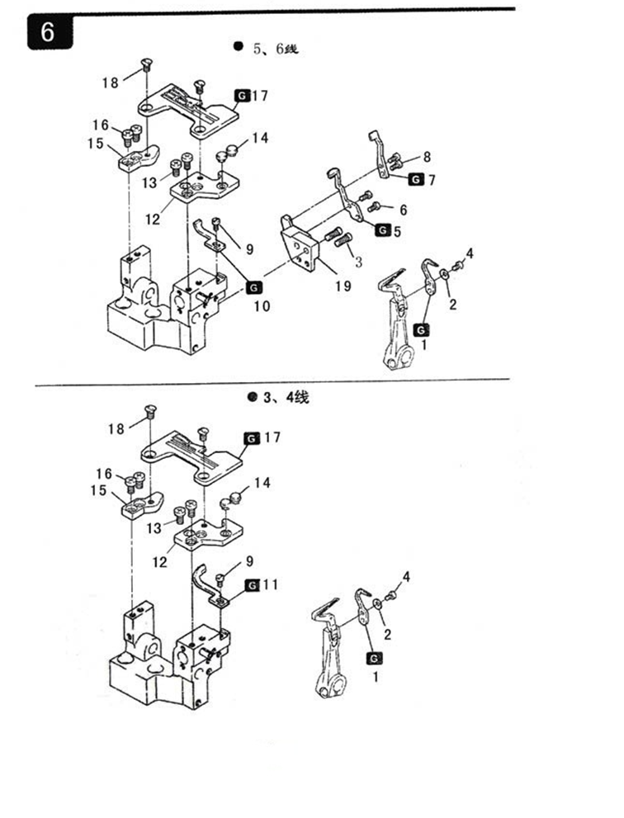
6.针板部分
序号 | 图号 | 名称 |  | 3 线 | 4 线 | 4  宽 | 5 线 | 5 宽 | 5 厚 | 6  线 | 备注
 |  | 中文 | 英文
1 | 201.06-01 | 主直针后护针板 | Lower Looper | 1 | 1 | 1 | 1 | 1 | 1 | 1
2 | 09-0330507-1 | 主直针后护针板碟形垫圈 | Lower Looper Gasket | 1 | 1 | 1 | 1 | 1 | 1 | 1
3 | 01-904001021-1 | 护针板座螺钉 | Screw |  |  |  | 2 | 2 | 2 | 2
4 | 01-703000521-1 | 主直针后护针板螺钉(B) | Lower Looper Screw (B) | 1 | 1 | 1 | 1 | 1 | 1 | 1
5 | 203.06-05 | 链直针后护针板 | Roar Needle Guard |  |  |  | 1 | 1 | 1 | 1
6 | 01-503000621-1 | 链直针后护针板螺钉 | Screw |  |  |  | 2 | 2 | 2 | 2
7 | 203.06-07 | 主直针前护针板 | Front Needle Guard |  |  |  | 1 | 1 | 1 | 1
8 | 01-503000621-1 | 主直针前护针板螺钉 | Screw |  |  |  | 2 | 2 | 2 | 2
9 | 01-504000821-1 | 主直针前护针板螺钉 | Screw | 1 | 1 | 1 | 1 | 1 | 1 | 1
10 | 203.06-10 | 链针前护针板 | Needle Guard |  |  |  | 1 | 1 | 1 | 1
11 | 201.06-11 | 主针前护针板 | Thread Guide Upper | 1 | 1 | 1
12 | 295.06-12 | 针板座 | Needle Plate Base | 1 | 1 | 1 | 1 | 1 | 1 | 1
13 | 01-404000823-1 | 针板座螺钉 | Screw | 2 | 2 | 2 | 2 | 2 | 2 | 2
14 | 201.03-16 | 防震塞 | Rubber Cushion | 2 | 2 | 2 | 2 | 2 | 2 | 2
15 | 201.06-15 | 针板定位块 | Needle Plate Positioning Block | 1 | 1 | 1 | 1 | 1 | 1 | 1
16 | 01-404000823-1 | 针板定位块螺钉 | Screw | 2 | 2 | 2 | 2 | 2 | 2 | 2
17 | 246.06-17 | 针板 | Needle Plate | 1
 | 247.06-17 | 针板 | Needle Plate |  | 1
 | 293.06-17 | 针板 | Needle Plate |  |  | 1
 | 248.06-17 | 针板 | Needle Plate |  |  |  | 1
 | 250.06-17 | 针板 | Needle Plate |  |  |  |  | 1
 | 249.06-17P | 针板 | Needle Plate |  |  |  |  |  | 1
 | 256.06-17 | 针板 | Needle Plate |  |  |  |  |  |  | 1
18 | 01-204000821-2 | 针板螺钉 | Screw | 2 | 2 | 2 | 2 | 2 | 2 | 2
19 | 203.06-19 | 护针板座 | Needle Guard Plate Base |  |  |  | 1 | 1 | 1 | 1

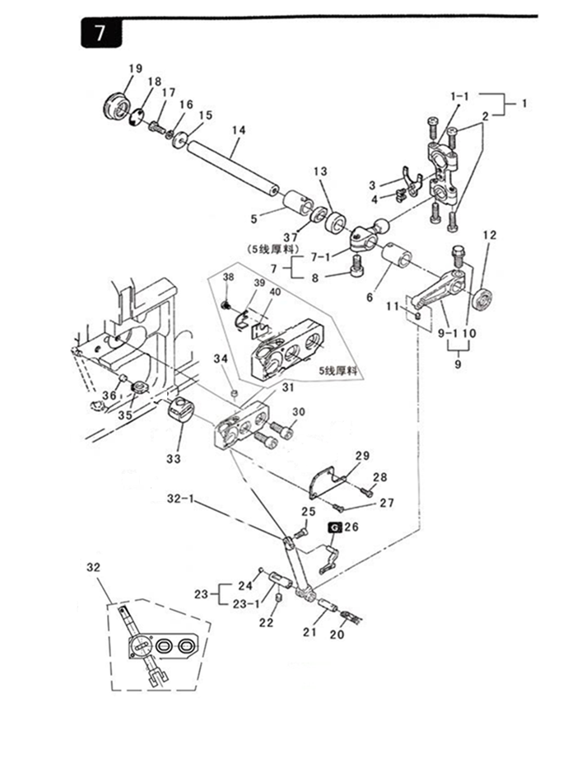
7.上弯针传动部分
序  号 | 图号 |  | 名称 |  | 3  线 | 4  线 | 4  宽 | 5  线 | 5 宽 | 5  厚 | 6  线 | 备注
 |  |  | 中文 | 英文
1 | 201.07-01 |  | 弯针球连杆组件 | Looper Ball Connecting Rod ASM | 1 | 1 | 1 | 1 | 1 | 1 | 1
1-1 | 201.07-01-01 |  | 弯针球连杆 | Looper Ball Connecting Rod | 1 | 1 | 1 | 1 | 1 | 1 | 1
2 | 01-404001623-1 |  | 弯针球连杆螺钉 | Screw | 4 | 4 | 4 | 4 | 4 | 4 | 4
3 | 201.07-03 |  | 防震片 | Rubber Cushion | 1 | 1 | 1 | 1 | 1 | 1 | 1
4 | 01-103000621-1 |  | 螺钉 | Screw | 2 | 2 | 2 | 2 | 2 | 2 | 2
5 | 201.07-05 |  | 上弯针轴后轴套 | Upper Looper Shaft Rear Bushing | 1 | 1 | 1 | 1 | 1 | 1 | 1
6 | 201.07-06A |  | 弯针轴前轴套 | Looper Shaft Front Bushing | 1 | 1 | 1 | 1 | 1 | 1 | 1
7 | 201.07-07 |  | 上弯针球曲柄组件 | Upper Looper Ball Crank ASM | 1
7 | 202.07-07 |  | 上弯针球曲柄组件 | Upper Looper Ball Crank ASM |  | 1 | 1 | 1 | 1 | 1 | 1
7-1 | 201.07-07-01 |  | 上弯针球曲柄 | Upper Looper Ball Crank | 1
7-1 | 202.07-07-01 |  | 上弯针球曲柄 | Upper Looper Ball Crank |  | 1 | 1 | 1 | 1 | 1 | 1
8 | 01-506751224-1 |  | 上弯针球曲柄螺钉 | Upper Looper Ball Crank Screw | 1 | 1 | 1 | 1 | 1 | 1 | 1
9 | 201.07-09 |  | 摇杆曲柄组件 | Upper Looper Arm ASM | 1 | 1 | 1 | 1 | 1 | 1 | 1
9-1 | 201.07-09-01 |  | 摇杆曲柄 | Upper Looper Arm | 1 | 1 | 1 | 1 | 1 | 1 | 1
10 | 19-706751225-1 |  | 螺钉 | Screw | 1 | 1 | 1 | 1 | 1 | 1 | 1
11 | 01-803000444-1 |  | 连杆销固定螺钉 | Setscrew | 1 | 1 | 1 | 1 | 1 | 1 | 1
12 | 13-09340190 |  | 油封 | Oil Seal | 1 | 1 | 1 | 1 | 1 | 1 | 1
13 | HXS3-7 |  | 挡圈 | Stopping Gasket | 1 |  |  | 1 | 1 | 1
 | HX3-7 |  | 挡圈 | Stopping Gasket |  | 1 |  |  |  |  | 1
 | HX3-7A |  | 挡圈 | Stopping Gasket |  |  | 1
14 | 201.07-14 |  | 弯针轴 | Looper Shaft | 1 | 1 | 1 | 1 | 1 | 1 | 1
15 | 05-053201452-5 |  | 弯针轴垫片 | Looper Shaft Washer | 1 | 1 | 1 | 1 | 1 | 1 | 1
16 | 07-0521313-1 |  | 弹簧垫圈 | Spring Washer | 1 | 1 | 1 | 1 | 1 | 1 | 1
17 | 01-705001021-1 |  | 六角头开槽螺钉 | Screw | 1 | 1 | 1 | 1 | 1 | 1 | 1
18 | 201.07-18 |  | 防油片 | Oil Proof Spacer | 1 | 1 | 1 | 1 | 1 | 1 | 1
19 | 201.07-19 |  | 橡胶帽 | Rubber Cap | 1 | 1 | 1 | 1 | 1 | 1 | 1
20 | 201.07-40 |  | 油线 | Oil Thread | 1 | 1 | 1 | 1 | 1 | 1 | 1
21 | 201.07-21 |  | 连杆销轴 | Gauge Fixing Pin | 1 | 1 | 1 | 1 | 1 | 1 | 1
22 | 01-804000414-1 |  | 机壳销紧定螺钉 | Setscrew | 1 | 1 | 1 | 1 | 1 | 1 | 1
23 | 201.07-23 |  | 机壳销组件 | Pin Components | 1 | 1 | 1 | 1 | 1 | 1 | 1
23-1 | 201.07-23-01 |  | 机壳销 | Machine Pin | 1 | 1 | 1 | 1 | 1 | 1 | 1
7.上弯针传动部分
序  号 |  | 图号 | 名称 |  | 3 线 | 4 线 | 4  宽 | 5 线 | 5 宽 | 5 厚 | 6  线 | 备注
 |  |  | 中文 | 英文
24 |  | 201.07-23-02 | 钢球 | Steel Ball | 1 | 1 | 1 | 1 | 1 | 1 | 1
25 |  | 01-935000621-1 | 上弯针紧定螺钉 | Setscrew | 1 | 1 | 1 | 1 | 1 | 1 | 1
26 |  | 201.07-26 | 上弯针 | Upper Looper | 1 |  |  | 1 | 1 | 1
 |  | 202.07-26 | 上弯针 | Upper Looper |  | 1 | 1 |  |  |  | 1
27 |  | 01-125000621-1 | 挡板螺钉A | Screw A | 1 | 1 | 1 | 1 | 1 | 1 | 1
28 |  | 01-525000821-1 | 挡板螺钉B | Screw B | 1 | 1 | 1 | 1 | 1 | 1 | 1
29 |  | 201.07-29 | 摇杆座盖 | Upper Looper Gange Cover | 1 | 1 | 1 | 1 | 1 | 1 | 1
30 |  | 01-506001624-1 | 上弯针滑杆座螺钉 | Screw | 2 | 2 | 2 | 2 | 2 | 2 | 2
31 |  | 201.07-31 | 摇杆座 | Upper Looper Guide Support | 1 | 1 | 1 | 1 | 1 |  | 1
 |  | 293.07-31 | 摇杆座 | Upper Looper Guide Support |  |  | 1
 |  | 204.07-31 | 摇杆座 | Upper Looper Guide Support |  |  |  |  |  | 1
32 |  | 201.07-32A-00 | 摇杆组件 | Upper Looper Holder ASM | 1 | 1 |  | 1 | 1 |  | 1
 |  | 293.07-32-00 | 摇杆组件 | Upper Looper Holder ASM |  |  | 1
 |  | 204.07-32A-00 | 摇杆组件 | Upper Looper Holder ASM |  |  |  |  |  | 1
32-1 |  | 201.07-32-01 | 摇杆 | Upper Looper Holder | 1 | 1 |  | 1 | 1 | 1 | 1
 |  | 201.07-32-01A | 摇杆 | Upper Looper Holder | 1 | 1 | 1 | 1 | 1 | 1 | 1
33 |  | 201.07-32-02 | 摆轴 | Thrust Collar | 1 | 1 |  | 1 | 1 | 1 | 1
 |  | 201.07-32-02A | 摆轴 | Thrust Collar | 1 | 1 | 1 | 1 | 1 | 1 | 1
34 |  | 201.07-32-03 | 烧结铜滤芯 | Oil Plug | 1 | 1 | 1 | 1 | 1 | 1 | 1
35 |  | 179130-050 | 油棉（摇杆） | Felt | 1 | 1 | 1 | 1 | 1 | 1 | 1
36 |  | 201.07-36 | 油塞 | Oil Plug | 1 | 1 | 1 | 1 | 1 | 1 | 1
37 |  | 204.07-37 | 挡圈 | Stopping Gasket |  |  |  |  |  | 1
38 |  | 01-503000421-1 | 螺钉M3X4 | Screw |  |  |  |  |  | 1
39 |  | 201.07-39 | 挡片 | Thrust |  |  |  |  |  | 1
40 |  | 201.07-40 | 毛毡 | Felt |  |  |  |  |  | 1

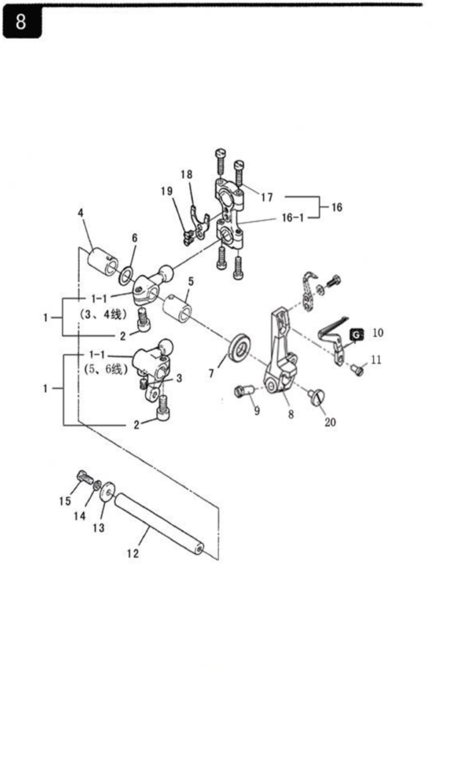
8.下弯针传动部分
序  号 | 图号 | 名称 |  | 3  线 | 4  线 | 4  宽 | 5  线 | 5  宽 | 5  厚 | 6  线 | 备注
 |  | 中文 | 英文
1 | 201.08-01 | 下弯针球曲柄组件 | Lower Looper Ball Crank ASM | 1 | 1 | 1
1-1 | 201.08-01-01 | 下弯针球曲柄 | Lower Looper Ball Crank | 1 | 1 | 1
1 | 203.08-01 | 下弯针球曲柄组件 | Lower Looper Ball Crank ASM |  |  |  | 1 | 1 | 1 | 1
1-1 | 203.08-01-01 | 下弯针球曲柄 | Lower Looper Ball Crank |  |  |  | 1 | 1 | 1 | 1
2 | 01-506751224-1 | 下弯针球曲柄螺钉(A) | Screw (A) | 1 | 1 | 1 | 1 | 1 | 1 | 1
3 | 01-805000514-1 | 下弯针球曲柄螺钉(B) | Screw (B) |  |  |  | 1 | 1 | 1 | 1
4 | 201.07-06 | 弯针球曲柄后铜套 | Rear Copper Collar | 1 | 1 | 1 | 1 | 1 | 1 | 1
5 | 201.07-06 | 弯针球曲柄前铜套 | Front Copper Collar | 1 | 1 | 1 | 1 | 1 | 1 | 1
6 | 201.08-06 | 铜垫片 | Copper Gasket | 1 | 1 | 1
7 | 13-09340190 | 油封 | Oil Seal | 1 | 1 | 1 | 1 | 1 | 1 | 1
8 | 2101.08-01 | 下弯针架 | Lower Looper Bracket | 1 | 1 | 1 | 1 | 1 | 1 | 1
9 | 01-705001325-1 | 下弯针架固定螺钉 | Lower Looper Bracket Setscrew | 1 | 1 | 1 | 1 | 1 | 1 | 1
10 | 201.08-10 | 下弯针 | Lower Looper | 1 |  | 1 | 1 | 1 | 1 | 1
 | 202.08-10 | 下弯针 | Lower Looper |  | 1
11 | 01-535000621-1 | 下弯针固定螺钉 | Lower Looper Setscrew | 1 | 1 | 1 | 1 | 1 | 1 | 1
12 | 201.07-14 | 弯针轴 | Looper Shaft | 1 | 1 | 1 | 1 | 1 | 1 | 1
13 | 05-053201452-5 | 弯针轴垫片 | Looper Shaft Gasket | 1 | 1 | 1 | 1 | 1 | 1 | 1
14 | 07-0521313-1 | 弹簧垫圈 | Spring Washer | 1 | 1 | 1 | 1 | 1 | 1 | 1
15 | 01-705001021-1 | 六角头开槽螺钉 | Screw | 1 | 1 | 1 | 1 | 1 | 1 | 1
16 | 201.07-01 | 弯针球连杆组件 | Lopper Ball Rod Components | 1 | 1 | 1 | 1 | 1 | 1 | 1
16-1 | 201.07-01-01 | 弯针球连杆 | Lopper Ball Rod | 1 | 1 | 1 | 1 | 1 | 1 | 1
17 | 01-404001623-1 | 弯针球连杆螺钉 | Lopper Ball Rod Screw | 4 | 4 | 4 | 4 | 4 | 4 | 4
18 | 201.07-03 | 防震片 | Rubber Cushion | 1 | 1 | 1 | 1 | 1 | 1 | 1
19 | 01-103000621-1 | 螺钉 | Screw | 2 | 2 | 2 | 2 | 2 | 2 | 2
20 | 01-604000721-1 | 螺钉(大帽） | Screw | 1 | 1 | 1 | 1 | 1 | 1 | 1
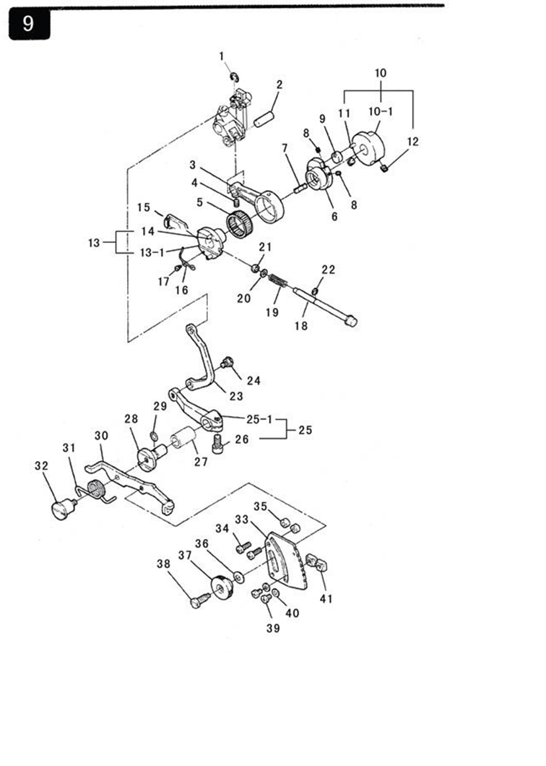

9.针距调节部分
序  号 | 图号 | 名称 |  | 3  线 | 4  线 | 4  宽 | 5  线 | 5  宽 | 5 厚 | 6  线 | 备注
 |  | 中文 | 英文
1 | 06-0600812-1 | 轴用挡圈 | Gasket | 1 | 1 | 1 | 1 | 1 | 1 | 1
2 | 201.05-13 | 销轴 | Pin | 1 | 1 | 1 | 1 | 1 | 1 | 1
3 | 201.09-03 | 送布连杆 | Feeding Connecting Rod | 1 | 1 | 1 | 1 | 1 | 1 | 1
4 | 01-804000614-1 | 送布连杆紧固螺钉 | Setscrew | 1 | 1 | 1 | 1 | 1 | 1 | 1
5 | 14-K222610 | 送布连杆滚针轴承 | Feeding Needle Bearing | 1 | 1 | 1 | 1 | 1 | 1 | 1
6 | 201.09-06 | 针距凸轮 | Cam | 1 | 1 | 1 | 1 | 1 | 1 | 1
7 | 201.09-07 | 弹簧片 | Spring | 1 | 1 | 1 | 1 | 1 | 1 | 1
8 | 01-803000414-1 | 内六角紧定螺钉 | Hexagon Setscrew | 2 | 2 | 2 | 2 | 2 | 2 | 2
9 | 201.09-09 | 针距凸轮滑块 | Cam Block | 1 | 1 | 1 | 1 | 1 | 1 | 1
10 | 201.09-10 | 针距调节座组件 | Adjusting Base Components | 1 | 1 | 1 | 1 | 1 | 1 | 1
10-1 | 201.09-10-01 | 针距调节座 | Adjusting Base | 1 | 1 | 1 | 1 | 1 | 1 | 1
11 | 201.09-10-02 | 定位销 | Position Pin | 1 | 1 | 1 | 1 | 1 | 1 | 1
12 | 01-805000514-1 | 针距调节座紧定螺钉 | Position Pin Setscrew | 2 | 2 | 2 | 2 | 2 | 2 | 2
13 | 201.09-13 | 偏心轮组件 | Eccentric Wheel Components | 1 | 1 | 1 | 1 | 1 | 1 | 2
13-1 | 201.09-13-01 | 偏心轮 | Eccentric Wheel | 1 | 1 | 1 | 1 | 1 | 1 | 1
14 | 201.09-13-02 | 定位销 | Position Pin | 2 | 2 | 2 | 2 | 2 | 2 | 2
15 | 201.09-15 | 内齿 | Inside Gear | 1 | 1 | 1 | 1 | 1 | 1 | 1
16 | 201.09-16 | 弹簧 | Spring | 1 | 1 | 1 | 1 | 1 | 1 | 1
17 | 201.09-17 | 压簧固定螺钉 | Setscrew | 1 | 1 | 1 | 1 | 1 | 1 | 1
18 | 201.09-18 | 针距调节轴 | Ratio Adjusting Rod | 1 | 1 | 1 | 1 | 1 | 1 | 1
19 | 201.09-19 | 差动调节簧 | Ratio Adjusting Spring | 1 | 1 | 1 | 1 | 1 | 1 | 1
20 | 05-050050760-4 | 垫片 | Gasket | 1 | 1 | 1 | 1 | 1 | 1 | 1
21 | 201.09-21 | 油封 | Oil Seal | 1 | 1 | 1 | 1 | 1 | 1 | 1
22 | 06-0300607-1 | 开口挡圈 | E-ring | 1 | 1 | 1 | 1 | 1 | 1 | 1
23 | 201.09-23 | 差动调节连杆 | Ratio Adjusting Rod | 1 | 1 | 1 | 1 | 1 | 1 | 1
24 | 201.09-24 | 差动调节连杆螺钉 | Ratio Adjusting Rod Screw | 1 | 1 | 1 | 1 | 1 | 1 | 1
25 | HX4-1 | 差动调节曲柄组件 | Ratio Adjusting Crank ASM | 1 | 1 | 1 | 1 | 1 | 1 | 1
25-1 | 201.09-25-01 | 差动调节曲柄 | Ratio Adjusting Crank | 1 | 1 | 1 | 1 | 1 | 1 | 1
26 | 01-506751224-1 | 固定螺钉 | Setscrew | 1 | 1 | 1 | 1 | 1 | 1 | 1
27 | 201.09-27 | 差动轴套 | Ratio Bushing | 1 | 1 | 1 | 1 | 1 | 1 | 1
28 | 201.09-28 | 差动轴 | Ratio Shaft | 1 | 1 | 1 | 1 | 1 | 1 | 1
29 | 12-060200 | O型圈 | O-ring | 1 | 1 | 1 | 1 | 1 | 1 | 1
30 | 201.09-30 | 差动调节杠杆 | Ratio Adjusting Lever | 1 | 1 | 1 | 1 | 1 | 1 | 1
31 | 201.09-31 | 差动扳手簧 | Ratio Spanner Spring | 1 | 1 | 1 | 1 | 1 | 1 | 1
32 | 201.09-32 | 差动扳手固定螺钉 | Ratio Spanner Setscrew | 1 | 1 | 1 | 1 | 1 | 1 | 1
33 | 201.09-33 | 针距调节指示板 | Adjusting Indicater | 1 | 1 | 1 | 1 | 1 | 1 | 1
34 | 01-404001223-1 | 固定螺钉 | Setscrew | 2 | 2 | 2 | 2 | 2 | 2 | 2
35 | 201.09-35 | 固定垫圈 | Spacer | 2 | 2 | 2 | 2 | 2 | 2 | 2
36 | 09-0620513-1 | 弹性垫圈（碟形） | Elastic Spacer (Dish-Live) | 1 | 1 | 1 | 1 | 1 | 1 | 1
37 | 201.09-37 | 差动调节螺母 | Ratio Adjusting Nut | 1 | 1 | 1 | 1 | 1 | 1 | 1
38 | 201.09-38 | 差动调节螺钉 | Ratio Adjusting Screw | 1 | 1 | 1 | 1 | 1 | 1 | 1
39 | 01-404000623-1 | 固定螺钉 | Setscrew | 2 | 2 | 2 | 2 | 2 | 2 | 2
40 | 05-043080900-4 | 平垫片 | Washer | 2 | 2 | 2 | 2 | 2 | 2 | 2
41 | 201.09-41 | 螺母 | Ratio Adjusting Nut | 2 | 2 | 2 | 2 | 2 | 2 | 2

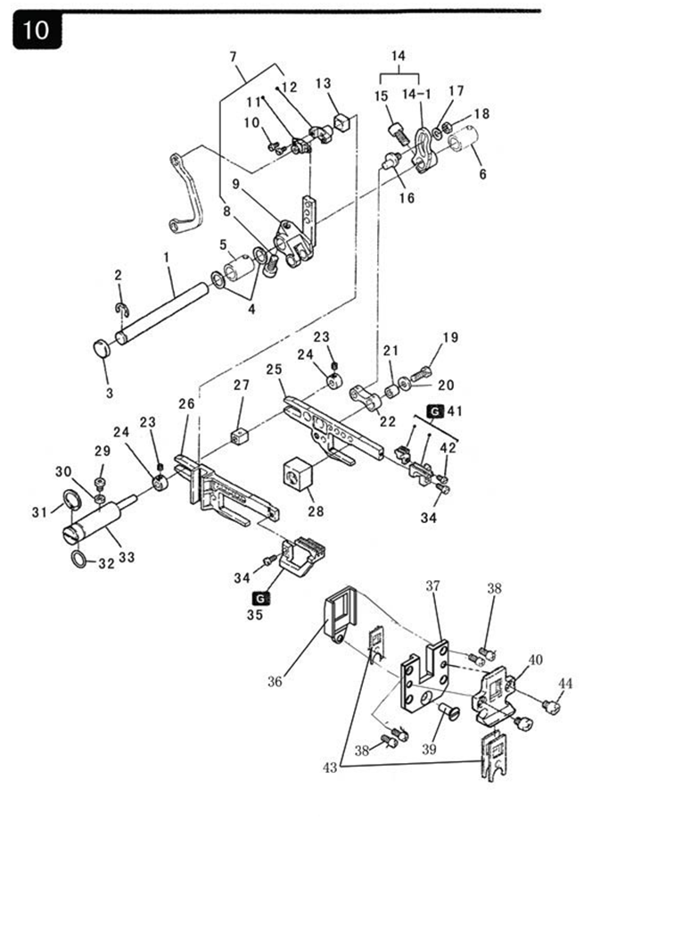
10.送布传动部分
序  号 | 图号 | 名称 |  | 3 线 | 4 线 | 4  宽 | 5 线 | 5 宽 | 5 厚 | 6  线 | 备注
 |  | 中文 | 英文
1 | 201.10-01 | 送布轴 | Feed Rocker Shaft | 1 | 1 | 1 | 1 | 1 | 1 | 1
2 | 06-0700814-1 | 开口挡圈 | E-ring | 1 | 1 | 1 | 1 | 1 | 1 | 1
3 | 22-15504017 | 油封 | Oil Seal | 1 | 1 | 1 | 1 | 1 | 1 | 1
4 | 201.08-06 | 铜垫片 | Copper Gasket | 2 | 2 | 2 | 2 | 2 | 2 | 2
5 | 201.07-06 | 送布轴前轴套 | Feed RockerShaftFrontBushing | 1 | 1 | 1 | 1 | 1 | 1 | 1
6 | 201.07-06 | 送布轴后轴套 | Feed Rocker ShaftRearBushing | 1 | 1 | 1 | 1 | 1 | 1 | 1
7 | 201.10-07 | 差动牙架调整曲柄组件 | Ratio Adjusting Crank ASM | 1 | 1 | 1 | 1 | 1 | 1 | 1
8 | 01-506751224-1 | 差动牙架调整曲螺钉 | Ratio Adjusting Crank Screw | 1 | 1 | 1 | 1 | 1 | 1 | 1
9 | 201.10-07-02 | 差动牙架调整曲柄 | Ratio Adjusting Crank | 1 | 1 | 1 | 1 | 1 | 1 | 1
10 | 01-503000621-1 | 滑块盖板螺钉 | Slipper Block Screw | 2 | 2 | 2 | 2 | 2 | 2 | 2
11 | 201.10-07-04 | 差动送布滑块盖板 | Slipper Block Cover | 1 | 1 | 1 | 1 | 1 | 1 | 1
12 | 201.10-07-05 | 差动牙架调整曲柄滑块 | Crank Block | 1 | 1 | 1 | 1 | 1 | 1 | 1
13 | 201.10-08 | 滑块 | Slipper Block | 1 | 1 | 1 | 1 | 1 | 1 | 1
14 | HX4-4 | 送布调整曲柄组件 | Feed Cloth Adjusting Crank ASM | 1 | 1 | 1 | 1 | 1 | 1 | 1
14-1 | 201.10-09-01 | 送布调整曲柄 | Feed Cloth Adjusting Crank | 1 | 1 | 1 | 1 | 1 | 1 | 1
15 | 01-506751424-1 | 送布调整曲柄紧固螺钉 | Setscrew | 1 | 1 | 1 | 1 | 1 | 1 | 1
16 | 201.10-11 | 偏心轴 | Eccentric Cam | 1 | 1 | 1 | 1 | 1 | 1 | 1
17 | 05-053101001-5 | 垫片 | Gasket | 1 | 1 | 1 | 1 | 1 | 1 | 1
18 | 03-605000400-1 | 送布牙连杆偏心轴螺母 | Nut | 1 | 1 | 1 | 1 | 1 | 1 | 1
19 | 01-705051325-1 | 送布牙架连杆套螺钉 | Screw | 1 | 1 | 1 | 1 | 1 | 1 | 1
20 | 05-053151102-5 | 送布牙架连杆套垫圈 | Gasket | 1 | 1 | 1 | 1 | 1 | 1 | 1
21 | 201.10-16 | 送布牙架连杆套 | Connecting Rod Bushing | 1 | 1 | 1 | 1 | 1 | 1 | 1
22 | 201.10-17 | 送布牙架连杆 | Connecting Rod | 1 | 1 | 1 | 1 | 1 | 1 | 1
23 | 01-804000414-1 | 挡圈螺钉 | Screw | 2 | 2 | 2 | 2 | 2 | 2 | 2
24 | 201.10-19 | 轴箍 | Thrust Collar | 2 | 2 | 2 | 2 | 2 | 2 | 2
25 | 201.10-20 | 送布牙架 | Feed Rocker Rank | 1 | 1 | 1 | 1 | 1 | 1 | 1
26 | 201.10-21 | 差动牙架 | Ratio Rank | 1 | 1 | 1 | 1 | 1 | 1 | 1
27 | 201.10-22 | 差动送布滑块 | Feed Slipper Block | 1 | 1 | 1 | 1 | 1 | 1 | 1
28 | 201.10-23 | 抬牙滑块 | Take-up Slipper Block | 1 | 1 | 1 | 1 | 1 | 1 | 1
29 | 01-404000823-1 | 螺钉 | Screw | 1 | 1 | 1 | 1 | 1 | 1 | 1
10.送布传动部分
序  号 | 图号 | 名称 |  | 3  线 | 4  线 | 4宽 | 5线 | 5  宽 | 5  厚 | 6  线 | 备注
 |  | 中文 | 英文
30 | 201.10-25 | 油封 | Oil Seal | 1 | 1 | 1 | 1 | 1 | 1 | 1
31 | 10-1401014-1 | 轴用弹性挡圈 | E-ring | 1 | 1 | 1 | 1 | 1 | 1 | 1
32 | 12-115160 | O型圈 | O-ring | 1 | 1 | 1 | 1 | 1 | 1 | 1
33 | 201.10-28 | 牙叉轴 | Shaft | 1 | 1 | 1 | 1 | 1 | 1 | 1
34 | 01-535000821-1 | 差动牙螺钉 | Screw | 2 | 2 | 2 | 2 | 2 | 2 | 2
35 | 201.10-30-00 | 差动牙 | Ratio dog | 1 | 1
 | 293.10-30-00 | 差动牙 | Ratio dog |  |  | 1
 | 203.10-30-00 | 差动牙 | Ratio dog |  |  |  | 1
 | 204.10-30-00P | 差动牙 | Ratio dog |  |  |  |  |  | 1
 | 205.10-30-00 | 差动牙 | Ratio dog |  |  |  |  | 1 |  | 1
36 | 260.10-31-02 | 油封密封盖 | Oil Sealing cover | 1 | 1 | 1 | 1 | 1 | 1 | 1
37 | 260.10-31-01 | 牙架导轨 | Guide Orbit | 1 | 1 | 1 | 1 | 1 | 1 | 1
38 | 01-404000823-1 | 牙架导轨螺钉 | Screw | 4 | 4 | 4 | 4 | 4 | 4 | 1
39 | 01-104001021-1 | 一字沉头螺钉 | Screw | 1 | 1 | 1 | 1 | 1 | 1 | 1
40 | 201.10-33 | 密封导架 | Guide Bracket | 1 | 1 | 1 | 1 | 1 | 1 | 1
41 | 201.10-36 | 主送布牙组件 | Main Feed Dog Components | 1 | 1 | 1
 | 201.10-36-01 | 主送布牙 | Main Feed Dog | 1 | 1 | 1
 | 201.10-36-02 | 副送布牙 | Differential Feed Dog | 1 | 1 | 1 | 1 | 1
41 | 203.10-36 | 主送布牙组件 | Main Feed Dog Components |  |  |  | 1 | 1 |  | 1
 | 203.10-36-01 | 主送布牙 | Main Feed Dog |  |  |  | 1 | 1
41 | 204.10-36 | 主送布牙组件 | Main Feed Dog Components |  |  |  |  |  | 1
 | 204.10-36-01 | 主送布牙 | Main Feed Dog |  |  |  |  |  | 1
 | 204.10-36-02 | 副送布牙 | Differential Feed Dog |  |  |  |  |  | 1
42 | 01-503000621-1 | 副送布牙螺钉 | Screw | 1 | 1 | 1 | 1 | 1 | 1 | 1
43 | 201.10-34 | 油封 | Oil Seal | 3 | 3 | 3 | 3 | 3 | 3 | 3
44 | 01-404000523-1 | 密封导架螺钉 | Screw | 2 | 2 | 2 | 2 | 2 | 2 | 2

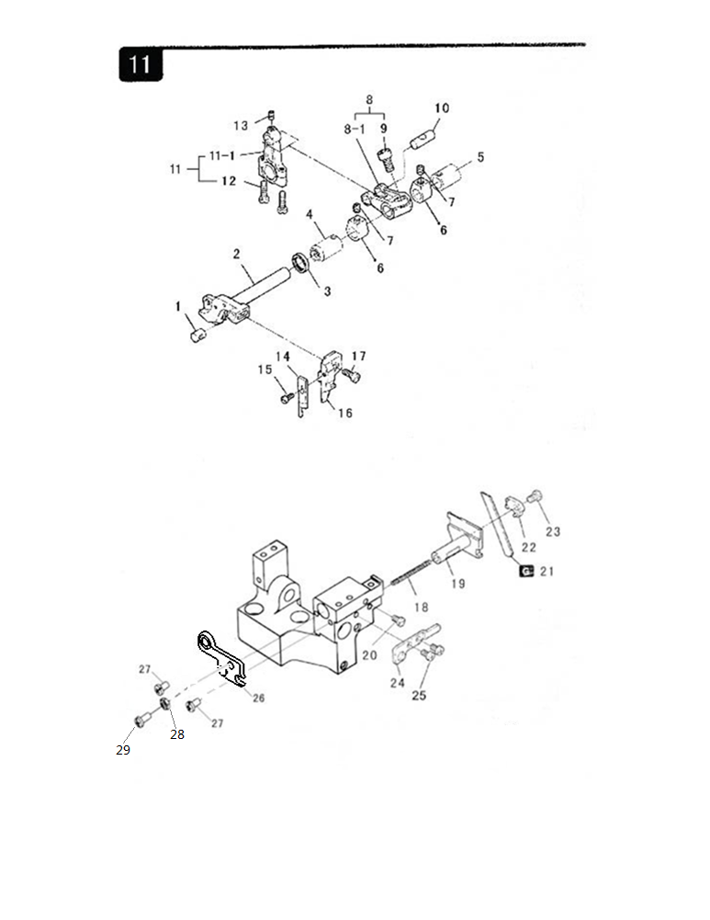
11.切布部分
序  号 | 图号 | 名称 |  | 3 线 | 4 线 | 4  宽 | 5 线 | 5 宽 | 5 厚 | 6  线 | 备注
 |  | 中文 | 英文
1 | 201.11-01 | 销轴 | Pin | 1 | 1 | 1 | 1 | 1 | 1 | 1
2 | 201.11-02 | 上刀轴 | Upper Knife Shaft | 1 | 1 | 1 | 1 | 1 | 1 | 1
3 | 13-09330150 | 骨架油封 | Oil Seal | 1 | 1 | 1 | 1 | 1 | 1 | 1
4 | 201.07-06 | 套筒 | Bushing | 1 | 1 | 1 | 1 | 1 | 1 | 1
5 | 201.07-06 | 套筒 | Bushing | 1 | 1 | 1 | 1 | 1 | 1 | 1
6 | 201.11-06 | 上刀轴箍 | Crank Pin | 2 | 2 | 2 | 2 | 2 | 2 | 2
7 | 01-806750514-1 | 挡圈螺钉 | Screw | 2 | 2 | 2 | 2 | 2 | 2 | 2
8 | 201.11-08 | 上切刀曲柄组件 | Feed Forked Arm Components | 1 | 1 | 1
8-1 | 201.11-08-01 | 上切刀曲柄 | Feed Forked Arm | 1 | 1 | 1
8 | 203.11-08 | 上切刀曲柄组件 | Feed Forked Arm Components |  |  |  | 1 | 1 | 1 | 1
8-1 | 203.11-08-01 | 上切刀曲柄 | Feed Forked Arm |  |  |  | 1 | 1 | 1 | 1
9 | 01-506751224-1 | 螺钉 | Screw | 1 | 1 | 1 | 1 | 1 | 1 | 1
10 | 201.05-13 | 销轴 | Pin | 1 | 1 | 1 | 1 | 1 | 1 | 1
11 | 201.11-11 | 上刀连杆组件 | Connecting Rod ASM | 1 | 1 | 1 | 1 | 1 | 1 | 1
11-1 | 201.11-11-01 | 上刀连杆 | Feed Forked Connecting Rod | 1 | 1 | 1 | 1 | 1 | 1 | 1
12 | 01-404001623-1 | 上切刀传动连杆固定螺钉 | Setscrew | 2 | 2 | 2 | 2 | 2 | 2 | 2
13 | 01-804000614-1 | 上切刀传动连杆紧定螺钉 | Setscrew | 1 | 1 | 1 | 1 | 1 | 1 | 1
14 | 201.11-14 | 上切刀 | Upper Knife | 1 | 1 | 1 | 1 | 1 | 1 | 1
15 | 01-535000821-1 | 上切刀固定螺钉 | Setscrew | 1 | 1 | 1 | 1 | 1 | 1 | 1
16 | 201.11-16 | 上刀座 | Plain Knife Support | 1 | 1 | 1
 | 203.11-16 | 上刀座 | Plain Knife Support |  |  |  | 1 | 1 | 1 | 1
17 | 01-504001221-1 | 上切刀架固定螺钉 | Setscrew | 1 | 1 | 1 | 1 | 1 | 1 | 1
18 | 201.11-18 | 下切刀弹簧 | Lower Knife Spring | 1 | 1 | 1 | 1 | 1 | 1 | 1
19 | 201.11-19 | 下切刀架 | Lower Knife Slide Stud | 1 | 1 | 1
 | 203.11-19 | 下切刀架 | Lower Knife Slide Stud |  |  |  | 1 | 1 | 1 | 1
20 | 01-504000821-1 | 下切刀架固定螺钉 | Setscrew | 1 | 1 | 1 | 1 | 1 | 1 | 1
21 | 201.11-21 | 下切刀 | Lower Knife | 1 | 1 | 1 | 1 | 1 | 1 | 1
22 | 201.11-22 | 下切刀压板 | Lower Knife Presser Board | 1 | 1 | 1 | 1 | 1 | 1 | 1
23 | 01-705000821-1 | 下切刀固定螺钉 | Setscrew | 1 | 1 | 1 | 1 | 1 | 1 | 1
24 | 201.11-24 | 下切刀架支板 | Lower Knife Bracket Support | 1 | 1 | 1 | 1 | 1 | 1 | 1
25 | 01-404000823-1 | 下切刀架定位板固定螺钉 | Setscrew | 2 | 2 | 2 | 2 | 2 | 2 | 2
26 | 296.34-41-00 | 感应器挡板 | Spring Plate | 1 | 1 | 1 | 1 | 1 | 1 | 1
27 | 01-404000823-1 | 弹簧挡板固定螺钉 | Spring Plate Setscrew | 2 | 2 | 2 | 2 | 2 | 2 | 2
28 | 03-604000320-1 | 螺母 | Nut | 1 | 1 | 1 | 1 | 1 | 1 | 1
29 | 01-404001223-1 | 螺钉 | Screw | 1 | 1 | 1 | 1 | 1 | 1 | 1
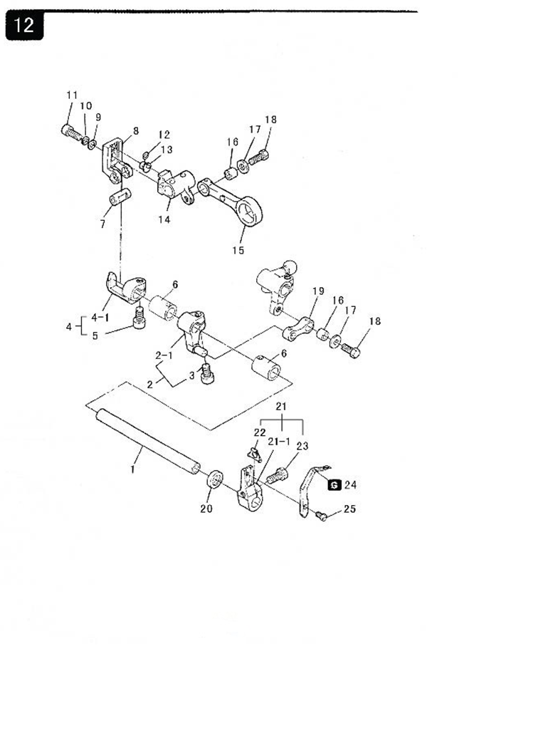
12.前弯针传动部分
序号 | 图号 | 名称 |  | 3 线 | 4 线 | 4  宽 | 5 线 | 5 宽 | 5 厚 | 6  线 | 备注
 |  | 中文 | 英文
1 | 203.12-01 | 前弯针轴 | Front Looper Shaft |  |  |  | 1 | 1 | 1 | 1
2 | 203.12-02 | 前弯针曲柄组件 | Front Looper Crank ASM |  |  |  | 1 | 1 | 1 | 1
2-1 | 203.12-02-01 | 前弯针曲柄 | Front Looper Crank |  |  |  | 1 | 1 | 1 | 1
3 | 01-506751224-1 | 前弯针曲柄固定螺钉 | Front Looper Crank Setscrew |  |  |  | 1 | 1 | 1 | 1
4 | 203.12-04 | 驱动座组件 | Driving Base ASM |  |  |  | 1 | 1 | 1 | 1
4-1 | 203.12-04-01 | 驱动座 | Driving Base |  |  |  | 1 | 1 | 1 | 1
5 | 01-506751224-1 | 驱动座紧定螺钉 | Driving Base Setscrew |  |  |  | 1 | 1 | 1 | 1
6 | 201.07-06 | 弯针纵轴轴套 | Cushion |  |  |  | 2 | 2 | 2 | 2
7 | 203.12-07 | 驱动曲柄销 | Driving Crank Pin |  |  |  | 1 | 1 | 1 | 1
8 | 203.12-08 | 驱动曲柄 | Driving Crank |  |  |  | 1 | 1 | 1 | 1
9 | 05-053101001-5 | 垫片 | Gasket |  |  |  | 1 | 1 | 1 | 1
10 | 07-0521313-1 | 弹簧垫片 | Cushion |  |  |  | 1 | 1 | 1 | 1
11 | 01-505001224-1 | 螺钉 | Screw |  |  |  | 1 | 1 | 1 | 1
12 | 12-038140 | O型圈 | O-ring |  |  |  | 1 | 1 | 1 | 1
13 | 203.12-13 | 偏心轴 | Eccentric Cam Shaft |  |  |  | 1 | 1 | 1 | 1
14 | 203.12-14 | 调节曲柄 | Adjusting Crank |  |  |  | 1 | 1 | 1 | 1
15 | 203.12-15 | 前弯针驱动连杆 | Main Feed Driving Link |  |  |  | 1 | 1 | 1 | 1
16 | 201.10-16 | 套筒 | Pin Collar |  |  |  | 2 | 2 | 2 | 2
17 | 05-053151102-5 | 垫片 | Washer |  |  |  | 2 | 2 | 2 | 2
18 | 01-705051325-1 | 螺钉 | Screw |  |  |  | 2 | 2 | 2 | 2
19 | 203.12-25 | 前弯针连杆 | Main Feed Link |  |  |  | 1 | 1 | 1 | 1
20 | 13-09340190 | 骨架油封 | Oil Seal |  |  |  | 1 | 1 | 1 | 1
21 | HXW6-8 | 前弯针架组件 | Front Looper Bracket ASM |  |  |  | 1 | 1 | 1 | 1
 | 203.12-21 | 前弯针架 | Front Looper Bracket |  |  |  | 1 | 1 | 1 | 1
22 | 203.12-21-02 | 垫片 | Washer |  |  |  | 1 | 1 | 1 | 1
23 | 01-705001325-1 | 前弯针架固定螺钉 | Setscrew |  |  |  | 1 | 1 | 1 | 1
24 | 203.12-24A | 前弯针 | Front Looper |  |  |  | 1 | 1 | 1 | 1
25 | 01-535000621-1 | 前弯针固定螺钉 | Front Looper Setscrew |  |  |  | 1 | 1 | 1 | 1

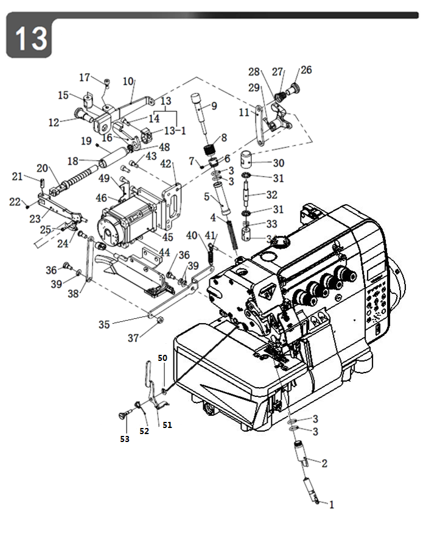

13.压布传动部分
序  号 | 图号 | 名称 |  | 3 线 | 4 线 | 4  宽 | 5 线 | 5 宽 | 5 厚 | 6  线 | 备注
 |  | 中文 | 英文
1 | 260.13-35A | 压杆头组件 | Presser Rod Head ASM | 1 | 1 | 1 | 1 | 1 | 1 | 1
2 | 293.13-38 | 压杆铜套 | Presser rod Copper Collar | 1 | 1 | 1 | 1 | 1 | 1 | 1
3 | 12-106100 | O型圈 | O-ring | 2 | 2 | 2 | 2 | 2 | 2 | 2
4 | 296.13-29 | 弹簧 | Spring | 1 | 1 | 1 | 1 | 1 | 1 | 1
5 | 260.13-37A | 压杆防油管 | Presser rod Anti-oil tube | 1 | 1 | 1 | 1 | 1 | 1 | 1
6 | 260.13-28 | 调压螺母锁紧套 | Nut Regulation Collar | 1 | 1 | 1 | 1 | 1 | 1 | 1
7 | 01-804000414-1 | 无帽内六角螺钉 | Screw | 1 | 1 | 1 | 1 | 1 | 1 | 1
8 | 296.13-36 | 调牙螺帽 | Presser nut | 1 | 1 | 1 | 1 | 1 | 1 | 1
9 | 296.13-27A | 调牙螺钉 | Presser Screw Regulation | 1 | 1 | 1 | 1 | 1 | 1 | 1
10 | 296.34-13 | 抬压脚板 | Lidt and press the foot plate | 1 | 1 | 1 | 1 | 1 | 1 | 1
11 | 296.34-17 | 连接板 | Junction Pate | 1 | 1 | 1 | 1 | 1 | 1 | 1
12 | 296.34-28 | 抬压脚轴位螺钉 | Axial crew | 1 | 1 | 1 | 1 | 1 | 1 | 1
13 | 201.13-13 | 抬压脚曲柄组件 | Presser Foot Bushing | 1 | 1 | 1 | 1 | 1 | 1 | 1
13-1 | 201.13-13-01 | 抬压脚曲柄 | Lifting Presser Foot Crank | 1 | 1 | 1 | 1 | 1 | 1 | 1
14 | 01-506751424-1 | 抬压脚曲柄螺钉 | Lifting Presser Foot Crank Screw | 1 | 1 | 1 | 1 | 1 | 1 | 1
15 | 296.34-33 | 压脚压头 | Press foot pressure head | 1 | 1 | 1 | 1 | 1 | 1 | 1
16 | 296.34-14 | 抬压脚轴杠杆 | Lifting Lever Link | 1 | 1 | 1 | 1 | 1 | 1 | 1
17 | 01-505001224-1 | 调节螺钉 | Presser Spring Regulation | 1 | 1 | 1 | 1 | 1 | 1 | 1
18 | 296.34-16 | 压脚轴套 | Presser Foot Bushing | 1 | 1 | 1 | 1 | 1 | 1 | 1
19 | 01-804000414-1 | 螺钉 M4×4 | Screw | 1 | 1 | 1 | 1 | 1 | 1 | 1
20 | 296.34-10 | 压脚轴 | Lifting Shaft | 1 | 1 | 1 | 1 | 1 | 1 | 1
21 | 296.34-38 | 铰链销 | Hinge Pin | 1 | 1 | 1 | 1 | 1 | 1 | 1
22 | 01-804050414-1 | 铰链销紧定螺钉 | Hinge Pin Setscrew | 1 | 1 | 1 | 1 | 1 | 1 | 1
23 | 296.34-09 | 抬压脚臂 | Lifting Presser Foot Arm | 1 | 1 | 1 | 1 | 1 | 1 | 1
24 | 249.27-04 | 护片 | Thread Cutting Knife | 1 | 1 | 1 | 1 | 1 | 1 | 1
25 | 01-903000621-1 | 护片螺钉 | Thread Cutting Knife Screw | 1 | 1 | 1 | 1 | 1 | 1 | 1
26 | 296.34-30 | 轴螺钉 | Axial crew | 2 | 2 | 2 | 2 | 2 | 2 | 2
27 | 296.30-01-06 | 小夹线器弹簧 | Spring | 2 | 2 | 2 | 2 | 2 | 2 | 2
28 | 296.34-18 | 旋转曲柄 | Rotating crank | 1 | 1 | 1 | 1 | 1 | 1 | 1
29 | 01-506751424-1 | 调节螺钉 | Presser Spring Regulation | 1 | 1 | 1 | 1 | 1 | 1 | 1
30 | 296.34-20 | 剪线驱动上轴头 | Upper shaft head | 1 | 1 | 1 | 1 | 1 | 1 | 1
31 | 296.34-31 | 减震垫 | Shock ad | 2 | 2 | 2 | 2 | 2 | 2 | 2
32 | 296.34-19 | 剪线驱动轴 | Thread cutting drive shaft | 1 | 1 | 1 | 1 | 1 | 1 | 1
33 | 03-606000500-1 | 调节螺母 | Nut | 1 | 1 | 1 | 1 | 1 | 1 | 1
34 | 296.34-21 | 剪线驱动下轴头 | Lower shaft head | 1 | 1 | 1 | 1 | 1 | 1 | 1
35 | 296.34-22 | 剪线杠杆 | Thread cutting lever | 1 | 1 | 1 | 1 | 1 | 1 | 1
36 | 296.34-29 | 轴位螺钉 | Axial crew | 1 | 1 | 1 | 1 | 1 | 1 | 1
13.压布传动部分
序  号 | 图号 | 名 称 |  | 3 线 | 4 线 | 4  宽 | 5 线 | 5 宽 | 5 厚 | 6  线 | 备注
 |  | 中文 | 英文
37 | 03-605000400-1 | 调节螺母M5×4 | Screw | 1 | 1 | 1 | 1 | 1 | 1 | 1
38 | 296.34-23 | 剪线转接板 | Wire cutting adapter plate | 1 | 1 | 1 | 1 | 1 | 1 | 1
39 | 08-0700311-1 | 波形垫圈 | Corrugated gasket | 3 | 3 | 3 | 3 | 3 | 3 | 3
40 | 296.34-34 | 拉簧 | Tension spring | 1 | 1 | 1 | 1 | 1 | 1 | 1
41 | 01-404001623-1 | 十字一字螺钉 | Screw | 1 | 1 | 1 | 1 | 1 | 1 | 1
42 | 296.34-12 | 电机安装板 | Motor ounting plate | 1 | 1 | 1 | 1 | 1 | 1 | 1
43 | 01-505001224-1 | 内六角槽圆柱头螺钉 M5×12 | Setscrew | 5 | 5 | 5 | 5 | 5 | 5 | 5
44 | 01-505001224-1 | 步进电机螺钉 | Stepper motor screws | 4 | 4 | 4 | 4 | 4 | 4 | 4
45 | 296.34-07 | 步进电机 | Stepper motor | 1 | 1 | 1 | 1 | 1 | 1 | 1
46 | 05-053101000-1 | 平垫片 | Washer | 4 | 4 | 4 | 4 | 4 | 4 | 4
48 | 296.34-36 | 压脚轴扭簧 | Torsion spring of presser foot shaft | 1 | 1 | 1 | 1 | 1 | 1 | 1
49 | 296.34-37 | 压线板 | Tonsion disc | 1 | 1 | 1 | 1 | 1 | 1 | 1
50 | 05-051081203-5 | 平垫片 | Washer | 1 | 1 | 1 | 1 | 1 | 1 | 1
51 | 296.13-30 | 扳手 | Wrench
52 | 260.13-31A | 抬压脚扳手簧 | Spring | 1 | 1 | 1 | 1 | 1 | 1 | 1
53 | 296.13-40 | 抬压脚螺钉 | Screw

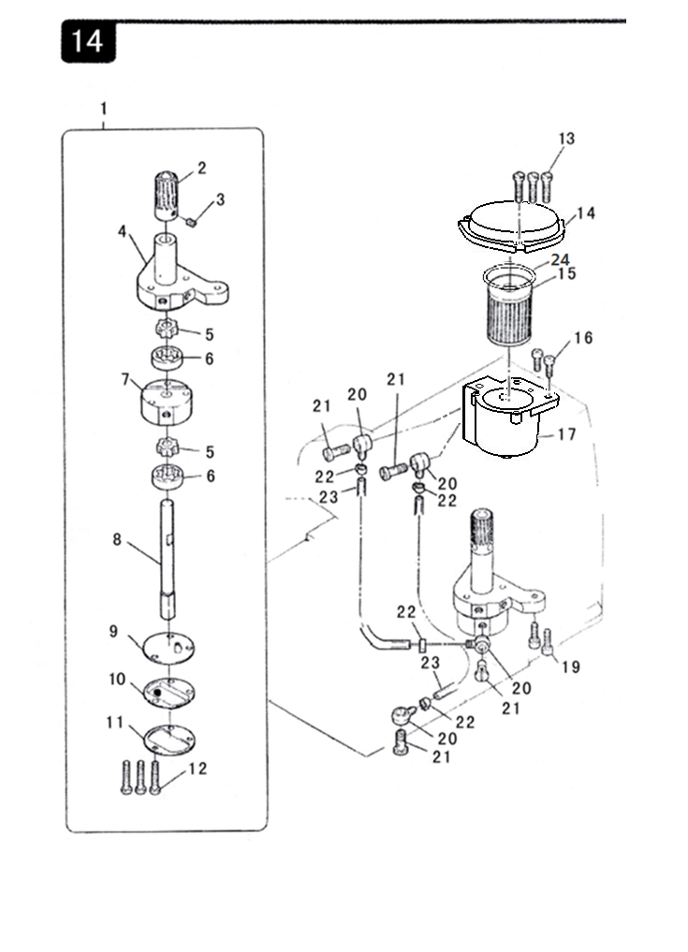
14.润滑部分
序号 | 图号 | 名称 |  | 3 线 | 4 线 | 4  宽 | 5 线 | 5 宽 | 5 厚 | 6  线 | 备注
 |  | 中文 | 英文
1 | HXW5-1 | 油泵组件（大油量） | Oil Pump ASM | 1 | 1 | 1 | 1 | 1 | 1 | 1
2 | 210.14-00 | 油泵蜗轮 | Worm Gear | 1 | 1 | 1 | 1 | 1 | 1 | 1
3 | 01-805000514-1 | 油泵蜗轮紧定螺钉 | Worm Gear Setscrew | 1 | 1 | 1 | 1 | 1 | 1 | 1
4 | 201.14-01-03 | 油泵体 | Oil Pump | 1 | 1 | 1 | 1 | 1 | 1 | 1
5 | 210.14-01-04 | 大油泵转子 | Pinion Gear(big) | 1 | 1 | 1 | 1 | 1 | 1 | 1
6 | 210.14-01-05 | 大油泵定子 | Oil Pump Pinion(big) | 1 | 1 | 1 | 1 | 1 | 1 | 1
7 | 210.14-01-06 | 油泵底座 | Oil Pump Base | 1 | 1 | 1 | 1 | 1 | 1 | 1
8 | 201.14-01-07 | 油泵主轴 | Gear Pump Shaft Large | 1 | 1 | 1 | 1 | 1 | 1 | 1
9 | 201.14-01-08 | 油泵底板 | Pinion Spacer | 1 | 1 | 1 | 1 | 1 | 1 | 1
10 | 201.14-01-09 | 滤油网 | Filter | 1 | 1 | 1 | 1 | 1 | 1 | 1
11 | 201.14-01-10 | 滤油网固定片 | Filter Gasket | 1 | 1 | 1 | 1 | 1 | 1 | 1
12 | 201.14-01-11 | 油泵底板固定螺钉 | Setscrew | 3 | 3 | 3 | 3 | 3 | 3 | 3
13 | 01-504002221-1 | 螺钉 | Screw | 3 | 3 | 3 | 3 | 3 | 3 | 3
14 | 296.34-25 | 滤油器上盖 | Filter Box Cover | 1 | 1 | 1 | 1 | 1 | 1 | 1
15 | 201.14-05 | 滤油器 | Cartridge Filter | 1 | 1 | 1 | 1 | 1 | 1 | 1
16 | 01-404001223-1 | 螺钉 | Screw | 2 | 2 | 2 | 2 | 2 | 2 | 2
17 | 296.34-24 | 滤油器底座 | Filter Casing | 1 | 1 | 1 | 1 | 1 | 1 | 1
19 | 01-504001621-1 | 螺钉 | Screw | 2 | 2 | 2 | 2 | 2 | 2 | 2
20 | 201.14-10 | 油管接头 | Oil Pipe Joint | 4 | 4 | 4 | 4 | 4 | 4 | 4
21 | 201.14-11 | 油管活接头螺钉 | Screw | 4 | 4 | 4 | 4 | 4 | 4 | 4
22 | 201.20-08 | 油管卡簧 | Oil Pipe Spring | 4 | 4 | 4 | 4 | 4 | 4 | 4
23 | 201.20-09YGA | 油管 | Tubing | 1 | 1 | 1 | 1 | 1 | 1 | 1
24 | 12-410200 | O型橡胶密封圈 | O-shaped rubber sealingring | 1 | 1 | 1 | 1 | 1 | 1 | 1

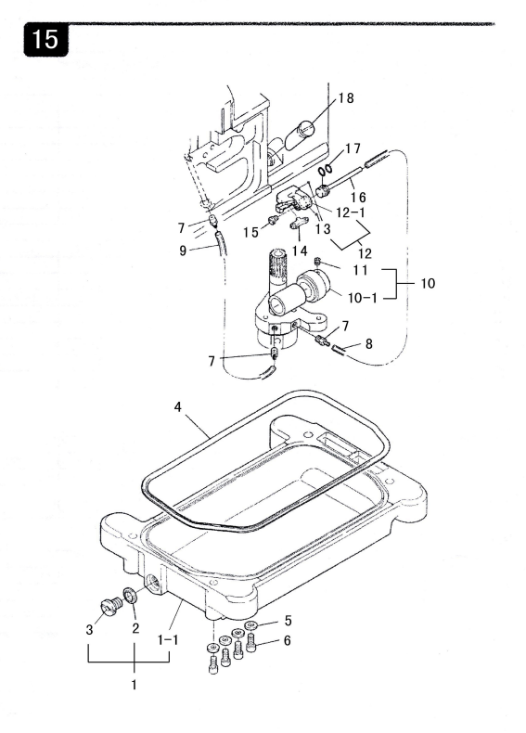

15.油盘部分
序  号 | 图号 | 名称 |  | 3 线 | 4 线 | 4  宽 | 5 线 | 5 宽 | 5 厚 | 6  线 | 备注
 |  | 中文 | 英文
1 | 210.15-01 | 油盘组件 | Oil Tray ASM | 1 | 1 | 1 | 1 | 1 | 1 | 1
1-1 | 210.15-01-01 | 油盘 | Oil Tray | 1 | 1 | 1 | 1 | 1 | 1 | 1
2 | 201.15-01-02 | 放油螺钉油封 | Oil Seal | 1 | 1 | 1 | 1 | 1 | 1 | 1
3 | 201.15-01-03 | 放油螺钉 | Oil Release Screw | 1 | 1 | 1 | 1 | 1 | 1 | 1
4 | 210.15-04 | 密封圈 | Oil Reservior Gasket | 1 | 1 | 1 | 1 | 1 | 1 | 1
5 | 05-053201450-1 | 垫片 | Gasket | 4 | 4 | 4 | 4 | 4 | 4 | 4
6 | 01-505001224-1 | 油盘固定螺钉 | Setscrew | 4 | 4 | 4 | 4 | 4 | 4 | 4
7 | 201.15-07 | 油管接头 | Oil Pipe Joint | 3 | 3 | 3 | 3 | 3 | 3 | 3
8 | 201.20-09YGA | 油管 | Oil Pipe | 1 | 1 | 1 | 1 | 1 | 1 | 1
9 | 201.20-09YGA | 油管 | Oil Pipe | 1 | 1 | 1 | 1 | 1 | 1 | 1
10 | 210.14-00 | 蜗杆组件 | Worm Rod ASM | 1 | 1 | 1 | 1 | 1 | 1 | 1
10-1 | 210.15-10-01 | 蜗杆 | Worm Rod | 1 | 1 | 1 | 1 | 1 | 1 | 1
11 | 01-804000414-1 | 螺钉 | Screw | 2 | 2 | 2 | 2 | 2 | 2 | 2
12 | 201.15-12 | 针杆回油器组件 | Oil Returning Components | 1 | 1 | 1 | 1 | 1 | 1 | 1
12-1 | 201.15-12-01 | 针杆回油器 | Oil Returning | 1 | 1 | 1 | 1 | 1 | 1 | 1
13 | 201.15-12-02 | 钢球 | Steel Ball | 2 | 2 | 2 | 2 | 2 | 2 | 2
14 | 201.15-14 | 毛毡 | Felt | 1 | 1 | 1 | 1 | 1 | 1 | 1
15 | 01-404000823-1 | 螺钉 | Screw | 1 | 1 | 1 | 1 | 1 | 1 | 1
16 | 201.15-16A | 排油杆 | Oil Release Rod | 1 | 1 | 1 | 1 | 1 | 1 | 1
17 | 12-060200 | O型圈 | O-ring | 2 | 2 | 2 | 2 | 2 | 2 | 2
18 | 201.15-18 | 圆柱形油窗 | Oil Window | 1 | 1 | 1 | 1 | 1 | 1 | 1

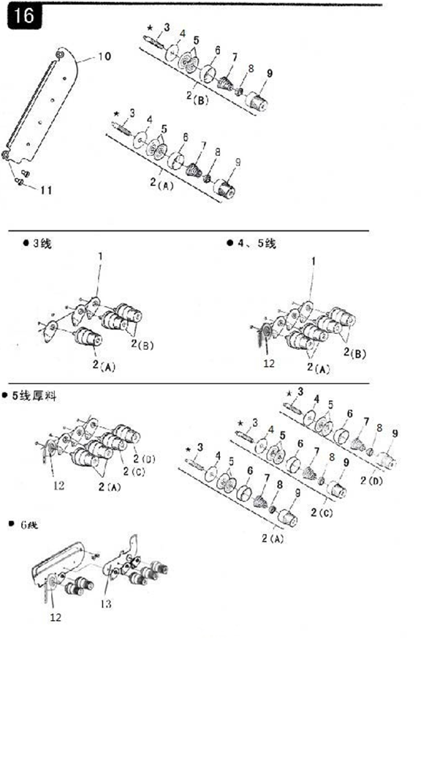
16.夹线器部分
序号 | 图号 | 名称 |  | 3 线 | 4 线 | 4  宽 | 5 线 | 5 宽 | 5 厚 | 6  线 | 备注
 |  | 中文 | 英文
1 | 201.16-01 | 过线板（C） | Thread Tension Disk (C) | 3 | 3 | 3 | 3 | 3 | 3 | 4
2 | 201.16-02 A | 夹线器组件A | Thread Tension Components A | 1 | 2 | 2 | 2 | 2 | 2 | 3
 | 201.16-02 B | 夹线器组件B | Thread Tension Components B | 2 | 2 | 2 | 2 | 2 |  | 2
 | 204.16-02 C | 夹线器组件C | Thread Tension Components C |  |  |  |  |  | 1
 | 204.16-02 D | 夹线器组件D | Thread Tension Components D |  |  |  |  |  | 1
3 | 201.16-02-01 | 夹线螺钉 | Thread Tension Screw | 3 | 4 | 4 | 4 | 4 | 4 | 5
4 | 201.16-02-02 | 羊毛垫 | Felt | 3 | 4 | 4 | 4 | 4 | 4 | 5
5 | 201.16-02-03 | 夹线片 | Thread Tension Disk | 6 | 8 | 8 | 8 | 8 | 8 | 10
6 | 201.16-02-04 | 夹线器座 | Thread Tension Base | 3 | 4 | 4 | 4 | 4 | 4 | 5
7 | 201.16-02-05A | 夹线簧A | Thread Tension Spring A | 1 | 2 | 2 | 2 | 2 | 2 | 3
 | 201.16-02-05B | 夹线簧B | Thread Tension Spring B | 2 | 2 | 2 | 2 | 2 |  | 2
 | 204.16-02-05C | 夹线簧C | Thread Tension Spring C |  |  |  |  |  | 1
 | 204.16-02-05D | 夹线簧D | Thread Tension Spring D |  |  |  |  |  | 1
8 | 201.16-02-06 | 止动套 | Stopping Bushing | 3 | 4 | 4 | 4 | 4 | 4 | 5
9 | 201.16-02-07 | 夹线调节螺母 | Thread Tension Knob | 3 | 4 | 4 | 4 | 4 | 4 | 5
10 | HX7-6 | 过线板（B） | Thread Tension Disk (B) | 1 | 1 | 1 | 1 | 1 | 1 | 1
11 | 01-204000821-2 | 螺钉 | Screw | 2 | 2 | 2 | 2 | 2 | 2 | 2
12 | 201.16-01G | 针线过线板 | Thread Tension Disk |  | 1 | 1 | 1 | 1 | 1
 | 206.16-01G | 针线过线板 | Thread Tension Disk |  |  |  |  |  |  | 1
13 | 206.16-04 | 三针过线板 | Thread Tension Disk |  |  |  |  |  |  | 1

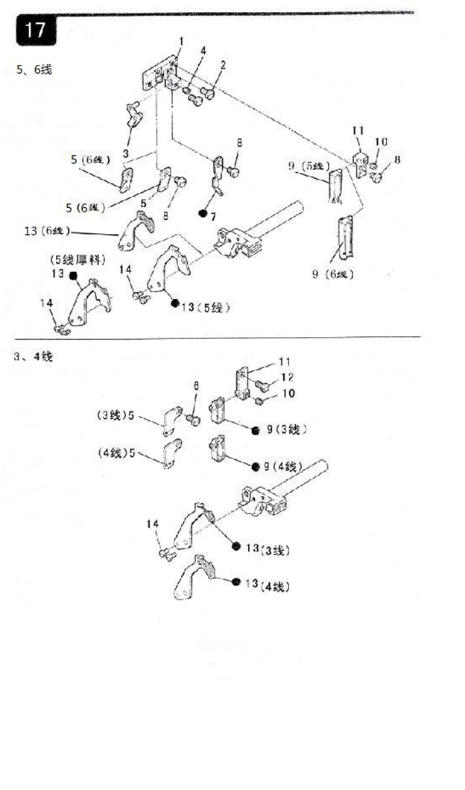
17.过线件部分（1）
序号 | 图号 | 名称 |  | 3 线 | 4 线 | 4  宽 | 5 线 | 5 宽 | 5 厚 | 6  线 | 备注
 |  | 中文 | 英文
1 | 203.17-01 | 过线板固定座 | Thread Tension Base |  |  |  | 1 | 1 | 1 | 1
2 | 01-604000821-1 | 过线板固定座螺钉 | Thread Tension Base Screw |  |  |  | 2 | 2 | 2 | 2
3 | 203.17-03 | 过线板组件 | Thread Tension ASM |  |  |  | 1 | 1 | 1 | 1
4 | 01-804000414-1 | 过线板螺钉 | Screw |  |  |  | 1 | 1 | 1 | 1
5 | 201.17-05 | 穿线板 | Thread Tension Disk | 1
 | 202.17-05 | 穿线板 | Thread Tension Disk |  | 1 | 1
 | 203.17-05 | 穿线板 | Thread Tension Disk |  |  |  | 1 | 1 | 1
 | 206.17-05 | 穿线板 | Thread Tension Disk |  |  |  |  |  |  | 1
6 | 01-604000821-1 | 穿线板螺钉 | Screw | 1 | 1 | 1 |  |  |  | 1
7 | 203.17-07 | 单孔过线板 | Single-hole Thread Guide Disk |  |  |  | 1 | 1 |  | 1
 | 204.17-07 | 单孔过线板 | Single-hole Thread Guide Disk |  |  |  |  |  | 1
8 | 01-504000521-1 | 单孔过线板固定螺钉 | Setscrew |  |  |  | 3 | 3 | 3 | 3
9 | 201.17-09 | 二眼过线板组件 | Two-hole Thread Tension ASM | 1
 | 202.17-09 | 二眼过线板组件 | Two-hole Thread Tension ASM |  | 1 | 1
 | 203.17-09 | 二眼过线板组件 | Two-hole Thread Tension ASM |  |  |  | 1 | 1 | 1
 | 206.17-09 | 二眼过线板组件 | Two-hole Thread Tension ASM |  |  |  |  |  |  | 1
10 | 01-804000414-1 | 二眼过线板螺钉 | Screw | 1 | 1 | 1 | 1 | 1 | 1 | 1
11 | 201.17-11 | 过线板座 | Thread Tension Base | 1 | 1 | 1
 | 203.17-11 | 过线板座 | Thread Tension Base |  |  |  | 1 | 1 | 1 | 1
12 | 01-604000821-1 | 过线板座螺钉 | Screw | 1 | 1 | 1
13 | 201.17-13 | 挑线板 | Thread Take-up Disk | 1
 | 202.17-13A | 挑线板 | Thread Take-up Disk |  | 1 | 1
 | 203.17-13 | 挑线板 | Thread Take-up Disk |  |  |  | 1 | 1
 | 204.17-13 | 挑线板 | Thread Take-up Disk |  |  |  |  |  | 1
 | 206.17-13 | 挑线板 | Thread Take-up Disk |  |  |  |  |  |  | 1
14 | 01-603000621-1 | 挑线板固定螺钉 | Setscrew | 2 | 2 | 2 | 2 | 2 | 2 | 2

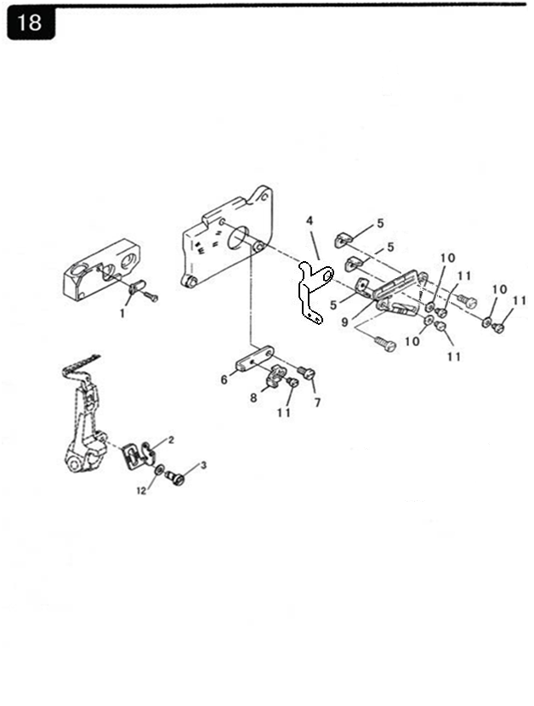
18.过线件部分（2）
序号 | 图号 | 名称 |  | 3 线 | 4 线 | 4  宽 | 5 线 | 5 宽 | 5 厚 | 6  线 | 备注
 |  | 中文 | 英文
1 | 201.18-01 | 过线板 | Thread Tension Disk | 1 | 1 | 1 | 1 | 1 | 1 | 1
2 | 2101.20-01 | 下弯针过线板（A） | Lower Looper Thread Guide Disk A | 1 | 1 | 1 | 1 | 1 | 1 | 1
3 | 01-535000621-1 | 过线板螺钉 | Screw | 1 | 1 | 1 | 1 | 1 | 1 | 1
4 | 201.18-04A | 上弯针过线板（A） | Upper Looper Thread Guide Disk A | 1 | 1 | 1 | 1 | 1 |  | 1
 | 204.18-04 | 上弯针过线板（A） | Upper Looper Thread Guide Disk A |  |  |  |  |  | 1
5 | 201.18-05 | 弯针过线板（B） | Looper Thread Guide Disk B | 3 | 3 | 3 | 3 | 3 | 3 | 3
6 | 201.18-06 | 上弯针过线板（C） | Upper Looper Thread Guide Disk C | 1 | 1 | 1 | 1 | 1 | 1 | 1
7 | 01-504000821-1 | 上弯针过线板螺钉 | Screw | 1 | 1 | 1 | 1 | 1 | 1 | 1
8 | 201.18-08 | 下弯针过线板（C） | Lower Looper Thread Guide Disk C | 1 | 1 | 1 | 1 | 1 | 1 | 1
9 | 201.18-09 | 过线板调整架 | Adjusting Bracket | 1 | 1 | 1 | 1 | 1 | 1 | 1
10 | 05-032050700-1 | 过线板螺钉垫片 | Gasket | 3 | 3 | 3 | 3 | 3 | 3 | 3
11 | 01-503000421-1 | 上弯针过线板螺钉 | Screw | 4 | 4 | 4 | 4 | 4 | 4 | 4
12 | 05-036080800-1 | 平垫片 | Gasket | 1 | 1 | 1 | 1 | 1 | 1 | 1

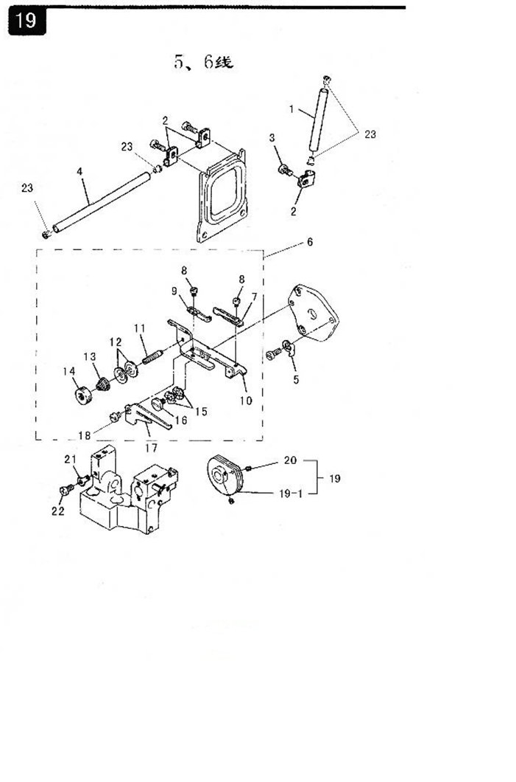
19.过线件部分（3）
序  号 | 图号 | 名称 |  | 3 线 | 4 线 | 4  宽 | 5 线 | 5 宽 | 5 厚 | 6  线 | 备注
 |  | 中文 | 英文
1 | 203.19-04 | 长过线管 | Thread Pipe (short) |  |  |  | 1 | 1 | 1 | 1
2 | 203.19-02 | 过线管夹 | Thread Pipe Clamp |  |  |  | 3 | 3 | 3 | 3
3 | 01-404000823-1 | 过线管夹固定螺钉 | Screw |  |  |  | 1 | 1 | 1 | 1
4 | 203.19-04 | 长过线管 | Thread Pipe (long) |  |  |  | 1 | 1 | 1 | 1
5 | 203.19-05 | 过线环 | Thread Ring |  |  |  | 1 | 1 | 1 | 1
6 | HXW7-9 | 前弯针导线架组件 | Components |  |  |  | 1 | 1 | 1 | 1
7 | 203.19-06-01 | 过线板 A | Thread Tension Disk A |  |  |  | 1 | 1 | 1 | 1
8 | 01-503000421-1 | 过线板螺钉 | Screw |  |  |  | 2 | 2 | 2 | 2
9 | 203.19-06-03 | 过线板B | Thread Tension Disk B |  |  |  | 1 | 1 | 1 | 1
10 | 203.19-06-04 | 导线架 | Thread Guide Rack |  |  |  | 1 | 1 | 1 | 1
11 | 203.19-06-05 | 压线螺钉 | Screw |  |  |  | 1 | 1 | 1 | 1
12 | 203.19-06-06 | 压线板 | Thread Presser Disk |  |  |  | 2 | 2 | 2 | 2
13 | 203.19-06-07 | 压线簧 | Thread Presser Spring |  |  |  | 1 | 1 | 1 | 1
14 | 203.19-06-08 | 压线螺母 | Thread Presser Nut |  |  |  | 1 | 1 | 1 | 1
15 | 08-0700311-1 | 波形弹性垫圈 | Elastic Cushion |  |  |  | 2 | 2 | 2 | 2
16 | 201.03-08 | 导线架螺钉 | Screw |  |  |  | 1 | 1 | 1 | 1
17 | 203.19-06-11 | 导线板 | Thread Guide Disk |  |  |  | 1 | 1 | 1 | 1
18 | 01-504000521-1 | 导线板螺钉 | Screw |  |  |  | 1 | 1 | 1 | 1
19 | 203.19-07 | 张力变换凸轮组件 | Tension Changing Cam ASM |  |  |  | 1 | 1 | 1 | 2
19-1 | 203.19-07-01 | 张力变换凸轮 | Tension Changing Cam |  |  |  | 1 | 1 | 1 | 1
20 | 01-803000314-1 | 凸轮轴套紧定螺钉 | Set screw |  |  |  | 2 | 2 | 2 | 2
21 | 203.19-08 | 过线板 | Thread Tension Disk |  |  |  | 1 | 1 | 1 | 1
22 | 01-404000623-1 | 过线板螺钉 | Screw |  |  |  | 1 | 1 | 1 | 1
23 | 203.19-09 | 过线管磁眼 | Screw |  |  |  | 1 | 1 | 1 | 1

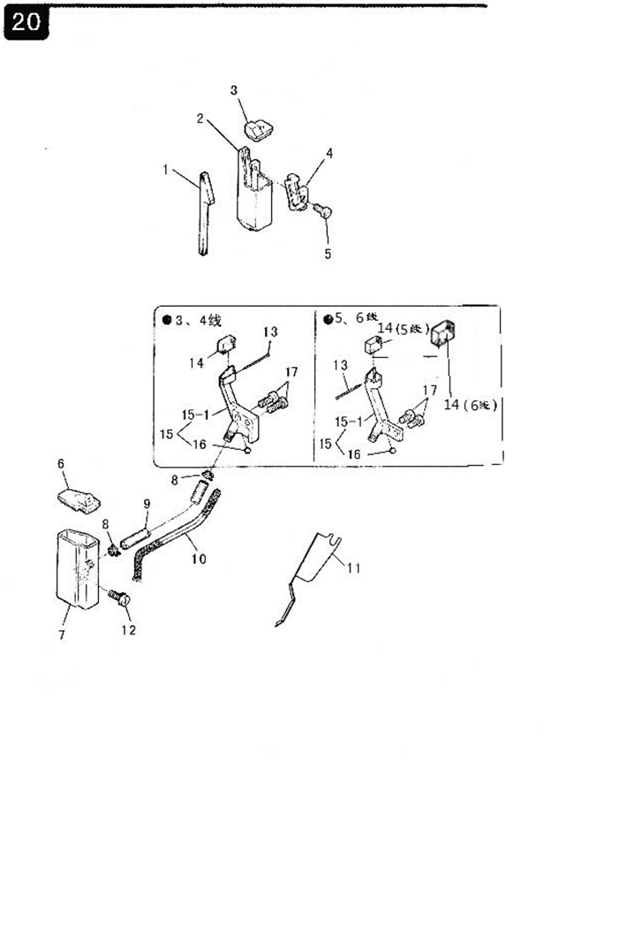
20.硅油装置部分
序  号 | 图号 | 名称 |  | 3 线 | 4 线 | 4  宽 | 5 线 | 5 宽 | 5 厚 | 6  线 | 备注
 |  | 中文 | 英文
1 | 201.20-01 | 滤油毡 | Filter Felt | 1 | 1 | 1
 | 203.20-01 | 滤油毡 | Filter Felt |  |  |  | 1 | 1 | 1 | 1
2 | 201.20-02 | 硅油盒 | Silicon Oil Box | 1 | 1 | 1 | 1 | 1 | 1 | 1
3 | 201.20-03 | 油箱盒盖 | Box Cover | 1 | 1 | 1 | 1 | 1 | 1 | 1
4 | 201.20-04 | 压板 | Presser Disk | 1 | 1 | 1
 | 203.20-04 | 压板 | Presser Disk |  |  |  | 1 | 1 | 1 | 1
5 | 01-404001023-1 | 压板螺钉 | Screw | 1 | 1 | 1 | 1 | 1 | 1 | 1
6 | 201.20-06 | 小油箱盖 | Tank Cover | 1 | 1 | 1 | 1 | 1 | 1 | 1
7 | 201.20-07 | 小油箱 | Tank Small | 1 | 1 | 1 | 1 | 1 | 1 | 1
8 | 201.20-08A | 卡簧 | Spring | 2 | 2 | 2 | 2 | 2 | 2 | 2
9 | 201.20-09 | 油管 | Oil Pipe | 1 | 1 | 1 | 1 | 1 | 1 | 1
10 | 201.20-10 | 油线 | Oil Thread | 1 | 1 | 1 | 1 | 1 | 1 | 1
11 | 201.20-11 | 挡板 | Thrust | 1 | 1 | 1 | 1 | 1 | 1 | 1
12 | 18-404001223-3 | 小油箱固定螺钉 | Setscrew (zinc) | 1 | 1 | 1 | 1 | 1 | 1 | 1
13 | 201.20-13 | 机针冷却器油线钉 | Screw | 1 | 1 | 1 | 1 | 1 | 1 | 1
14 | 201.20-14 | 油毡 | Felt | 1 | 1 | 1
 | 203.20-14 | 油毡 | Felt |  |  |  | 1 | 1 | 1
 | 205.20-14 | 油毡 | Felt |  |  |  |  |  |  | 1
15 | 201.20-15 | 机针冷却器组件 | Needle Fridger Components | 1 | 1 | 1
15-1 | 201.20-15-01 | 机针冷却器 | Needle Fridger | 1 | 1 | 1
15 | 203.20-15 | 机针冷却器组件 | Needle Fridger Components |  |  |  | 1 | 1 | 1 | 1
15-1 | 203.20-15-01 | 机针冷却器 | Needle Fridger |  |  |  | 1 | 1 | 1 | 1
16 | 201.20-15-02 | 钢球 | Steel Ball | 1 | 1 | 1 | 1 | 1 | 1 | 1
17 | 01-404000823-1 | 机针冷却器固定螺钉 | Setscrew |  |  |  | 2 | 2 | 2 | 2
 | 01-404001223-1 | 机针冷却器固定螺钉 | Setscrew | 2 | 2 | 2

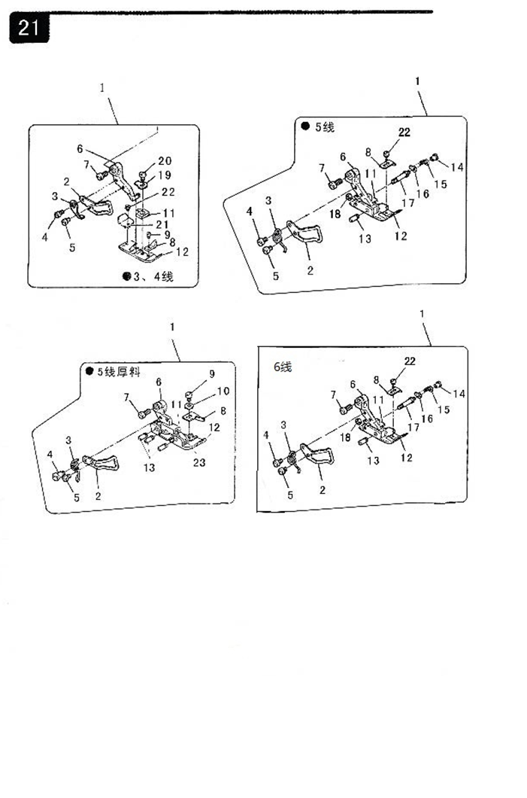
21.压脚部分
序号 | 图号 | 名称 |  | 3 线 | 4 线 | 4  宽 | 5 线 | 5 宽 | 5 厚 | 6  线 | 备注
 |  | 中文 | 英文
1 | 225.21-01A | 压脚组件 | Presser Foot Components | 1
 | 296.21-01 | 压脚组件 | Presser Foot Components |  | 1
 | 263.21-01A | 压脚组件 | Presser Foot Components |  |  | 1
 | 203.21-01 | 压脚组件 | Presser Foot Components |  |  |  | 1
 | 204.21-01 | 压脚组件 | Presser Foot Components |  |  |  |  |  | 1
 | 205.21-01 | 压脚组件 | Presser Foot Components |  |  |  |  | 1
 | 206.21-01 | 压脚组件 | Presser Foot Components |  |  |  |  |  |  | 1
2 | 201.21-01-01 | 护指器 | Stopper | 1 | 1 | 1
 | 203.21-01-01 | 护指器 | Stopper |  |  |  | 1 | 1 |  | 1
 | 204.21-01-01 | 护指器 | Stopper |  |  |  |  |  | 1
3 | 201.21-01-02 | 压脚弹簧 | Presser Foot Spring | 1 | 1 | 1
 | 203.21-01-02 | 压脚弹簧 | Presser Foot Spring |  |  |  | 1 | 1 |  | 1
 | 204.21-01-02 | 压脚弹簧 | Presser Foot Spring |  |  |  |  |  | 1
4 | 01-503000521-1 | 压脚弹簧固定螺钉 | Setscrew | 1 | 1 | 1 | 1 | 1 | 1 | 1
5 | 01-503000421-1 | 护指器固定螺钉 | Setscrew | 1 | 1 | 1 | 1 | 1 | 1 | 1
6 | 201.21-01-05 | 压脚柄 | Presser Foot Crank | 1 | 1 | 1
 | 203.21-01-05 | 压脚柄 | Presser Foot Crank |  |  |  | 1 |  |  | 1
 | 204.21-01-05 | 压脚柄 | Presser Foot Crank |  |  |  |  |  | 1
 | 205.21-01-05 | 压脚柄 | Presser Foot Crank |  |  |  |  | 1
7 | 01-535000821-1 | 压脚柄固定螺钉 | Screw | 1 | 1 | 1 | 1 | 1 | 1 | 1
8 | 201.21-01-07 | 压脚小舌 | Stitch Tongue | 1 | 1 | 1
 | 203.21-01-07 | 压脚小舌 | Stitch Tongue |  |  |  | 1 | 1
 | 204.21-01-07 | 压脚小舌 | Stitch Tongue |  |  |  |  |  | 1
 | 206.21-01-07 | 压脚小舌 | Stitch Tongue |  |  |  |  |  |  | 1
9 | 02-506560421-1 | 压脚小舌固定螺钉 | Stitch Tongue Setscrew | 1 | 1 | 1 |  |  | 1
10 | 204.21-01-09 | 压脚小舌固定螺钉垫片 | Gasket |  |  |  |  |  | 1
11 | 201.21-01-10 | 小压脚 | Presser Foot (small) | 1
 | 202.21-01-10 | 小压脚 | Presser Foot (small) |  | 1 | 1
 | 263.21-01-10 | 小压脚 | Presser Foot (small)
 | 203.21-01-10 | 小压脚 | Presser Foot (small) |  |  |  | 1 |  |  | 1
 | 204.21-01-10 | 小压脚 | Presser Foot (small) |  |  |  |  |  | 1
 | 205.21-01-10 | 小压脚 | Presser Foot (small) |  |  |  |  | 1
21.压脚部分
序号 | 图号 | 名称 |  | 3 线 | 4 线 | 4  宽 | 5 线 | 5 宽 | 5 厚 | 6  线 | 备注
 |  | 中文 | 英文
12 | 226.21-01-11 | 压脚底板 | Presser Foot Plate | 1 | 1 | 1
 | 203.21-01-11 | 压脚底板 | Presser Foot Plate |  |  |  | 1
 | 204.21-01-11 | 压脚底板 | Presser Foot Plate |  |  |  |  |  | 1
 | 205.21-01-11 | 压脚底板 | Presser Foot Plate |  |  |  |  | 1
 | 206.21-01-11 | 压脚底板 | Presser Foot Plate |  |  |  |  |  |  | 1
13 | 203.21-01-12 | 压脚底板连接螺钉 | Screw |  |  |  | 1 | 1 |  | 1
 | 204.21-01-12 | 压脚底板连接螺钉 | Screw |  |  |  |  |  | 1
14 | 203.21-01-13 | 小压脚固定螺母 | Nut |  |  |  | 1 | 1 |  | 1
15 | 203.21-01-14 | 小压脚弹簧 | Presser Foot Spring |  |  |  | 1 | 1 |  | 1
16 | 203.21-01-15 | 小压脚弹簧定位片 | Positioning Plate |  |  |  | 1 | 1 |  | 1
17 | 203.21-01-16 | 小压脚活动轴 | Moving Shaft |  |  |  | 1 | 1 |  | 1
18 | 203.21-01-17 | 锁紧螺母 | Setscrew |  |  |  | 1 | 1 |  | 1
19 | 201.21-01-18 | 压脚柄压板 | Presser Plate | 1 | 1 | 1
20 | 02-508440623-1 | 压脚柄压板固定螺钉 | Setscrew | 1 | 1 | 1
21 | 201.21-01-20G | 挡布板 | Retainer | 1 | 1 | 1
22 | 02-506560321-1 | 挡布板固定螺钉 | Setscrew | 1 | 1 | 1 | 1 | 1 |  | 1
23 | 204.21-01-22 | 压脚支撑板 | Presser Foot Support Plate |  |  |  |  |  | 1

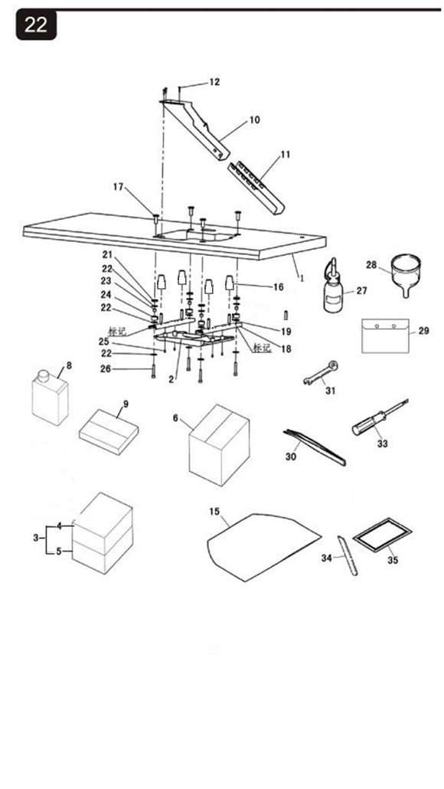
22.附件部分(1)
序 号 |  | 图号 | 名称 |  | 3  线 | 4  线 | 4  宽 | 5  线 | 5  宽 | 5  厚 | 6  线 | 备  注
 |  |  | 中文 | 英文
1 |  | 210.22-01E | 台板 | Table(Semi-Sunken) | 1 | 1 | 1 | 1 | 1 | 1 | 1
 |  | 210.22-01G | 台板 | Table(Semi-Sunken) | 1 | 1 | 1 | 1 | 1 | 1 | 1 | 普通型用
2 |  | 209.22-15 | 台板托盘 | Frame Holding Plate | 1 | 1 | 1 | 1 | 1 | 1 | 1
3 |  | 296.22-03 | 泡沫箱组件 | Foam Box ASM | 1 | 1 | 1 | 1 | 1 | 1 | 1
4 |  | 295.22-03-01 | 泡沫箱（上） | Foam Box (Up) | 1 | 1 | 1 | 1 | 1 | 1 | 1
5 |  | 295.22-03-02 | 泡沫箱（下） | Foam Box (Down) | 1 | 1 | 1 | 1 | 1 | 1 | 1
6 |  | 296.22-04 | 外包装箱 | Packing Box (Outside) | 1 | 1 | 1 | 1 | 1 | 1 | 1
8 |  | 201.22-06A | 大油壶 | Oil pot | 1 | 1 | 1 | 1 | 1 | 1 | 1
9 |  | HX-1C（C） | 三线大附件箱组件（8V） | Big Accessories Box Asm | 1
 |  | HX-2C（C） | 四线大附件箱组件（8V ） | Big Accessories Box Asm |  | 1 | 1
 |  | HX-3C（C） | 五线大附件箱组件（8V ） | Big Accessories Box Asm |  |  |  | 1
 |  | HX-4C（C） | 五线厚料大附件箱组件（8V ） | Big Accessories Box Asm |  |  |  |  |  | 1
 |  | HX-5C（C） | 六线大附件箱组件（8V ） | Big Accessories Box Asm |  |  |  |  |  |  | 1
 |  | HX-8C(D) | 三线大附件箱组件（8V ） | Big Accessories Box Asm | 1
 |  | HX7C(KSC) | 四线大附件箱组件（KSC）
 |  | HX-9C(D) | 四线大附件箱组件（8V ） | Big Accessories Box Asm |  | 1 | 1
 |  | HX-10C(D) | 五线大附件箱组件（8V ） | Big Accessories Box Asm |  |  |  | 1 | 1
 |  | HX-11C(D) | 五线厚料大附件箱组件（8V ） | Big Accessories Box Asm |  |  |  |  |  | 1
 |  | HX-12C(D) | 六线大附件箱组件（8V） | Big Accessories Box Asm |  |  |  |  |  |  | 1
10 |  | 201.22-07-02 | 漏斗槽上段 | Cloth Waste Chute Upper | 1 | 1 | 1 | 1 | 1 | 1 | 1
11 |  | 201.22-07-03 | 漏斗槽下段 | Cloth Waste Chute Lower | 1 | 1 | 1 | 1 | 1 | 1 | 1
12 |  | 21-2350162-4 | 漏斗槽上段螺钉 | Setscrew | 3 | 3 | 3 | 3 | 3 | 3 | 3
22.附件部分(1)
序号 | 图号 |  | 名称 |  | 3 线 | 4 线 | 4  宽 | 5 线 | 5 宽 | 5 厚 | 6  线 | 备注
 |  |  | 中文 | 英文
13 | HXT12-1(UTC) |  | 附件箱组件 | Small Accessories Box Asm | 1 | 1 | 1 | 1 | 1 | 1 | 1
14 | 295.22-07-10-01 |  | 附件箱（D) | Small Accessories Box (D) | 1 | 1 | 1 | 1 | 1 | 1 | 1
15 | 201.22-07-08-02 |  | 防尘罩 | Dust-Proof Cap | 1 | 1 | 1 | 1 | 1 | 1 | 1
16 | 201.22-07-08-03A |  | 托盘防震连接垫 | Dust-Proof Rubber | 4 | 4 | 4 | 4 | 4 | 4 | 4
17 | 201.22-07-08-04 |  | 台板固定螺套 | Holding Plate Bolt | 4 | 4 | 4 | 4 | 4 | 4 | 4
18 | 209.22-11 |  | 托架 | Bracket | 2 | 2 | 2 | 2 | 2 | 2 | 2
19 | 209.22-16 |  | 固定套 | Fixed Sleece | 4 | 4 | 4 | 4 | 4 | 4 | 4
20 | 209.22-14 |  | 定位螺钉销 | Positioning Screw Pin | 4 | 4 | 4 | 4 | 4 | 4 | 4
21 | 311.20-14 |  | 垫片1 | Gasket 1 | 4 | 4 | 4 | 4 | 4 | 4 | 4
22 | 311.20-15 |  | 垫片2 | Gasket 2 | 12 | 12 | 12 | 12 | 12 | 12 | 12
23 | 311.20-16 |  | 内套 | Inner Sleeve | 4 | 4 | 4 | 4 | 4 | 4 | 4
24 | 311.20-17 |  | 橡胶套 | Rvbber Sleeve | 4 | 4 | 4 | 4 | 4 | 4 | 4
25 | 01-404000823-1 |  | 托盘螺钉 | Tray Screw | 4 | 4 | 4 | 4 | 4 | 4 | 4
26 | 01-508004524-1 |  | 台板托盘螺钉 | Fram Holding Plate Screw | 4 | 4 | 4 | 4 | 4 | 4 | 4
27 | 201.22-07-08-09 |  | 小油壶 | Oil Container | 1 | 1 | 1 | 1 | 1 | 1 | 1
28 | 201.22-07-08-10 |  | 油漏斗 | Oil Funnel | 1 | 1 | 1 | 1 | 1 | 1 | 1
29 | 201.22-07-08-11 |  | 附件袋 | Accessories Bag | 1 | 1 | 1 | 1 | 1 | 1 | 1
30 | 201.22-07-08-13 |  | 镊子 | Tweezers | 1 | 1 | 1 | 1 | 1 | 1 | 1
31 | 201.22-07-08-14 |  | 双头扳手S8 | Double-ended Spanner S8 | 1 | 1 | 1 | 1 | 1 | 1 | 1
33 | 201.22-07-08-16 |  | 有柄内六角扳手S1.5 | Hexagon Spanner S1.5 | 1 | 1 | 1 | 1 | 1 | 1 | 1
34 | 201.11-21 |  | 下切刀 | Knife | 1 | 1 | 1 | 1 | 1 | 1 | 1
35 | 201.05-32G |  | 机针（DCX27#11) | Needle | 2 | 2 | 2 |  |  |  | 3
 | 203.05-32 |  | 机针（DCX27#14) | Needle |  |  |  | 2 | 2
 | 204.05-32 |  | 机针（DCX27#21) | Needle |  |  |  |  |  | 2

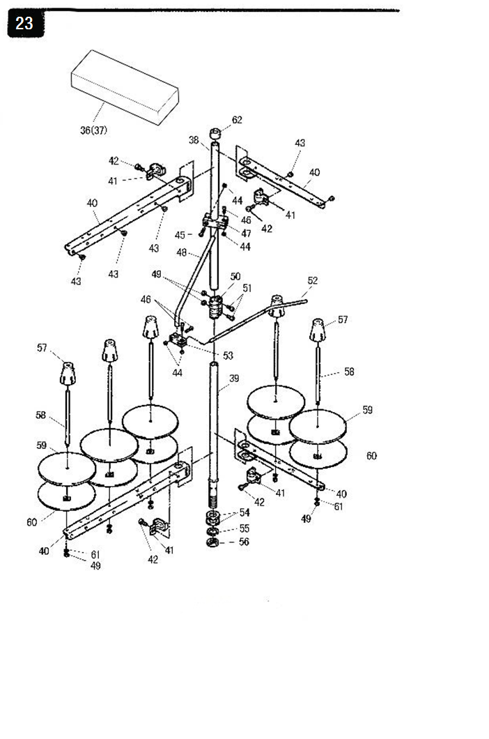
23.附件部分（2）
序号 | 图号 | 名称 |  | 3  线 | 4  线 | 4  线 | 5  线 | 5  宽 | 5  厚 | 6  线 | 备注
 |  | 中文 | 英文
36 | 201.22-07-09 | 中附件箱组件 | Center Accessories Box ASM | 1
 | 202.22-07-09 | 中附件箱组件 | Center Accessories Box ASM |  | 1 | 1
 | 203.22-07-09 | 中附件箱组件 | Center Accessories Box ASM |  |  |  | 1 | 1 | 1
 | 206.22-07-09 | 中附件箱组件 | Center Accessories Box ASM |  |  |  |  |  |  | 1
37 | 201.22-07-09-01 | 中附件箱（B） | Center Accessories Box (B) | 1 | 1 | 1 | 1 | 1 | 1 | 1
38 | 201.22-07-09-02 | 线架上管 | Thread Standing Pipe (upper) | 1 | 1 | 1 | 1 | 1 | 1 | 1
39 | 201.22-07-09-03 | 线架下管 | Thread Standing Pipe (lower) | 1 | 1 | 1 | 1 | 1 | 1 | 1
40 | 201.22-07-09-04 | 过线臂（长） | Thread Guide Arm (long) | 2 |  |  | 2 | 2 | 2 | 2
 | 202.22-07-09-04 | 过线臂（短） | Thread Guide Arm (short) |  | 4 | 4 | 2 | 2 | 2 | 2
41 | 201.22-07-09-05 | 张扣 | Thread Guide Arm Joint | 2 | 4 | 4 | 4 | 4 | 4 | 4
42 | 201.22-07-09-06 | 张扣螺钉 | Thread Guide Arm Joint Screw | 2 | 4 | 4 | 4 | 4 | 4 | 4
43 | 201.22-07-09-07 | 过线磁眼 | Thread Guide Hole | 3 | 4 | 4 | 5 | 5 | 5 | 5
44 | 201.22-07-09-08 | 螺母 | Nut | 2 | 4 | 4 | 4 | 4 | 4 | 4
45 | 201.22-07-09-09 | 大固定夹螺钉A | Setscrew A | 1 | 1 | 1 | 1 | 1 | 1 | 1
46 | 201.22-07-09-10 | 固定夹螺钉B | Setscrew B | 3 | 3 | 3 | 3 | 3 | 3 | 3
47 | 201.22-07-09-11 | 大固定夹 | Thread Standing Guide Base(big) | 1 | 1 | 1 | 1 | 1 | 1 | 1
48 | 201.22-07-09-12 | 固定夹连接杆 | Thread Standing Guide Arm | 1 | 1 | 1 | 1 | 1 | 1 | 1
49 | 201.22-07-09-13 | 螺母 | Nut | 5 | 5 | 5 | 7 | 7 | 7 | 7
50 | 201.22-07-09-14 | 上下管接头 | Thread Standing Rod Joint | 1 | 1 | 1 | 1 | 1 | 1 | 1
51 | 201.22-07-09-15 | 接头螺钉 | Screw | 2 | 2 | 2 | 2 | 2 | 2 | 2
52 | 201.22-07-09-16 | 穿线杆 | Thread Standing Thread Guide | 1 | 1 | 1 | 1 | 1 | 1 | 1
53 | 201.22-07-09-17 | 小固定夹 | Thread Standing Guide Base(small) | 1 | 1 | 1 | 1 | 1 | 1 | 1
54 | 201.22-07-09-18 | 下管垫片 | Washer | 2 | 2 | 2 | 2 | 2 | 2 | 2
55 | 201.22-07-09-19 | 弹簧垫 | Spring Washer | 1 | 1 | 1 | 1 | 1 | 1 | 1
56 | 201.22-07-09-20 | 大螺母 | Big Nut | 1 | 1 | 1 | 1 | 1 | 1 | 1
57 | 201.22-07-09-21 | 线圈芯 | Spool Retainer | 3 | 4 | 4 | 5 | 5 | 5 | 5
58 | 201.22-07-09-22 | 线圈轴 | Spool Pin | 3 | 4 | 4 | 5 | 5 | 5 | 5
59 | 201.22-07-09-23 | 线盘垫 | Spool Rest Cushion | 3 | 4 | 4 | 5 | 5 | 5 | 5
60 | 201.22-07-09-24 | 线盘 | Spool Rest | 3 | 4 | 4 | 5 | 5 | 5 | 5
61 | 201.22-07-09-25 | 弹性垫圈 | Spring Washer | 3 | 4 | 4 | 5 | 5 | 5 | 5
62 | 201.22-07-09-26 | 上管盖帽 | Thread Stand Rod Rubber Cap | 1 | 1 | 1 | 1 | 1 | 1 | 1

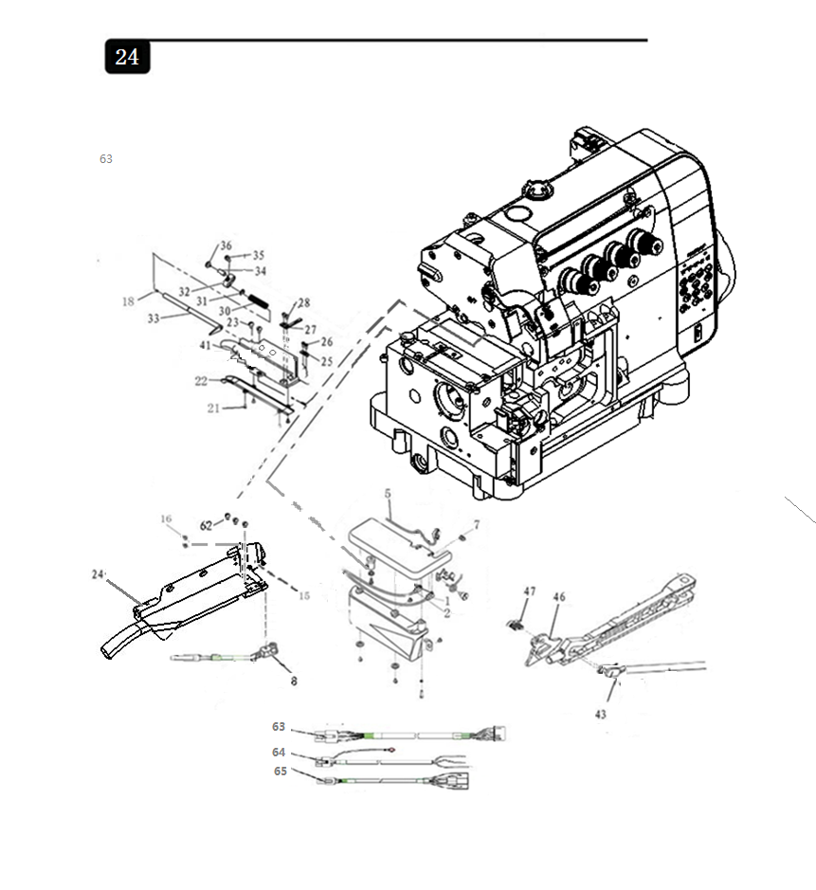
24.自动感应器部分(1）
序  号 | 图号 | 名称 |  | 3 线 | 4 线 | 4宽 | 5 线 | 5 宽 | 5 厚 | 6 线 | 备  注
 |  | 中文 | 英文
1 | 30049963 | 前感应器 | Before the sensor housing | 1 | 1 | 1 | 1 | 1 | 1 | 1
2 | 30049964 | 中感应器 | After the sensor housing | 1 | 1 | 1 | 1 | 1 | 1 | 1
5 | 296.34-39-00 | 缝台安全开关组件（霍尔） | Safety Switch ASM | 1 | 1 | 1 | 1 | 1 | 1 | 1
7 | 01-40400823-1 | 螺钉 | Screw | 1 | 1 | 1 | 1 | 1 | 1 | 1
8 | 296.33-09 | 接受光眼组件) | Incept Sensor ASM | 1 | 1 | 1 | 1 | 1 | 1 | 1
9 | 210.27-07 | 安全开关外罩 | Safety Switch Housing | 1 | 1 | 1 | 1 | 1 | 1 | 1
10 | 01-403001022-3 | 螺钉 | Screw | 2 | 1 | 1 | 1 | 1 | 1 | 1
11 | 03-603000240-3 | 六角螺母 | Nut | 2 | 1 | 1 | 1 | 1 | 1 | 1
12 | 01-1030006232-3 | 螺钉 | Screw | 2 | 1 | 1 | 1 | 1 | 1 | 1
13 | HXTD8-14 | 接收感应器组件 | Incept Sensor ASM | 1 | 1 | 1 | 1 | 1 | 1 | 1
15 | 296.33-12-05 | 吸风挡布板 | Suction guide plate cutting line | 1 | 1 | 1 | 1 | 1 | 1 | 1
 | 293.27-23 | 定刀定位板 | Suction guide plate cutting line | 1 | 1 | 1 | 1 | 1 | 1 | 1
16 | 01-503000521-1 | 开槽圆柱头螺钉 | Screw | 2 | 2 | 2 | 2 | 2 | 2 | 2
21 | 01-103000421-1 | 一字槽沉头螺钉 | Screw | 4 | 4 | 4 | 4 | 4 | 4 | 4
22 | 296.33-12-03 | 吸风管 | Suction Tube Cover | 1 | 1 | 1 | 1 | 1 | 1 | 1
23 | 01-503000421-1 | 开槽圆柱头螺钉 | Screw | 2 | 2 | 2 | 2 | 2 | 2 | 2
24 | 296.33-12 | 刀组组件 | Suction Guide Plate Cutting Line | 1 | 1 | 1 | 1 | 1 | 1 | 1 | 三光眼
25 | 296.33-12-09 | 定刀压板 | Adjust The Fixed Knife Block | 1 | 1 | 1 | 1 | 1 | 1 | 1
26 | 01-503000821-1 | 螺钉 | Screw | 2 | 2 | 2 | 2 | 2 | 2 | 2
27 | 296.33-12-08 | 定刀 | Fixed Knife | 1 | 1 | 1 | 1 | 1 | 1 | 1
28 | 01-103000621-1 | 开槽圆柱头螺钉 | Screw | 2 | 2 | 2 | 2 | 2 | 2 | 2
30 | 296.33-12-11 | 切刀压簧 | Cutter Pressure Spring | 1 | 1 | 1 | 1 | 1 | 1 | 1
31 | 06×0.8×10 | 动刀弹簧挡圈 | Mobile Knife Spring Ring | 1 | 1 | 1 | 1 | 1 | 1 | 1
32 | 246.27-17 | 切刀连杆 | Cutter Link | 1 | 1 | 1 | 1 | 1 | 1 | 1
33 | 296.33-12-10 | 动刀 | Mobile Knife | 1 | 1 | 1 | 1 | 1 | 1 | 1
34 | 210.27-18A | 切刀连杆销 | Cutter Link Pin | 1 | 1 | 1 | 1 | 1 | 1 | 1
35 | 01-504000824-1 | 内六角圆柱头螺钉 | Screw | 1 | 1 | 1 | 1 | 1 | 1 | 1
36 | 210.27-18A | 切刀连杆销螺钉 | Screw | 1 | 1 | 1 | 1 | 1 | 1 | 1
41 | 07-0631616-1 | 弹簧垫片 | Spring Washer | 2 | 2 | 2 | 2 | 2 | 2 | 2
46 | 249.27-04 | 护片 | Conservation Piece | 1 | 1 | 1 | 1 | 1 | 1 | 1
47 | 01-503000621-1 | 螺钉 | Screw | 2 | 2 | 2 | 2 | 2 | 2 | 2
63 | X-05-41D | 机头连接线 | Nose Connection | 1 | 1 | 1 | 1 | 1 | 1 | 1 | 三光眼
 | X-05-41E | 机头连接线 | Nose Connection | 1 | 1 | 1 | 1 | 1 | 1 | 1 | 二光眼
64 | 30050266 | 电控电源输入线 | Electrical Power Supply Input Line | 1 | 1 | 1 | 1 | 1 | 1 | 1
65 | 30050349 | 脚踏控速器转接线 | Foot Control Speed Switch Wiring | 1 | 1 | 1 | 1 | 1 | 1 | 1

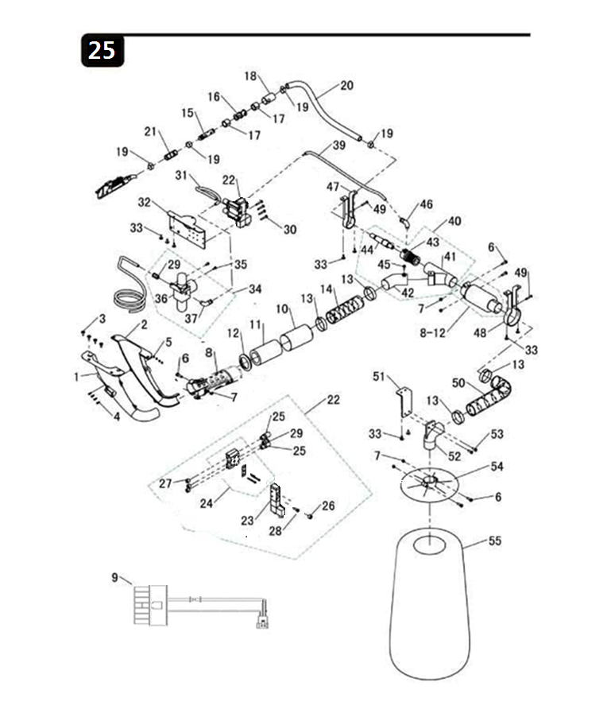

25.吸尘部分（1）
序号 | 图号 | 名称 |  | 3 线 | 4 线 | 5 线 | 5 宽 | 5 厚 | 6 线 | 备注
 |  | 中文 | 英文
1 | 246.28-03-01 | 吸风口L | Suction air L | 1 | 1 | 1 | 1 | 1 | 1
2 | 246.28-03-02 | 吸风口R | Suction air R | 1 | 1 | 1 | 1 | 1 | 1
3 | 21-2350162-4 | 十字槽木螺钉 | Screw | 4 | 4 | 4 | 4 | 4 | 4
4 | 01-403001022-3 | 十字槽盘头螺钉 | Screw | 4 | 4 | 4 | 4 | 4 | 4
5 | 03-603000240-3 | 六角螺母 | Nut | 4 | 4 | 4 | 4 | 4 | 4
6 | 01-405002022-3 | 十字盘头螺钉M5*20 | Screw | 4 | 4 | 4 | 4 | 4 | 4
7 | 03-605000450-3 | 六角螺母 | Nut | 4 | 4 | 4 | 4 | 4 | 4
8 | 210.28-05-01A | 消音管 | Silencer Tube | 2 | 2 | 2 | 2 | 2 | 2
9 | X-05-40A | 电磁阀转接线（一阀） | Solenoid Valve Transfer Connection(Three Valve） | 1 | 1 | 1 | 1 | 1 | 1
 | X-05-40C | 电磁阀转接线（二阀） | Solenoid Valve Transfer Connection(Four Valve） | 1 | 1 | 1 | 1 | 1 | 1 | 侧吸
10 | 210.28-05-03 | 消音外壳盖 | Silencer Outer Covering | 2 | 2 | 2 | 2 | 2 | 2
11 | 210.28-05-04 | 消音管吸音绵 | Sound-absorbing Cotton | 2 | 2 | 2 | 2 | 2 | 2
12 | 210.28-05-05 | 消音外壳 | Silencer Outer Covering | 2 | 2 | 2 | 2 | 2 | 2
13 | 210.28-22 | 喉咕 | Throat Cushions | 4 | 4 | 4 | 4 | 4 | 4
14 | 210.28-24-01 | 螺旋软管38*150mm | Spiral Hose | 1 | 1 | 1 | 1 | 1 | 1
15 | 01-404002523-1 | 螺钉 | Screw | 1 | 1 | 1 | 1 | 1 | 1
16 | 210.28-24 | 螺旋软管38*320mm | Spiral Hose | 1 | 1 | 1 | 1 | 1 | 1
17 | 246.28-06 | 气管连接器支撑板 | Tracheal Connector Support Board | 1 | 1 | 1 | 1 | 1 | 1
18 | 246.28-65 | 吸风孔转接管 | Suction Connetor | 1 | 1 | 1 | 1 | 1 | 1
19 | 210.28-23 | 喉咕 | Throat Cushions | 2 | 2 | 2 | 2 | 2 | 2
20 | 210.28-24-01 | 螺旋软管(小) | Spiral Hose | 1 | 1 | 1 | 1 | 1 | 1
21 | 246.28-67 | 连接器支架2 | Connector Bracket 2 | 1 | 1 | 1 | 1 | 1 | 1
22 | 208.28-20C-00 | 电磁阀组件 | Solenoid Valve ASM | 1 | 1 | 1 | 1 | 1 | 1 | 一阀
 | 296.28-20E-00 | 电磁阀组件 | Solenoid Valve ASM |  |  |  |  |  |  | 二阀
23 | 260.28-20-03A | 电磁阀 | Solenoid Valve | 1 | 1 | 1 | 1 | 1 | 1 | 一阀
 | 260.28-20-03 | 电磁阀 | Solenoid Valve | 1 | 1 | 1 | 1 | 1 | 1 | 二阀
24 | 208.28-20-01 | 电磁阀底座 | Manifold | 1 | 1 | 1 | 1 | 1 | 1 | 一阀
 | 210.28-20-01 | 电磁阀底座 | Manifold | 1 | 1 | 1 | 1 | 1 | 1 | 二阀
序号 | 图号 | 名称 |  | 3 线 | 4 线 | 5 线 | 5 宽 | 5 厚 | 6 线 | 备注
 |  | 中文 | 英文
25 | 260.28-20-06 | 消音器接头 | Plastic Silencer | 2 | 2 | 2 | 2 | 2 | 2
26 | 260.28-20-08 | 堵头 | Plug | 1 | 1 | 1 | 1 | 1 | 1
27 | 260.28-20-04 | 堵头 | Plug | 3 | 3 | 3 | 3 | 3 | 3
28 | 260.28-20-07 | 外螺纹直通 | Screw Thread Straight Union | 2 | 2 | 2 | 2 | 2 | 2
29 | 260.28-20-05 | 外螺纹直通 | Screw Thread Straight | 1 | 1 | 1 | 1 | 1 | 1
30 | 18-404002823-3 | 三组合十字盘头螺钉 | Screw | 4 | 4 | 4 | 4 | 4 | 4
31 | 210.28-33 | PU管8*5*400mm | Pu Pipe(blue)PU8*5*400mm | 1 | 1 | 1 | 1 | 1 | 1
32 | 295.28-09A | 气控磁阀座支撑板 | Air Valve Support Board | 1 | 1 | 1 | 1 | 1 | 1
33 | 20-4421632-3 | 十字槽盘头自攻螺钉 | Screw | 7 | 7 | 7 | 7 | 7 | 7
34 | HX6800-12-10-01 | 过滤减压组件 | Filter-Regulator | 1 | 1 | 1 | 1 | 1 | 1
35 | 18-404000823-3 | 三组合十字一字盘头螺钉 | Screw | 2 | 2 | 2 | 2 | 2 | 2
36 | 78-AW20-02BCG-A | 空气洁净器（带压力表）R1/4' | Filter-Regulator | 1 | 1 | 1 | 1 | 1 | 1
37 | 72-KQ2L08-02S | L型螺纹弯通 | L Thread Bend Pass | 1 | 1 | 1 | 1 | 1 | 1
38 | 30041702 | PU管6*4*600mm | Pu Pipe6*4*600mm | 4 | 4 | 4 | 4 | 4 | 4
39 | 30041701 | PU管6*4*300mm | Pu Pipe6*4*300mm | 1 | 1 | 1 | 1 | 1 | 1
40 | 246.28-07 | 气管连接器组件 | Tracheal Connector ASM | 1 | 1 | 1 | 1 | 1 | 2
41 | 246.28-07-01 | 气管连接器 | Tracheal Connector | 1 | 1 | 1 | 1 | 1 | 1
42 | 246.28-07-02 | 气管转接管 | Tracheal Connector | 1 | 1 | 1 | 1 | 1 | 1
43 | 246.28-07-03 | 吹吸固定套 | Fixed Sets Of Blowing Smoke | 1 | 1 | 1 | 1 | 1 | 1
44 | 246.28-07-04 | 吹吸器 | Blowing And Suction Devise | 1 | 1 | 1 | 1 | 1 | 1
45 | 01-405000823-4 | 螺钉 | Screw | 1 | 1 | 1 | 1 | 1 | 1
46 | 210.28-25 | L型螺纹弯通 | L Thread Bend Pass | 1 | 1 | 1 | 1 | 1 | 1
47 | 246.28-66 | 连接器支架1 | Connector Bracket 1 | 1 | 1 | 1 | 1 | 1 | 1
48 | 246.28-67B | 连接器支架2 | Connector Bracket 2 | 1 | 1 | 1 | 1 | 1 | 1
49 | 01-404002523-1 | 螺钉 | Screw | 1 | 1 | 1 | 1 | 1 | 1
50 | 210.28-24 | 螺旋软管38*320mm | Spiral Hose | 2 | 2 | 2 | 2 | 2 | 2
51 | 246.28-06 | 气管连接器支撑板 | Tracheal Connector Support | 1 | 1 | 1 | 1 | 1 | 1
52 | 210.28-25 | L型螺纹弯通 | L Thread Bend Pass | 1 | 1 | 1 | 1 | 1 | 1
53 | 18-405001422-3 | 三组合十字盘头螺钉 | Screw | 2 | 2 | 2 | 2 | 2 | 2
54 | 210.28-08 | 吸尘桶上盖 | Clearing Barrels Above Cover | 1 | 1 | 1 | 1 | 1 | 1
55 | 210.28-10 | 吸尘袋 | Vacuum Cleaner Bags | 1 | 1 | 1 | 1 | 1 | 1
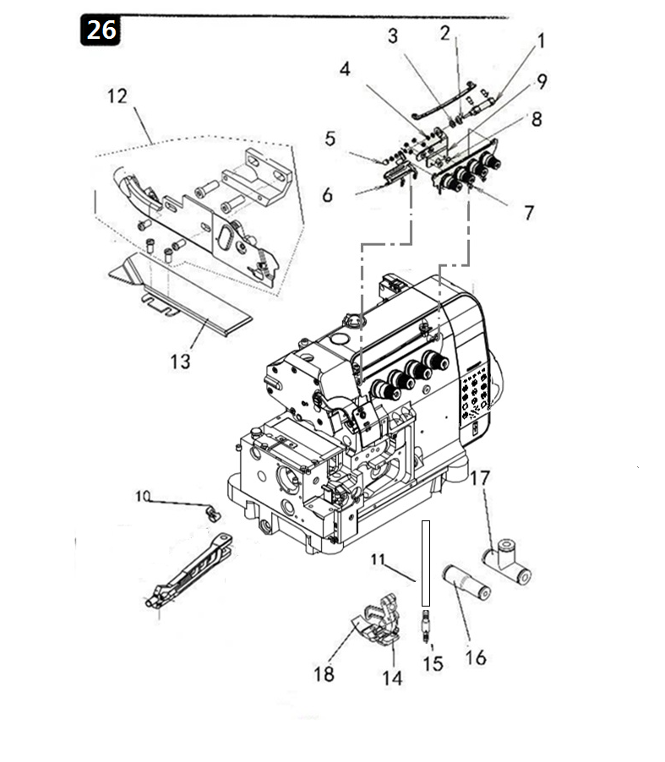
26.HX8V-14-00KSC系列专用件（松线装置）
序号 | 图号 | 名称 |  | 4  线 | 备  注
 |  | 中文 | 英文
1 | 260.30-07A | 气缸组件（松线组件） | Cylinder components (loosing line) | 1
2 | 08-0840815-1 | 波形垫圈 | Elastic Cushion | 1
3 | 03-608000300-2 | 薄帽螺母 | Thin Nut | 1
4 | 03-604000320-1 | 螺母 | Nut | 9
5 | 03-604000702-3 | M4球形螺帽 | Nut | 1
6 | 260.30-07-03 | 松线板 | Loose line panel | 1
7 | 01-104000721-1 | 螺钉 | Screw | 2
8 | 260.30-07-04 | 台螺钉 | Screw | 2
9 | 260.30-07-02 | 气缸支架（松线） | Cylinder bracket (loosing line) | 1
10 | 260.30-23 | 卡簧 | Spring | 2
11 | 103.08-36-1-4A | 油管（透明） | Pipe | 1
12 | 293.30-01 | 侧吸刀组件 | Side suction knife components | 1
13 | 260.30-02 | 下侧板 | Lower side panel | 1
14 | 260.30-03 | 气管接头 | Pipe connector | 1
15 | 226.21-01A-20 | 挡布板组件 | Buffle plate components | 1
16 | 260.30-06 | 直通（6变4) | Straight connector(6 chang 4) | 2
17 | 260.30-05 | 三通快插接头（6) | Tee junction knife components | 1
18 | 296.21-01A | 压脚组件 | Presser foot components | 1
备注：此零件手册仅作参考，如有更改恕不另作通知。

Remarks:This manual is only for reference.

If there is any modification,we apologize for the changing hence caused.

