HIKARI

说明书

OPERATION MANUAL

# 1.说明书HSAT-K7 TAPING MACHINE SPECIALLY FOR ADIDAS OPERATION MANUAL

|  |  |
| --- | --- |
| 涉及产品：MODEL | HSAT-K7阿迪达斯专用滚条机 HSAT-K7 TAPING MACHINE SPECIALLY FOR ADIDAS |
| 文件编号：FILE NO. |  |
| 文件版本：VERSION | A |

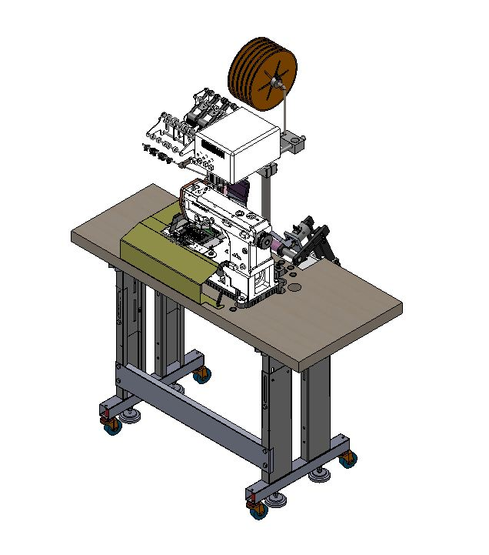

HSAT-K7阿迪达斯专用滚条机

注册人/生产企业：上海富山精密机械科技有限公司

MANUFACTURER: HIKARI(shanghai) PRECISE MACHINERY SCIENCE&TECHNOLOGY CO.,LTD.

企业地址：上海市金山区朱径工业区中达路800号，邮编：201201

ADDRESS: NO.800 ZHONGDA ROAD JINSHAN ZONE SHANGHAI 201500 CHINA

P. C.：201201

联系电话：+86-21-64371111

TEL:+86-21-64371111

传真：+86-21-64371111

FAX: +86-21-64371111

售后服务单位：上海富山精密机械科技有限公司

AFTER-SALE SERVICE DEPARTMENT:HIKARI(shanghai) PRECISE MACHINERY SCIENCE&TECHNOLOGY CO.,LTD.

**目录Content**

1.说明书HSAT-K7 TAPING MACHINE SPECIALLY FOR ADIDAS OPERATION MANUAL 0

2.产品性能指标 Product performance index 3

3.部件及操作使用说明Parts and operation manual 4

3.1部件示意图 Parts of the system diagram 4

3.2屏幕界面操作介绍Operation interface 10

3.3详细使用说明Operation instruction 11

4.电控相关的要求及操作使用注意事项Electrical control related requirements and precautions for operation and use 19

5. 安全注意事项Safety precautions 19

5.1 使用范围Application 19

5.2 工作环境 Working environment 19

5.3 安装 Installation 20

5.4 保养维修的规定 Provisions for maintenance 20

5.5 危险提示Danger notice 21

5.6 其它安全规定 Other safety regulations 22

# 2.产品性能指标[Product performance index](http://www.baidu.com/link?url=30qPYkc4i5BNe9qImtaCjS5u2EyJWHMdhQTWbPJqt6ZlugqZCpQYlln59SQ8a4TBwV8KYa1k4Fv2rz0gniVEyb-WNXpvsq9bT13a1fnaPq_QWvV976qn3t7u7vM_j4yv" \t "https://www.baidu.com/_blank)

|  |  |  |
| --- | --- | --- |
| **项目Project** | **范围Range** | **备注Note** |
| 工作模式**[Operating Mode](http://www.baidu.com/link?url=Gc4e9BKiPsjvSDGXPuPkpu3w2VVu42Zc1A0neYcL95ZPSft38YuRO5n0ay7XhTSisSBzQgpF5klHPvotFUnq2hjpVlCFyfTza4We6VaHd6I3bN6WRruxF8lmVxnZ_Hqk" \t "https://www.baidu.com/_blank)** | 手动模式、自动模式 manual/automatic |  |
| 适用裁片  Fabric piece | 直边裁片、斜边裁片、凸边裁片  Straight edge, beveled edge, convex edge |  |
| 收料功能Collection function | 可设置为开启或关闭。on/off |  |
| 膝控切刀功能Knee controlled trimmer | 可设置打开、关闭功能  on/off |  |
| 送料吹气功能  Air blowing | 可设置打开、关闭功能on/off |  |

# 

# 3.部件及操作使用说明Parts and operation manual

3.1部件示意图Parts of the system diagram

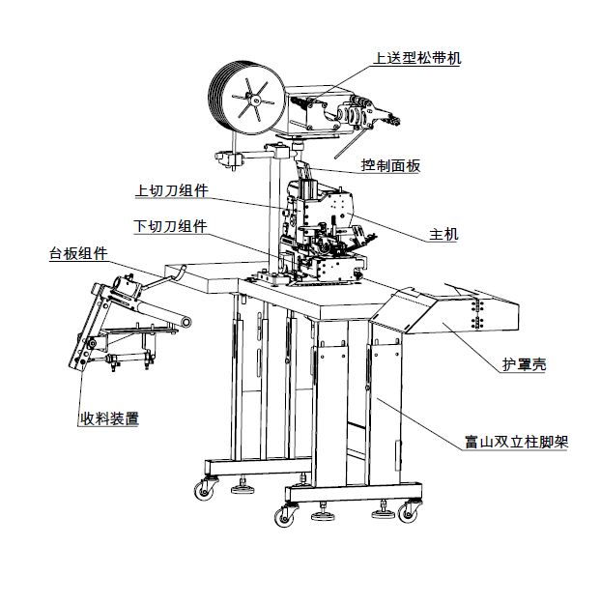

receiving device

Table assembly

Bottom trimmer assembly

Up trimmer assembly

Control panel

Top tape feeding device

Feeding roller

Protectioncover

Hikari double support stand

台板支架 TABLE ASSEMBLY

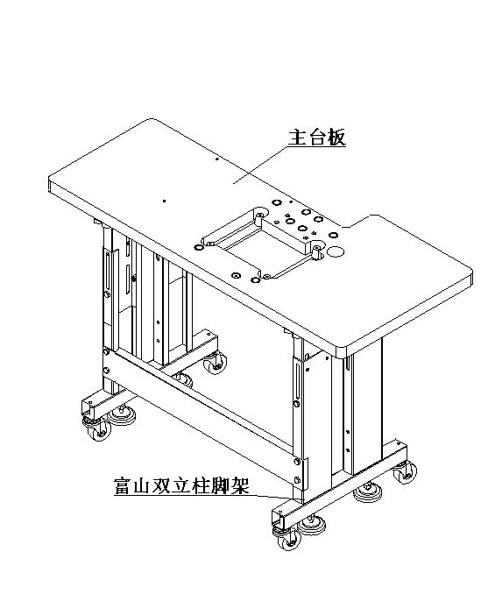

Hikari double support stand

Table

收料装置

Receiving device

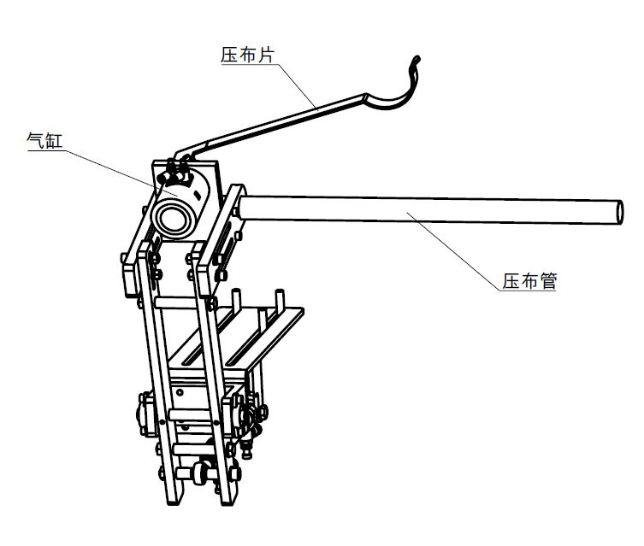

Pipeforfabrics pressing

Pressing cloth sheet

Valve

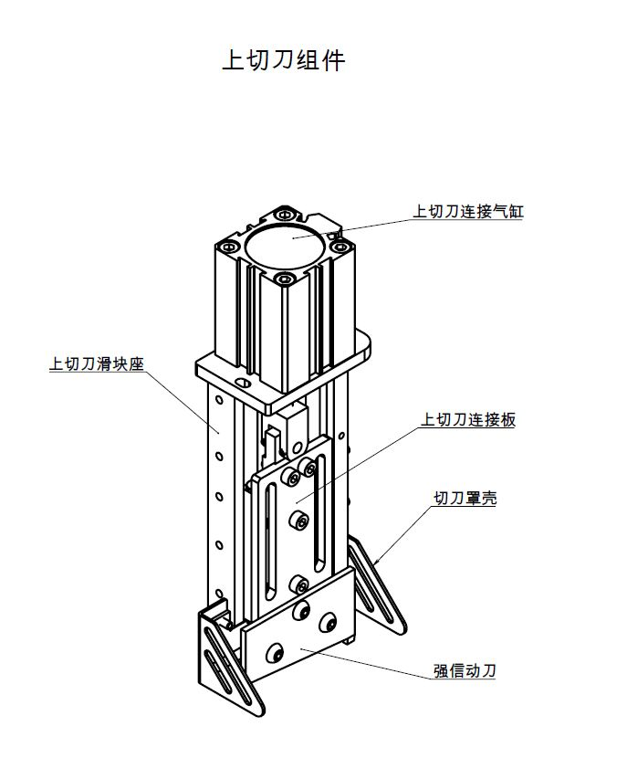

Strong H moveable trimmer

Trimmercover

Up trimmer assembly

Up trimmer connect board

Up trimmer valve

Up trimmer slider base

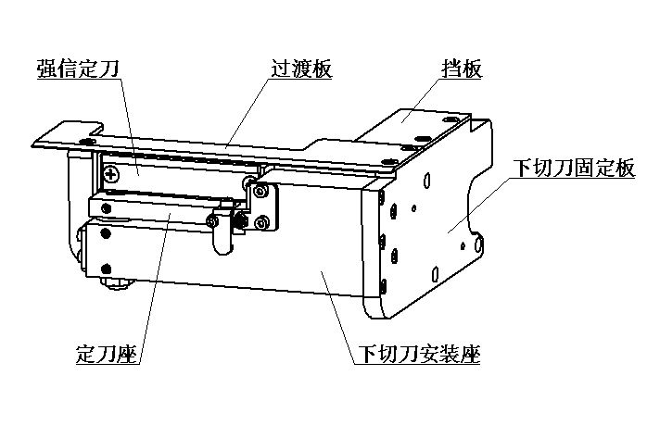

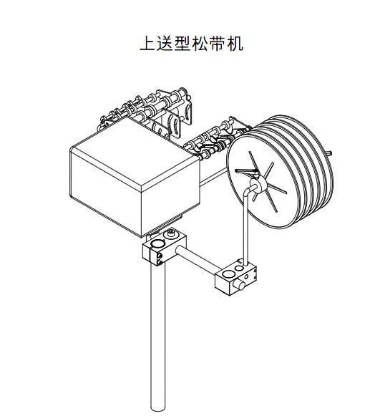

Upper tape feeding machine

## 3.2屏幕界面操作介绍Operation interface

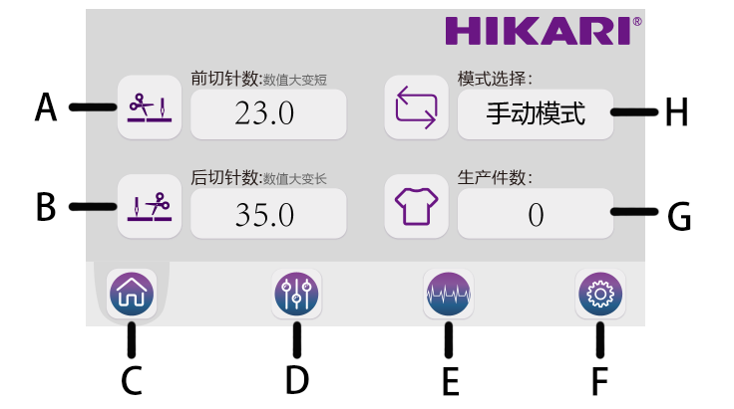

A：前切针数设置 front trimming stitches setting

B：后切针数设置Rear cutting stitches setting

C：主界面 Main interface

D：功能开关Operation functions on/off setting

E：输入输出控制测试 Input/output control test

F：版本信息 Version information

G：生产件数设置 Product quantity setting

H：模式设置 Working mode setting

## 3.3详细使用说明Operation instruction

|  |  |  |
| --- | --- | --- |
| **序号S.N** | **说明NAME** | **备注NOTE** |
| H | 模式设置Working mode setting | 手动模式：普通多针机模式（注：辅助装置功能无效）  自动模式：可开启自动切刀、自动收料、自动吹气功能Manual: normal multi-needle machine mode(note: auxiliary deviceisnoneffective)  Automatic：can use automatic trimmer, automatic receiving and automatic air blowing |
| A | 前切针数设置Front cutting stitches setting | 根据需求选取合适针数，调节分辨率0.1针，数值越大，前切滚条长度越短。  Stitch quantity is adjustable according to use. Resolution adjusted to 0.1 stitch. The higher the value, the shorter of start cutting tap length |
| B | 后切针数设置Rearcuttingstitches | 根据需求选取合适针数，调节分辨率0.1针，数值越大，后切滚条长度越长。  Thenumberofneedlestitchingis adjustable . Resolution adjusted to 0.1 stitch. The larger the value, the longer of end cutting tap length |
| C | 主界面按键Main interface setting | 主界面时，各设置功能生效，非主界面时，各设置功能不生效  All the setting will work when displayed in main interface. Otherwise it doesn’t work. |
| D | 功能开关按键  Operationfunctionson/off setting | 进入各功能设定界面：Enter interface of all functions    点图标，可关闭或打开各功能。Touchicon,tocontroloff/onfunction. |
| 点图标，进入切刀参数设置界面Touch icon, enter trimmer parameter setting interface  F:\03 龙门砍刀\工程\使用说明书\LMKD\裤腰机界面12.18-81.png  P1切刀保留时间：调整切刀开启时间，数值越大，切刀下压时间越长。P1 trimmer continuous time: adjust trimmer start time, the larger the value, the longer cutting press time |
| 点图标，进入吹气参数设置界面touch  to enter air blowing setting interface  F:\03 龙门砍刀\工程\使用说明书\LMKD\裤腰机界面12.18-82.png  P1吹气保留时间：调整吹气时间，数值越大，吹气时间越长，防止滚条卷起。P1 air blowing continuous time: adjust air blowing time, the larger the value, the longer air blowing time, it can avoid tape curling. |
| 点图标，进入收料参数设置界面Touch icon, enter receiving parameter setting interface.    **长收料装置设置参数：setting for long receiving device**  P1收料杆1保留时间：调整收料杆1停留时间，数值越大，停留时间越长。（用于长收料装置设置）  P2收料杆2保留时间：调整收料杆2停留时间，数值越大，停留时间越长。  P1 receiving shaft 1 continuous time: adjust receiving shaft 1 suspend time, the larger the value, the longer suspend time(for long receiving device)  P2 receiving shaft 2 continuous time: adjust receiving shaft 2 suspend time, the larger the value, the longer suspend time.  **短料装置设置参数：setting for short receiving device**  P3杆1进杆2打开时间：调整压杆1打开后多久时间，再让压杆2打开。  P4杆2开启多久吹气：调整压杆开启多久时间进行吹气。  P5切带后吹气多久：调整切带后吹气多久时间。  P6杆2关多久杆1回位：调整压杆2关闭多久时间再关闭压杆1。  P3 shaft 1 enter, shaft 1 turn on time : Adjust the time after pressing rod 1 is open, and then let pressing rod 2 open.  P4 shaft 2 open air blowing start time：adjust the time after pressing rod 2 is open,then start air blowing  P5 air blowing continuous time after cutting: adjust how long the air blowing will continue after cutting  P6 shaft 2 off, then shaft 1 return position: adjust the time after shaft has been turn off, then shaft 1 return position |
| 点图标，进入同步送料参数设置界面touch  icon, enter synchronism feeding setting interface.  F:\03 龙门砍刀\工程\软件\屏幕\屏幕软件\20200325\image\裤腰机界面12.18-11.png  P1同步针距：用于设置同步送带装置与机头针距相匹配。  例：设置3.5，表示针距匹配为3.5mm。  P2高速补偿：补偿，为补偿系数，数值越大同步送带装置高速越快。  P1 Synchronism stitching distance: used to set synchronism feeding device can match stitch distance. For example: if the setting is 3.5, it means stitch distance is 3.5mm.  P2 Compensation for high speed: compensated by using synchronism belt device match machine high speed. It is compensation modulus. The larger the value, the higher speed of synchronism belt device |
| E | 输入输出控制测试按键Input and output control setting | 进入输出控制及输入监控测试界面Enter input and output monitor test device  F:\03 龙门砍刀\工程\使用说明书\LMKD\裤腰机界面12.18-87.png  **输出监控：**点击OFF/ON，可关闭/打开气缸，查看各气缸是否正常工作。  **输入监控：**1、光眼信号：红色：无信号，绿色：有信号  2、膝控输入：红色：无信号，绿色：有信号  3、编码值：数值在0~1439内变化。  Output monitor: click off/on, can turn on /off air valve, check the condition of all air valve.  Inputmonitor:  1、Sensor signal: red,no signal. Green: normal  2、Knee control input:red,no signal. Green: normal  3、Encoding value：range 0~1439 |
| F | 版本信息按键Version information | 进入版本显示及语言设置界面Enter version display and language setting interface  F:\03 龙门砍刀\工程\软件\屏幕\屏幕软件\20200325\image\裤腰机界面12.18-06.png  F:\03 龙门砍刀\工程\使用说明书\LMKD\裤腰机界面12.18-91.png  **语言：**切换显示界面为中文或英文，切换后，重新上电生效。  **版本：**显示各版本信息。  **恢复出厂设置：**各参数将恢复出厂设置。  **P1速度限制：**机器工作于前切或后切动作时，最高速度被限制于此速度 。（点输入框输入密码313321进行设置，输入密码后再进行调整设置可点快捷进入）  Language: can exchange Chinese /English . it can not work without restarting.  Version:display all type version information  P1 speed control: when machineruningatstart or end cutting position, max speed will belimited within this one.(click the screen and enter password 313321 to set, itcan alsouse shortcut key after entering password) |
| G | 生产件数设置Product countingsetting | 进入生产件数及生产目标设置界面Enter product quantity and target setting interface    **F:\03 龙门砍刀\工程\使用说明书\LMKD\裤腰机界面12.18-79.png**  **生产件数：**每生产一件，计数一件，可加减、清零调整数值。  **生产目标：**设置目标件数，当达到生产件数时，会发出提示。点关闭/打开，将关闭/打开提示功能  Product quantity: counting one piece after each production, it can addandreducuenumber or setzeroautomatically  Product target: setting product target, it will note when reach target. Click on/off can turn on/off remindingnotefunction |

# 4.电控相关的要求及操作使用注意事项Electrical control related requirements and precautions for operation and use

主要技术数据Main technical parameter

供电电压范围：AC220V±10%Power supply voltage range: AC220V ± 1 0 %

供电电源频率：50Hz/60HzPower supply frequency: 50Hz / 60Hz

# 5. 安全注意事项Safety precautions

## 5.1 使用范围Application

本伺服控制器是为工业缝纫机开发设计的，如果在其它方面使用，请注意使用者的安全。This servo controller is developed for industrial sewing machines. If it is used in other aspects, please pay attention to the safety of users.

## 5.2 工作环境Working environment

1.2.1 电源电压请遵照电控电压±10%范围内。Power supply voltage should be within ± 10 % of the electronic control voltage .

1.2.2 请远离高频电磁波发射器等，以免所产生的电磁波干扰本控制器而发生错误动作。

 Please stay away from high-frequency electromagnetic wave transmitters, etc., so as to prevent the generated electromagnetic waves from interfering with the controller and causing malfunction.

1.2.3 温湿度 :temperature and humidity degree :

a.请在室温 0°C 以上、 45°C 以下的场所操作。 a. Please operate between0 C and 45 to do the operation.

b.禁止在日光直接照射的场所或室外运作。 b. It is forbidden to operate in a place exposed to direct sunlight or outdoors.

c.请不要过于接近暖气 (电热器) 旁运作。 Please do not be too close to the heating ( electric heater ) to do the operation.

d.请保持 30 % ~ 95 % 相对湿度（无凝露）。Please keep 30% ~ 95% relative humidity (non-condensing).

1.2.4 请不要在可燃气体或爆炸物附近操作。 Please do not operate near flammable gas or explosives.

## 5.3 安装Installation

1.3.1 控制器请遵照说明书进行正确安装。Please install controller correctly according to the instruction.

1.3.2 安装前请先关闭电源并拔掉电源线插头，然后进行安装。Please turn off the power and unplug the power cord before installation, and then install.

1.3.3 装钉电源线时请避免靠近会转动部件，最少要离开3公分以上。When nailing the power cord, please avoid close to the rotating parts, at least 3 cm away.

1.3.4 为防止噪声干扰或触电事故，请将缝纫机、控制箱接地。 To prevent noise interference or electric shock, ground the sewing machine and control box.

1.3.5 打开电源之前，确定此供应电压必须符合电控指定电压±15%范围内。Before turning on the power, make sure that the supply voltage must be within ± 15% of the specified voltage of the electronic control

## 5.4 保养维修的规定Provisions for maintenance

1.4.1 在操作保养或维修动作前，请先关闭电源。Please turn off the power before operating or maintaining.

1.4.2 当翻抬机头，更换机针或穿线时，请确认电源已关闭。When the turn lift the nose, more replacement when a needle or threading, make sure the power is off.

1.4.3 控制箱里面有危险高压电，所以关闭电源后要等 5 分钟以上方可打开控制箱。

There is dangerous high voltage electricity in the control box, so after turning off the power, wait 5 minutes or more to open the control box.

1.4.4 修理及保养的作业，要请经过训练的技术人员执行。repair management and maintenance operations, to ask trained technical personnel to perform the line .

1.4.5 不能在电机及控制箱运转的狀态下进行保养或维修。 not able to operate the motor and the control box shaped into the lower status row maintenance or repair.

1.4.6 所有维修用的零件，须由本公司提供或认可，方可使用。All maintenance parts must be provided or approved by the company before they can be used.

## 5.5 危险提示Danger notice

这个标示符号表示机器在安装时，安全上需要特别加以注意的事项，忽视此标记而进行错误操作可能会导致人员或是机器损伤。This symbol indicates that the machine indicated at the time of installation requires special attention on safety matters, this term indicate forward line mishandling can result in personal injury or machine.

## 5.6 其它安全规定Other safety regulations

1.在第一次接通电源后，请先以低速操作缝纫机并检查转动方向是否正确。

2.缝纫机运转时，请不要去触摸手轮、机针等会动作的部位。

3.所有可动作的部份，必须以所提供的防护装置加以隔离，防止身体接触，请勿在装置内塞入其它物品。

4.请不要在拆下电机护罩及其它安全装置的情形下操作。

5.不要使电机或控制箱掉在地上。

6.不要让茶水等液态物体流入控制箱或电机内部。

**5.6 Other safety regulations**

1.After the power is turned on for the first time, first operate the sewing machine at a low speed and check whether the direction of rotation is correct.

2.The sewing machine operation, please do not go to the site would touch the hand wheel action, machine needles.

3.All part of the operation, must be provided to guard isolated to prevent physical contact, in the apparatus do not plug into other articles.

4.Please not to operate the motor in the case of removing the shield and other security devices.

5. Does not make the motor control box or fall to the ground.

6.Does not make tea and other objects of liquid flow into the interior of the control box or motor.