Shanghai HIKARI Precision Machinery Technology Co., Ltd.

Instruction manual

|  |  |
| --- | --- |
| Products: | HAT-K5A[auto elastic joining machine] |
| File No: |  |
| File version: | A |

|  |  |  |  |  |
| --- | --- | --- | --- | --- |
| History of revision | | | | |
| Version | Revision No. | Descriptions | Date | Author |
| A | / | New file | 25-9-2021 | Zhong Liangcheng |

Auto elastic joining machine

instruction manual

Registered person/Manufacturer: Shanghai HIKARI Precision Machinery Technology Co., Ltd.

Address: No. 800, Zhongda Road, Zhujing Industrial Zone, Jinshan District, Shanghai, Postal Code: 201599

Tel: +86-21-67311111

Fax: +86-21-67311111

Table of contents

[*Before using this product, Please read the followings carefully before use* 1](#_Toc72230574)

[Property indexes 1](#_Toc72230575)

[Parts Info 2](#_Toc72230576)

[Components of machine frame 3](#_Toc72230577)

[Sewing unit 4](#_Toc72230578)

[Material holding units 5](#_Toc72230579)

[Stripping unit 6](#_Toc72230580)

[Ultrasonic cutter units 7](#_Toc72230581)

[Feeding length measuring units 8](#_Toc72230582)

[Material receiving units 9](#_Toc72230583)

[Ironing units 11](#_Toc72230584)

[Pull-through diagram 14](#_Toc72230585)

[Operation interface **错误！未定义书签。**](#_Toc72230586)

[Work interface of the machine **错误！未定义书签。**](#_Toc72230587)

[Working mode selection interface **错误！未定义书签。**](#_Toc72230588)

[Lower thread detection setting interface **错误！未定义书签。**](#_Toc72230589)

[Single-step debugging interface **错误！未定义书签。**](#_Toc72230590)

[Setting interface of machine parameters **错误！未定义书签。**](#_Toc72230591)

[Fault alarming and solution interface 1](#_Toc72230592)9

[Mode setting and operation instructions **错误！未定义书签。**](#_Toc72230593)

[1No logo mode **错误！未定义书签。**](#_Toc72230594)

[2LOGO mode **错误！未定义书签。**](#_Toc72230595)

[2.1Method for calibrating color code sensor: **错误！未定义书签。**](#_Toc72230596)

[2.2Single-stage **错误！未定义书签。**](#_Toc72230597)

[2.3Single-Logo multi-stage **错误！未定义书签。**](#_Toc72230598)

[2.4Multi-Logo **错误！未定义书签。**](#_Toc72230599)

[Electronic control requirements and precautions for use **错误！未定义书签。**](#_Toc72230600)

[Main technical indicators **错误！未定义书签。**](#_Toc72230601)

[1Safety precautions **错误！未定义书签。**](#_Toc72230602)

[1.1Scope of use **错误！未定义书签。**](#_Toc72230603)

[1.2Working environment **错误！未定义书签。**](#_Toc72230604)

[1.3Installation **错误！未定义书签。**](#_Toc72230605)

[1.4Provisions for maintenance **错误！未定义书签。**](#_Toc72230606)

[1.5Danger alert **错误！未定义书签。**](#_Toc72230607)

[1.6Other safety codes **错误！未定义书签。**](#_Toc72230608)

Auto elastic joining machine

# Before using this product, Please read the followings carefully before use。



# Property indexes

|  |  |  |  |
| --- | --- | --- | --- |
| **Property indexes of the auto elastic joining machine** | | | |
|  | Item | Range | Specifications |
| **Process indexes** | Type of elastic band | With or without mark |  |
| Stitch lines | oversewsuperimposed seam |  |
| Type of stitch lines | single needle flat-seaming |  |
| Maximum width of elastic ribbon | 80mm | HAT-K5A-C50YSL  8-50mm standard  HAT-K5A-C80YSL  50-80mm standard |
| Minimum width of elastic ribbon | 6mm |  |
| Minimum length of elastic ribbon | 180mm |  |
| Ironing function | automatic On/Off |  |
| Material receiving function | automatic On/Off |  |
| Operating mode | No Logo  Single-stage  Multi-Stage  Multi- Logo |  |
| cutting-up mode | Ultrasound-edgecold-edge | Optional |
| Marker | automatic On/Off | Optional |
| Top sewing speed | 2800(needle/min) |  |
| **System parameters** | Range of gauge distance | 0.3～12.7 (mm) |  |
| Resolution of gauge distance | 0.1(mm) |  |
| Panel upgrading mode | USB flash disk |  |
| Touch screen | 7 inch touch color screen |  |
| Detection types of broken stitches | digital encoder |  |
| Supply voltage range | 220V/50HZ± 10% |  |
| Rated power | 0.5KW |  |
| Operating temperature | 0℃~45℃ |  |
| Operating humidity | 35%～95%(no condensation) |  |
| Rated air pressure | Equal to or greater than0.5MPa |  |
| Gas consumption | 60(L/MIN) |  |
| Pneumatic components | AIRTAC |  |
| Working air pressure | 86kPa~106kPa |  |

# Parts Info

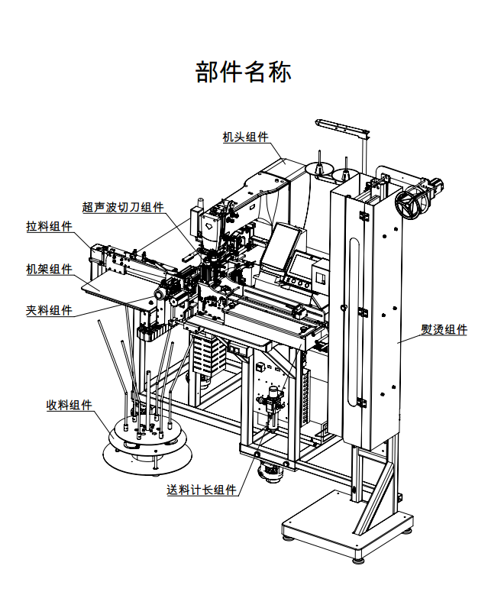

**Parts Info**

|  |  |
| --- | --- |
| 机头组件  超声波切刀组件  拉料组件  机架组件  夹料组件  熨烫组件  收料组件  送料计长组件 | head units  ultrasonic cutter units  [materialstripping](javascript:;) units  machine frame units  material holding units  ironing units  material receiving units  feeding length measuring units |

Components of machine frame

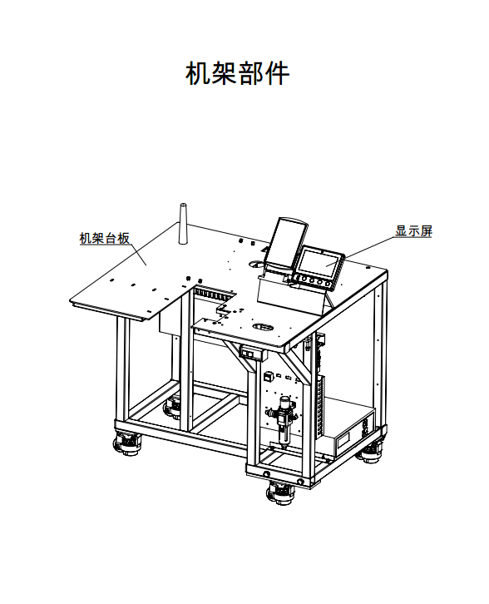

**Components of machine frame**

|  |  |
| --- | --- |
| 机架台板  显示屏 | machine frame table  display screen |

Sewing units

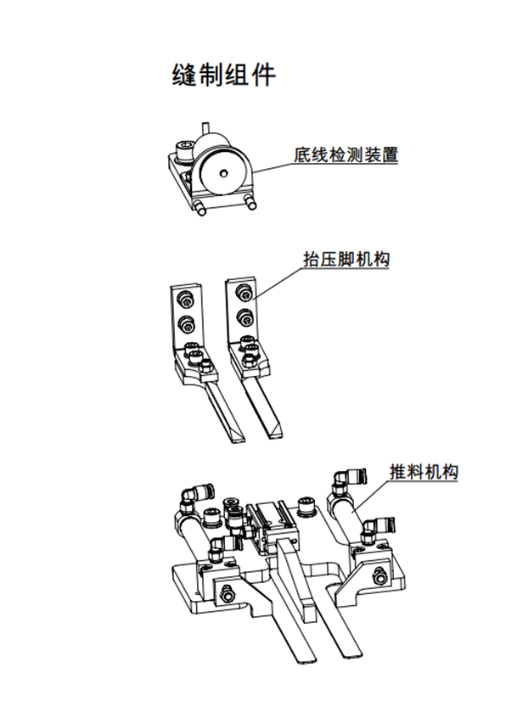

|  |  |
| --- | --- |
| 底线检测装置  抬压脚机构  推料机构 | foundation yarn detection device  presser foot unit  pushing unit |

Material holding units

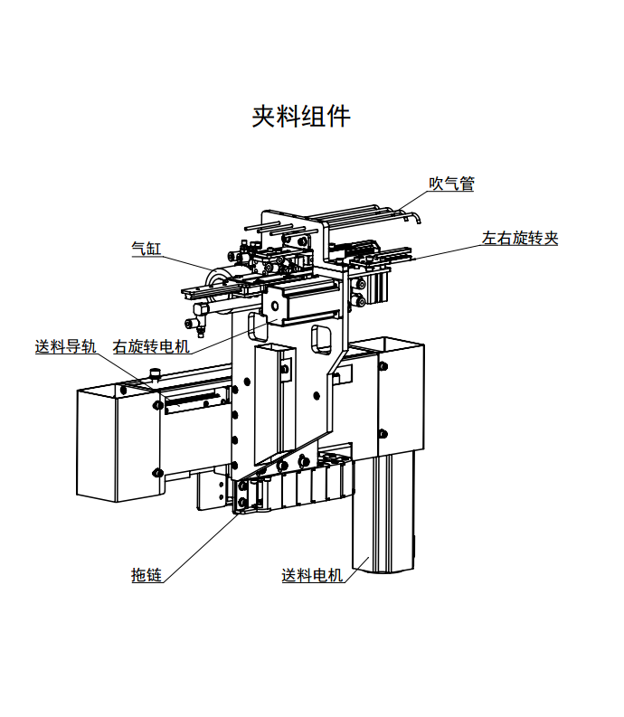

|  |  |
| --- | --- |
| 吹气管  左右旋转夹  气缸  送料导轨  右旋转电机  拖链  送料电机 | blowpipe  left and right rotating clamps  cylinder  feed rail  right rotating motor  drag links  feeding motor |

Material stripping units

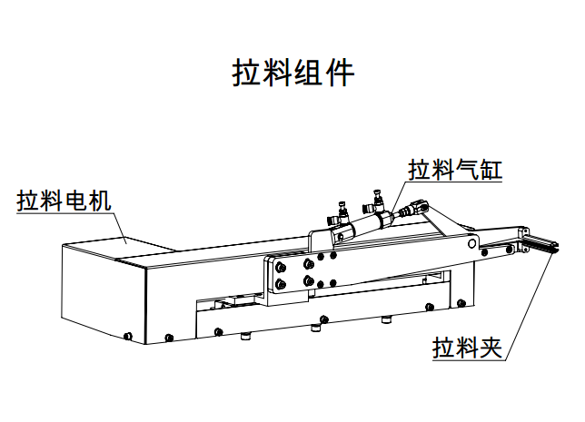

|  |  |
| --- | --- |
| 拉料电机  拉料气缸  拉料夹 | stripping motor  stripping cylinder  stripping clamp |

Ultrasonic cutter units

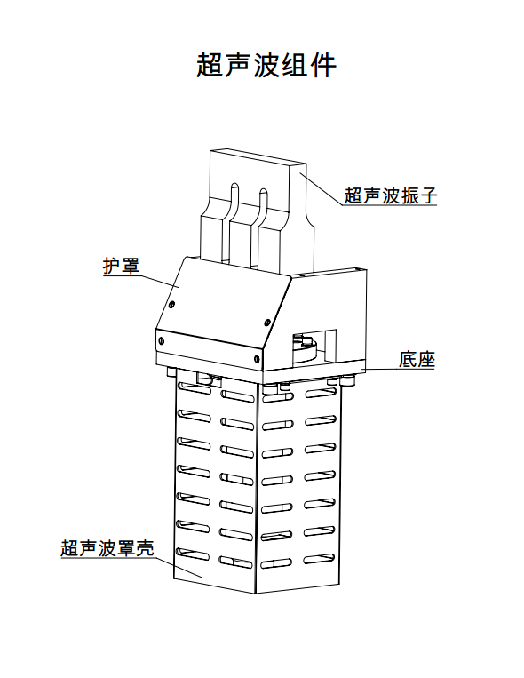

**Ultrasonic cutter units**

|  |  |
| --- | --- |
| 超声波振子  护罩  底座  超声波罩壳 | ultrasonic vibrator  shield  base  ultrasonic casing |

Feeding length measuring units

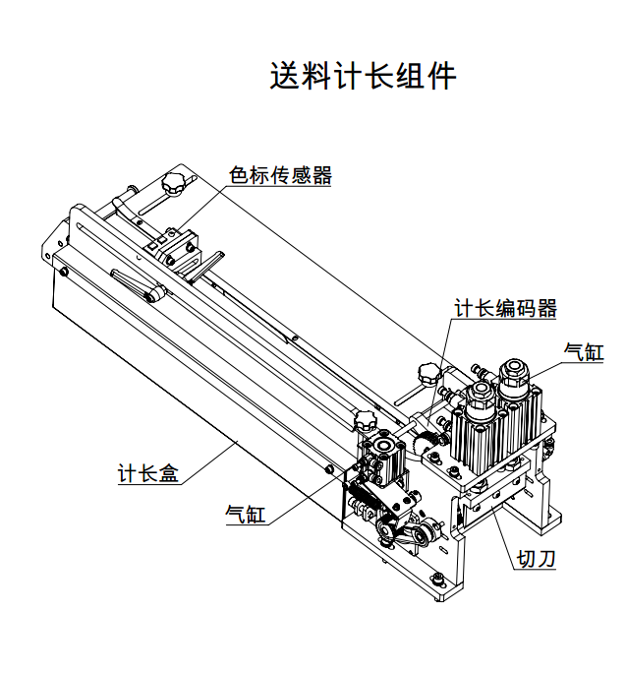

|  |  |
| --- | --- |
| 送料计长组件  色标传感器  计长编码器  气缸  计长盒  切刀 | feeding length measuring units  color code sensor  length encoder  cylinder  length counter  cutter |

Material receiving units

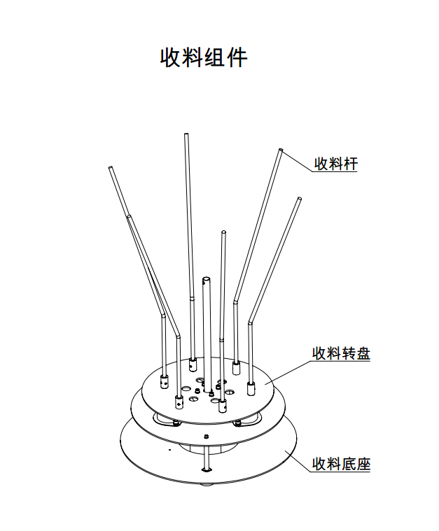

|  |  |
| --- | --- |
| 收料杆  收料转盘  收料底盘 | receiving rod  receiving rotor disc  receiving chassis |

Ironing units

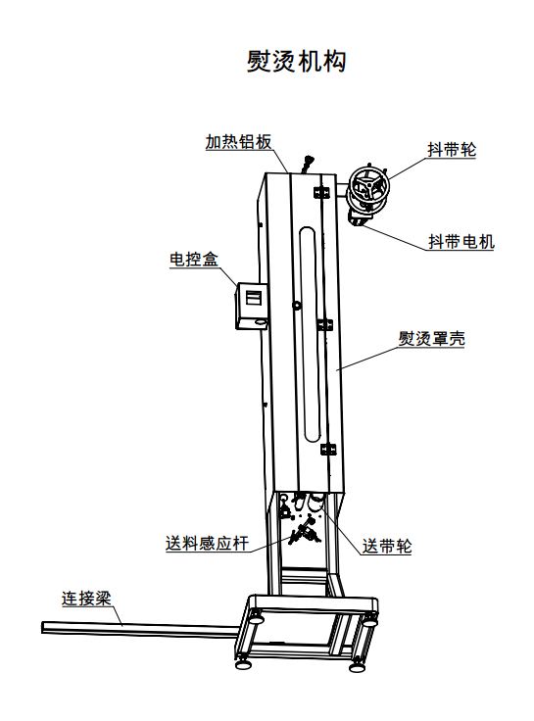

**Ironing units**

|  |  |
| --- | --- |
| 加热铝板  抖带轮  抖带电机  电控盒  熨烫罩壳  送料感应杆  送带轮  连接梁 | heating aluminum plate  shake wheel  shaking motor  electric control box  ironing cover  feeding sensor rod  conveyer wheel  connecting beam |

Pull-through diagram

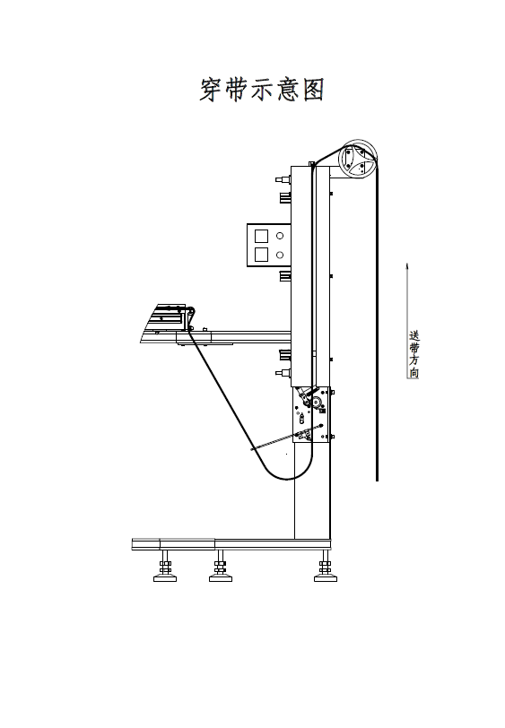

送带方向conveying direction

# Interface description

|  |  |  |  |
| --- | --- | --- | --- |
| Work interface of the machine  1: After powering on the machine, you may see the **main interface** of the machine as shown below:    2: Click the upper left corner of the main interface to display the language selection interface as shown below: | | 1: Procedures: **start the machine**;  2:Sewing mode:  ①Sewing for a single cycle: the machine stops automatically after sewing one piece;  ②Cyclic sewing: after the first boot, the machine will continue sewing;  2: Single operation:  **Elevation of pinch roller**: to adjust the pinch roller up and down  **Movement of knife**: to control the movement of the knife  3: Real-time display of the number of workpieces:  ①**The number of workpieces to be processed**: (click Reset to reset the number);  ②**Length of elastic ribbon** : ( length of elastic ribbon being processed);  ③**Preset output, preset number of workpieces**: when the preset number of workpieces reaches the preset output, the machine stops working;  ④**Length compensation:** (**adjust the length of elastic ribbon);**  ⑤ Left length, right length: (adjust the left and right lengths of the elastic ribbon being processed);  4:Working mode:  ① **No Logo，**②**single-stage，③single-mark and multi-Stage，④Multi- Logo，⑤Multi- Logo and multi-Stage**  5: Settings of rotor disc: set the bundling and inching parameters of the rotor disc;  6: **Action debugging**: Enter the **single-action debugging** interface to test the single action of the machine:  7: Monitoring interface: operation: **input detection, output control** | |
| Working mode selection interface  3: **Modify the working mode**: click to enter the following interface | | **Working mode selection:**  1**No Logo**: there is no need for special parameter settings, andthis mode applies toNo Logo elastic band.  2 **Single-stage**: style:    3 **Single-mark multi-stage**:  style:    4 **Multi- Logo**: style:    5 **Multi- Logo and multi-stage**:    For specific parameter settings, please refer to the descriptions about mode setting! | |
| Click on the lower right corner of the main interface to enter the foundation yarn detection setting interface as shown below.  lALPJwKtyKaIr8vNAf3NAyg_808_509  Single-step debugging interface  **4. Click** **to enter the single-step debugging interface:**  A single action combination is shown by default;  lALPJx8Zvcy9NQbNAfnNAyg_808_505  Click to switch to a single-step action, namely components of the action:  lALPJxRxQd53vrnNAe_NAyU_805_495 | | **Start time**: Set the time to detect the foundation yarn after the sewing operation starts (1000ms by default).  **End time**: Set the time to finish the detection of the foundation yarn after the sewing operation starts. The sewing time required varies from widths of elastic bands. The wider the band is, the longer it will take to complete the sewing( 1600ms by default).  **Continuous recheck time**: The longer the time is, the lower the detection sensitivity will be (100 by default)  Baseline value:set the bottom threshold for detection.  **1: Single-step check:**  It aims at debugging a single action of the mechanism; the user can make a switch between a single-step action and the action combination;  If the action goes wrong or should be canceled, directly click **reset** to reset the machine;  Exit this interface, and the system will automatically reset once; | |
| Setting interface of machine parameters  5. Click to enter the parameter setting interface:      **2: Units**      **3: Pushing unit**  lALPJxDjw0p2YBHNAZbNApE_657_406  **4 Material receiving unit**    **5 Stripping unit**    **6: Detection switch:** | | **Parameter setting interface**:  According to the different functions of the machine, the following designations are provided. When debugging or using, click the button corresponding to the designation according to the machine action; then, enter and adjust the specific parameter value;  1 Length measuring unit (as shown on the left)   * 1. Adjust the cutting-up effect. The larger the value is, the longer the time that the ultrasonic unit will work will be.   2. The running speed of the length measuring motor when feeding.   3. The speed at which the logo is detected when the length measuring motor is working.   4. The ratio of speed betweenthe pulling motor and the length measuring motor in the synchronous working context   5. Blowing time when the cutter moves.   6. Delay time for blowing after the presser foot of the machine head is pressed down.   7. Delay time for action of cutter cylinder   2 Units (as shown on the left)  2.1 Adjust the ironing time  2.2 Ironing switch  2.3 Adjust the cutting-up mode (Ultrasound-edge, cold-edge)  2.4 Motor selection. (motor A, motor B) (when motor A is not selected, choose motor B by default)  2.5 frequency of ribbon cutting.  2.6 Ironing motor selection. (Asynchronous, stepping) (The ironing motor is a stepping motor for machine K5 , and is an asynchronous motor for model A and C )  2.7 Streamlined mode. (Streamlinedmode by default) (there is no sewing operation in the streamlined mode, but the cutting operation. Normally, the machine works in a streamlined mode by default.)  2.8 Adjust the proportional coefficient of ironing-feeding length. the larger the coefficient is, the greater the length will be.  2.9 Feeding length detection threshold: the smaller the value is, the higher the detection sensitivity will be  2.10 Adjust the alarm time  2.11 Running detection mode. (running mode by default )  Default mode: the machine works normally;  Running mode: conduct running testbefore the machine leaves the factory  **3: Pushing unit**  3.1 Adjust the tilt angle of the right rotating motor so that the elastic band runs smoothly.  3.2 Speed of right rotating motor.  3.3 After the pushing unit receives the elastic band, push it forward in advance and wait for the last stitching.  3.4 Adjust the push-in position to find the best position for stitching.  3.5 The speed of the pushing motor during working.  3.6 Afterthe machine head completes material sewing, the pushing unit delays the push-in time.  **4 Material receiving unit**  4.1 The number of materials received by each receiving rod at a time  4.2 Adjust the time of the pushing cylinder of the head  4.3 Adjust the time of the presser foot cylinder of the head  **5 Stripping unit**  5.1 The speed of the stripping motor during moving right.  5.2 The distance that the stripping unit moves right to find the best position for stripping the materials  5.3 Setting of the pull-back distance of the stripping motor.  5.4 Setting of joint pull-back distance.  **6: Detection switch:**  Adjust foundation yard detection sensitivity; the lower the value is, the lower the sensitivity will be(The settings depend on the feedback value)  1.Foundation yard detection sensitivity: Adjust the foundation yard detection sensitivity; the larger the value is, the higher the sensitivity will be  2. Foundation yard detection switch: to check whether the system gives an alarm when the foundation yard reaches the target value  3. Air pressure detection switch: to check whether the system gives an alarm when the air pressure is lower than the set value  4. Elastic ribbon connector detection switch: to check whether the system gives an alarm when the elastic ribbon connector is detected  5. Elastic ribbon detection switch: to check whether the system gives an alarm when there is no elastic band detected  6. Positioning switch: whether to use a marker  7. Metal detection switch: to check whether the system gives an alarm when themetal exists in the elastic band  8. Receiving detection switch: to check whether the system gives an alarm when the elastic band is not removed afterthe machine head completes the sewing.  Note: When the functional switch is On, the machine will give an alarm and stop workingif the above problems occur. When the functional switch is Off, the machine will give no alarms and continue working, even if either of the above problem occurs. | |
| Fault alarming and solution interface  **3 Fault alarming:** | | | When a fault occurs, the machine will stop working and give an alarm: (click **OK**to release the alarm) |
| **Alarm content and solution:** | | | |
| **Alarm No.** | **Alarm Name** | | **Solution** |
| 1 | No alarm about elastic ribbon | | Please check the elastic band and put it in place |
| 2 | Connector alarm | | Please check the elastic band and remove the connector |
| 3 | Congestion alarm | | Please check the elastic band and put it in place |
| 5 | Air pressure alarm | | When the air pressure is lower than the set value, please check the ventilation device |
| 6 | Alarm for insufficient mark length | | Please check the actual length of the marked elastic band |
| 7 | No mark alarm detected | | Please check the operating mode and elastic band |
| 8 | Broken stitch alarm | | Please check whether the upper and lower threads are broken or not. |
| 9 | Insufficient lower thread alarm | | Please replace the lower thread before releasing the alarm |
| 10 | Abnormal reset of the head | | Please check if the head reset device works normally |
| 11 | Emergency stop | | Please check whether each device works normally |
| 12 | The head fails to be reset | | Please reset the head |
| 13 | Reach the sewing number | | The sewing number reaches the preset value |
| 14 | 5 Stripping unit | | The origin of the stripping unit is detected as abnormal |
| 15 | 3: The origin of the pushing unit is detected as abnormal | | Please check whether the origin sensor of the pulling unit works abnormally |
| 16 | Alarm for length measuring driver | | Please check the length measuring driver |
| 17 | Alarm for pushing driver | | Please check the pushing driver |
| 18 | Alarm for stripping driver | | Please check the stripping driver |
| 19 | Alarm for right rotating driver | | Please check the right rotating driver |
| 20 | Ironing feed alarm | | Please check the ironing feeder and restore the elastic band to the normal state |
| 21 | Receiving detection alarm | | Please check whether there is residual material on the machine head, and remove it manually |
| 22 | Feed length deviation alarm | | Please check whether there is any deviation in size and length.  If yes: 1. Please check the feed device  2. If there is no problem with the feed device, please set the length compensation  If no: please adjust the feed length detection threshold |
| 23 | No cylinder sensordetected | | Please check if the cylinder sensor is installed improperly  If yes: please adjust the sensor position  If no: please check whether the sensor is damaged and whether the wires are well connected |
| 24 | Deviation alarm of pushing motor reference position | | Please reset the unit |
| 25 | Deviation alarm of stripping motor reference position | | Please reset the unit |
| 26 | Deviation alarm of right rotating motor reference position | | Please reset the unit |
| 27 | Right rotating motor origin error | | Check if the right rotating motor runs when it is reset, 1. If no, check the driver, motor and corresponding connecting lines; 2. If yes, power off the motor and remove the phase lines before powering it on; go to the detection interface, and rotate the motor shaft to observe whether there is any change to X25 right rotating origin signal. If no signal change occurs, check whether the X25 connecting lines are connected correctly and whether the motor encoder is damaged. |
| 73 | Abnormal communication alarm of X1 axis driver | | Please contact the manufacturer |
| 74 | Abnormal communication alarm of X2 axis driver | | Please contact the manufacturer |
| 75 | Abnormal communication alarm of X3 axis driver | | Please contact the manufacturer |
| 76 | Abnormal communication alarm of X4 axis driver | | Please contact the manufacturer |

# Mode setting and operation instructions

1No Logo mode

Basic procedures:

1. Select the**No Logo** mode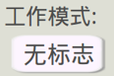.

2. Set the **length of elastic ribbon**, such as:300mm; enter 300 directly.

3. Set **the clamping length on the left and right**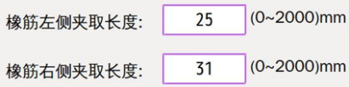, and select the seam line as needed.

4. Set the **preset output** value 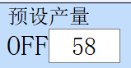and **lower thread count**lQLPDhs-ha3ScVk8zQEosPOoABv8jXqsAjccCxbAZAA_296_60.

5. Load the elastic band into the length-measuring unit according to the pull-through diagram; click the **cutter action** button to cut off the excess part.

6. Confirm that the units are put in place.

7. Select sewing mode: **sewing for a single cycle**.

8. Press the **start** button and the machine will automatically run.

9. After the sewing operation is completed and the machine stops working, check whether the actual length of the elastic band deviates from the preset one.

10. If there is any deviation, please make length compensation.

11. After the setting is completed, select the sewing mode: **cycle sewing**.

12. Click the **start** button, and the machine will automatically and cyclically work to complete the preset output.

2 LOGO mode

**2.1. Method for calibrating color code sensor:**

2.1.1. Set the light spot detection range of the color mark sensor as 10±1mm.

2.1.2. First align the light spot of the color code sensor to the LOGO, and press ON. After the indicator light flashes slowly, move the light spot and align it to the elastic band without LOGO. Then press OFF, and complete the calibration, after the indicator light flashes for about 2 seconds. For details, see Figure 1 below.

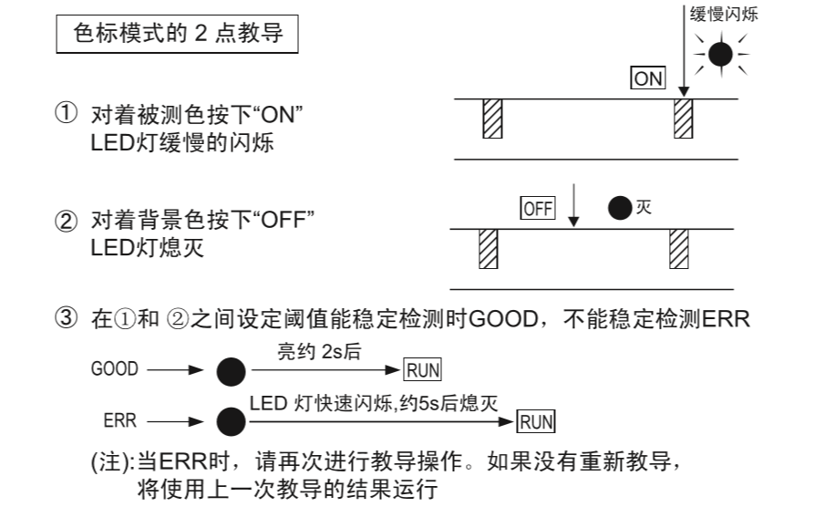

**Figure 1 Color code sensor calibrating method**

2.2, Single-stage:

Take the sample, and calculate the total length of the elastic ribbon, the length of the color code, the length of the LOGO, and the LOGO interval (see Figure 2 below); place the color code sensor in the place where the color code is located, and input and save the parameters in the operation interface. When the color code is not long enough to accommodate the color code sensor,input the proper advance detection distance. The error-proof detection distance is the distance designed to detect the presence of the LOGO before the end of sample feeding. If the LOGO is detected, an error will be reported and the machine stops working.

**Note**: This mode is suitable fortheelastic band with sparsely distributed logos, or large LOGO intervals.

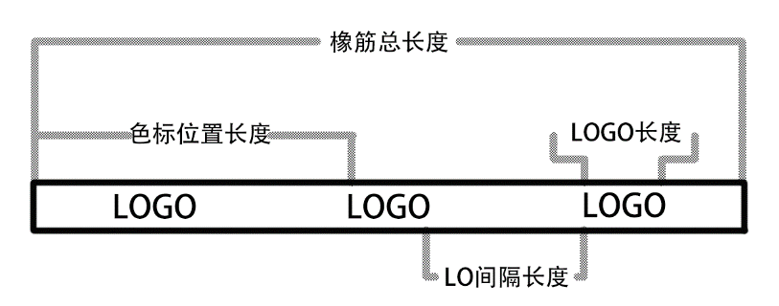

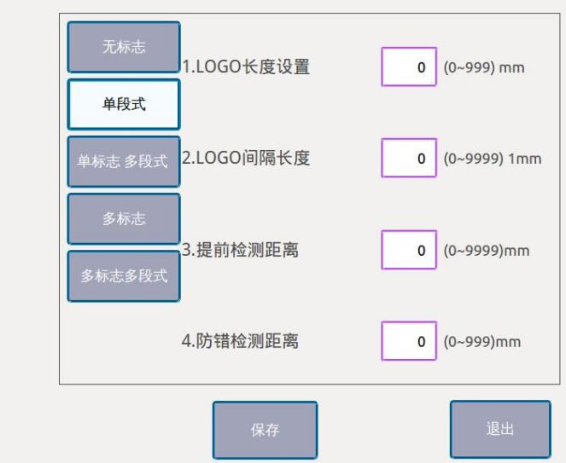

**Figure 2**

2.3. Single-Logo multi-stage:

Take two samples with different lengths, and calculate the total length of the elastic ribbons, the length of the LOGO, and the LOGO interval (see Figure 3 below); take the longer ribbon and calculate the length of color code; place the color code sensor in the place where the color code is located,calculate the length of two samples, and input and save the parameters in the operation interface （No additional parameter setting）. The error-proof detection distance is the distance designed to detect the presence of the LOGO before the end of sample feeding. If the LOGO is detected, an error will be reported and the machine stops working.

**Note**: This mode is suitable fortheelastic band with sparsely distributed logos, or large LOGO intervals.

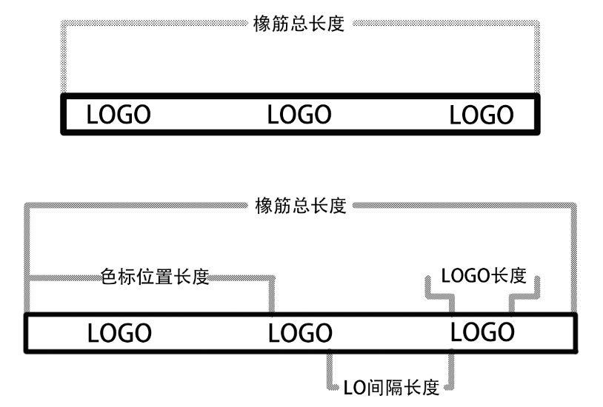

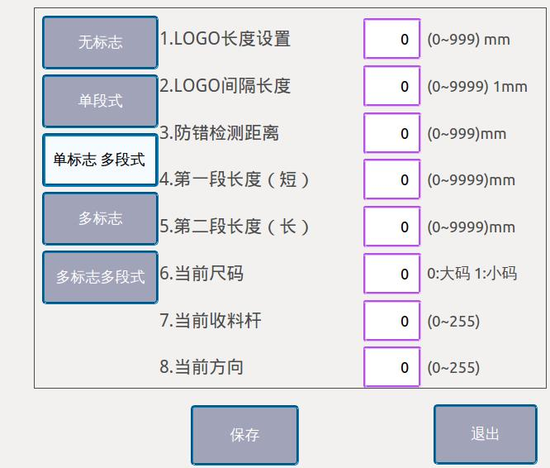

**Figure 3**

2.4 Multi-Logo:

Take the sample, and calculate the total length of the elastic ribbon, the length of the color code, the length of the LOGO, and the LOGO interval (see Figure 4 below); place the color code sensor in the place where the color code is located, and calculate the number of LOGOs before the LOGO where the color code sensor is located. Input and save the number of LOGOs in the operation interface.

**Note**: This mode is suitable forthe elastic band with densely distributed logos, or small LOGO intervals.

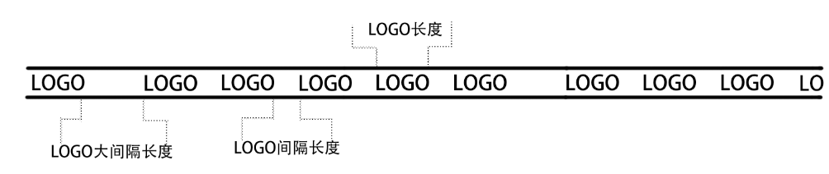

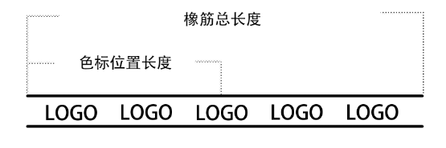

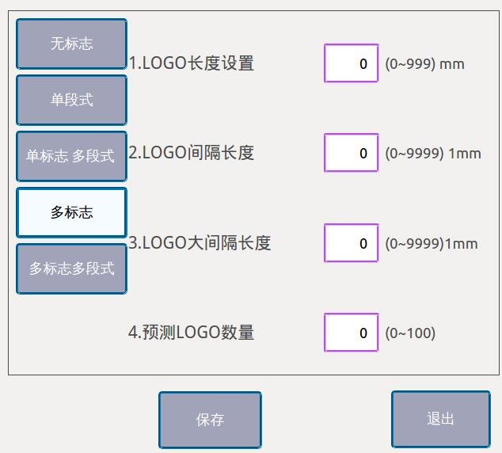

**Figure 4**

**2.5 Multi-Logo and multi-stage:**

Take two samples with different lengths, and calculate the total length of the elastic ribbons, the length of the LOGO,the LOGO interval and the maximum LOGO interval (see Figure 5 below); take the longer ribbon and calculate the length of color code; place the color code sensor in the place where the color code is located, and calculate the number of LOGOs before the LOGO where the color code sensor is located. Input the number of LOGOs; Measure the length of the finished elastic ribbons and enter the parameters in the operation interface. When the color code is not long enough to accommodate the color code sensor,input the proper advance detection distance. The error-proof detection distance is the distance designed to detect the presence of the LOGO before the end of sample feeding. If the LOGO is detected, an error will be reported and the machine stops working.

**Note**: This mode is suitable forthe elastic band with densely distributed logos, or small LOGO intervals.

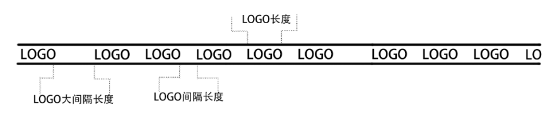

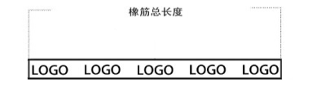

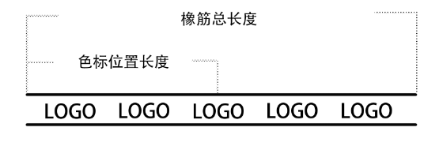

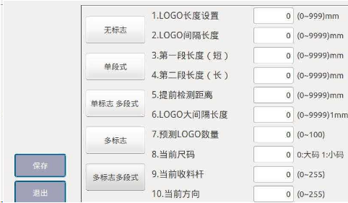

# Electronic control requirements and precautions for use

# 0. Main technical indicators

Supply voltage range: AC220V±10%

Supply frequency: 50Hz/60Hz

# 1. Safety precautions

## 1.1 Scope of use

This servo controller is specially designed for industrial sewing machines. If it is used for other purposes, always pay attention to the safety of users.

## 1.2 Working environment

1.2.1 The power voltage should fall withinthe electrical control voltage plus or minus 10%.

1.2.2 Please keep away from the high-frequency electromagnetic wave transmitter, etc., so as to avoid the error of the controller caused by the electromagnetic wave interference.

1.2.3 Temperature and humidity:

a. Please operate it in a place where the room temperature is above 0°C and below 45°C.

b. Do not use it in a place with direct sunlight or use outdoors.

c. Keep it away from a heater (electric heater).

d. Make sure that the relative humidity falls between 30% ~ 95%(without condensation).

1.2.4 Keep it away from flammable gas or explosives.

## 1.3Installation

1.3.1 Please install the controller strictly according to the user manual.

1.3.2 Please turn off the power and unplug the power cord before installation.

1.3.3 When the power cords are installed, please keep them at least 3cm away from the rotating parts.

1.3.4 In order to avoid noise interference or electric shock, please ground the sewing machine and control box.

1.3.5 Before turning on the power, make sure that the power voltage falls within the specified electrical control voltage plus or minus 15%.

## 1.4 Provisions for maintenance

## 1.4.1 Please turn off the power before maintenance.

1.4.2 When the machine head is lifted to change the needle or thread, please make sure that the power is turned off.

1.4.3 As the control box ishigh-voltage charged, it can be opened more than 5 minutes only after the power is turned off.

1.4.4 Repair or maintenance should be performed by trained technicians.

1.4.5 Maintenance or repair cannot be performed when the motor or control box is working.

1.4.6 All parts for the maintenance purpose must be provided or approved by the company before use.

## 1.5 Danger alert

This mark indicates the safety precautions that users should pay attention to when installing the machine. Faulty operation caused by neglect of this mark may result in personal injury or machine damage.

## 1.6 Other safety codes

1.6.1. After turning on the power for the first time, please run the sewing machine at low speed and check whether the machine rotates in a correct direction.

1.6.2. When the sewing machine is working, please do not touch the movable parts such as the handwheel and the needle.

1.6.3. All movable parts must be isolated with the provided protective devices to avoid body contact. Do not stuff the devices with other items.

1.6.4. Please do not operate the machine without the motor shield and other safety devices.

1.6.5. Prevent the motor or control box from falling to the floor.

1.6.6. Preventthe control box or the motor from tea and other objects in the liquid form.